Biology 11 The Gymnosperms Name:

Objectives - By the end of the lesson you should be able to:
- Compare and contrast bryophytes, pteridophytes and gymnosperms
- Describe the lifecycle of a gymnosperm
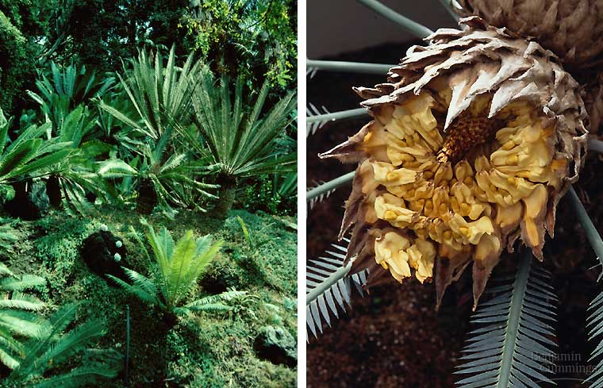
- Give examples of gymnosperms
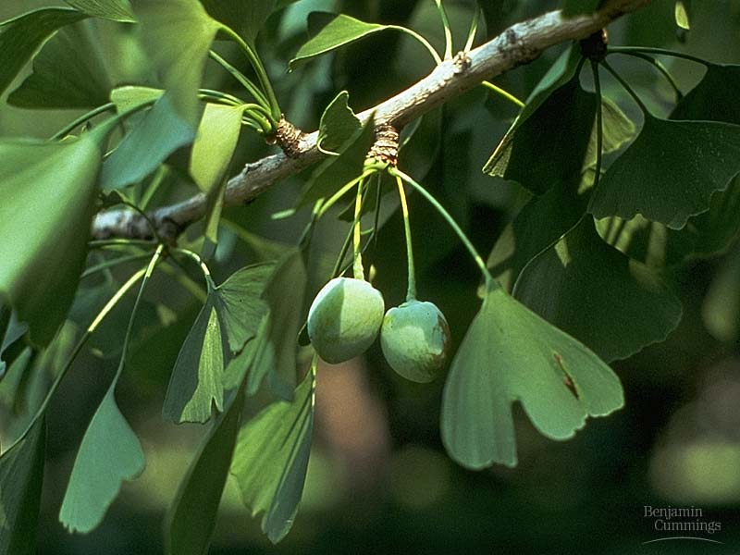

Evolution of Seeded Vascular Plants
- When the Mesozoic era got under way, it ushered in a time of geological and ___________________ instability
- Continental drift formed the “super continent” called ________________
- ___________ and _______________ conditions put survival pressure on the __________ dependent non-seeded vascular plants
- The key to survival was surviving _________________________________________

In plants, this resulted in three significant advances:
- _____________________ reduced even more and becomes protected and completely dependent upon sporophyte
- _______________________________ evolved into sexual pollen for air distribution of the gametes
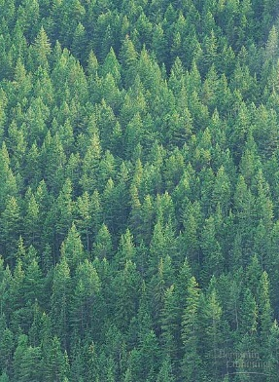
- Development of an ___________________ protecting mechanism (___________________) that also could more effectively distribute their species

_____________________: seeded vascular plants
- First evolved in Paleozoic era.
- Changes in the Mesozoic made this their era
- Dominant during this time were the ____________ and _______________

Conifers
- These are our familiar ___________ trees and shrubs
- They lived in the ____________ continental interiors
- When the climate changed at the end of the Mesozoic, the conifers were pre-adapted and flourished
Ex. Juniper, Pines etc…

Gymnosperms - .
- They are still the dominant plant in the _______ ______________ ___________
- They are the dominant biome in Canada called ___________________ or Taiga coniferous forests
- The ___________________has become very ______________
- It is utilizing all of the advantages so far evolved

Seeded Vascular Plants
  - ___________________
  - ___________________
    - male vs. female gametophytes
  - ___________________
    - naked seeds (no fruit)
  - __________________
    - contain male gametophyte
  - ____________________________________________________________
    - coniferous trees you are familiar with are diploid
    - reduced (microscopic) gametophyte
    - reduction of __________________ protects delicate egg & embryo in protective sporophyte
      - protected from __________________ & _________ radiation
Advances
- __________ ___________ are seen for the first time which allows the gymnosperms to live in _______________ conditions
- They no longer need ___________________ for reproduction
- Leaves are modified into ____________ (decrease water loss)
- The resins inside the needles act as a natural _____________________
- As a result, they became (and are) the dominant tree of the north temperate zones

Life Cycle
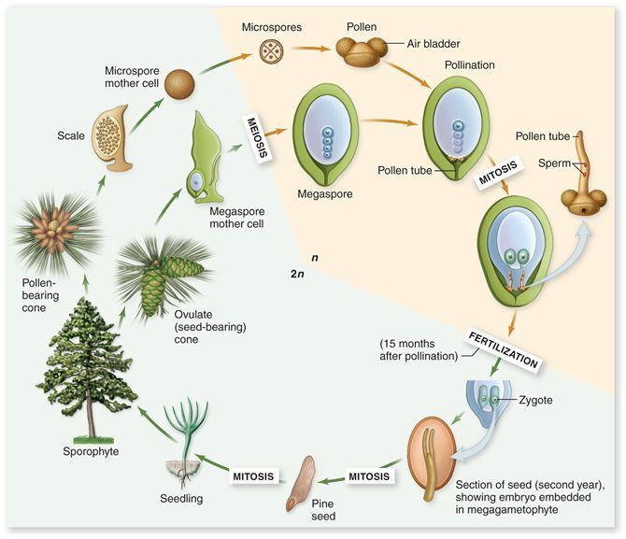

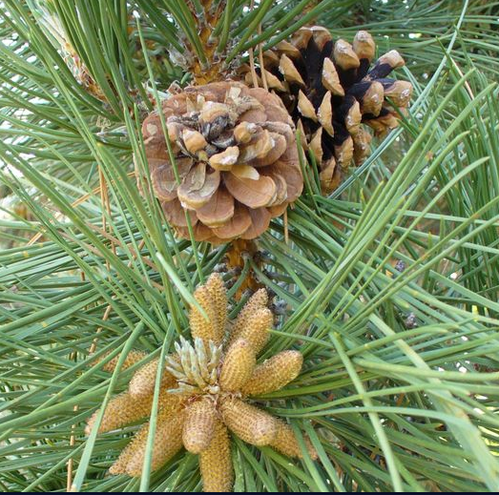
Male Cones
- The male gametophyte is the _____________________ formed by meiosis inside the male cone
- The male cone is small and short lived, dropping off the tree after a few weeks

Female Cone
- The female gametophyte is the ___________ formed by meiosis inside the female cone
- After _____________________ the female cone houses the seeds until next spring
- The female cone is _________ and long _________, dropping off the tree after 2 years!
Pollen
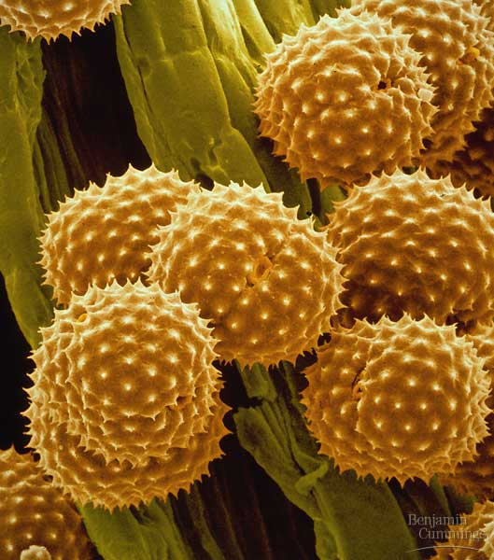
- Pollen eliminated the requirement for ________________ for fertilization
  - spread by ___________ & __________________
