SELF-TEST QUESTIONS: PHYLUM ANNELIDA

WHAT DO THE FOLLOWING TERMS MEAN?
Setae – stiff bristles
Parapodia – appendage like structures that act like paddles in aquatic annelids
cerebral ganglion – simple brain
septa – interior body walls that separate segments

WHAT IS THE CORRECT TERM FOR THE FOLLOWING?
The structure in an earthworm that secretes the mucous mating sheath – clitellum
The class to which sandworms belong – polychaeta
The name of the excretory organ – nephridia
Name of the lip over earthworm mouth - prostomium
The type of symmetry found in earthworms – bilateral

SHORT QUESTIONS
1. Discuss earthworm reproduction. – Hermaphrodites attach to each other in opposite directions with clitella close to each other. Mucous ring is formed around clitella where sperm and eggs are released. Fertilization takes place inside this ring then slides off to form a protective cocoon.
2. Discuss the earthworm digestive system. – Complete digestive system which is coordinated by muscles surrounding it. Ingested soil moves from mouth, to pharynx, to crop for storage, then to gizzard to be ground up (increasing surface area), then to long intestine to absorb nutrients, and wastes exit the anus.
3. Discuss the structure and functioning of parasitic leeches. – segmented, triploblastic, coelomates. Suckers on both ends of body to cling to hosts or posterior sucker to attach to rocks or leaves until a host passes by. May have scissor-like jaws to slice skin. May secrete anesthetic so they aren't noticed by host. Use pharynx to suck blood from victim.

LONG QUESTIONS
Draw and label a whole mount of an earthworm. Show as many structures as possible and annotate the diagram to give the functions of the labeled parts.

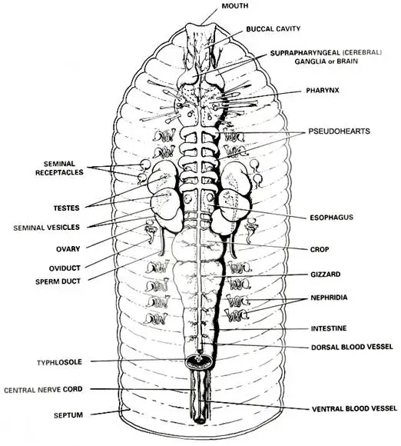

SELF-TEST QUESTIONS: PHYLUM ARTHROPODA

WHAT DO THE FOLLOWING TERMS MEAN?
Cephalothorax – fused body region consisting of head and thorax together
Exoskeleton – hard exterior skeleton (made from chitin in arthropoda)
Hemocoel – blood sac that organs sit in
telson & uropods – parts of the tail fan. 1 telson in the middle and 4 uropods on the sides of tail fan
open circulatory system – blood is not enclosed in blood vessels and is pumped into a blood-filled sac called a hemocoel.
Spiracles – small holes outside the body which lead to the tracheal tube respiratory system in insects
tracheal tubules – tubes that line the inside of insects which connect to air sacs surrounded in blood for respiration

WHAT IS THE CORRECT TERM FOR THE FOLLOWING?
The type of respiratory organ found in most spiders – book lungs
The claw-like feeding appendages of crayfish – cheliped
The number of legs per segment of a millipede – 2
The hard mouth part used for chewing in a crayfish – mandible
The exoskeleton that covers the cephalothorax in a crayfish – carapace

SHORT QUESTIONS
1. Discuss the arthropod exoskeleton structure and function. – made of hard chitin (a polysaccharide). May coloured for camouflage or spiky and spiny for defense. Thinner at joints to allow for movement. Anchored inside to opposing muscle groups to allow for movement. Removed during moulting and reformed in order for organism to grow.
2. Describe how insects are so well adapted to life on land. – 1. Size: tiny to minute - don’t eat much, can hide
2. Exoskeleton: hard, yet great strength
3. Short life span - don’t eat much
4. Reproduction: all sexual - variation
5. Flight: many advantages
6. Specialized appendages: eat many things
7. Adaption of exoskeleton: camouflage etc
8. Well developed sensory ability
9. Evolved social behavior
10. Very specific niches: minimizes competition

3. What are the 5 classes of arthropods and an example animal for each?
– Arachnida – spiders
– Crustacea – crabs
– Insecta – grasshopper
– Chilopoda – centipede
– Diplopoda - millipede

LONG QUESTIONS
Draw and label a crayfish. Annotate the diagram and discuss the function of each structure.
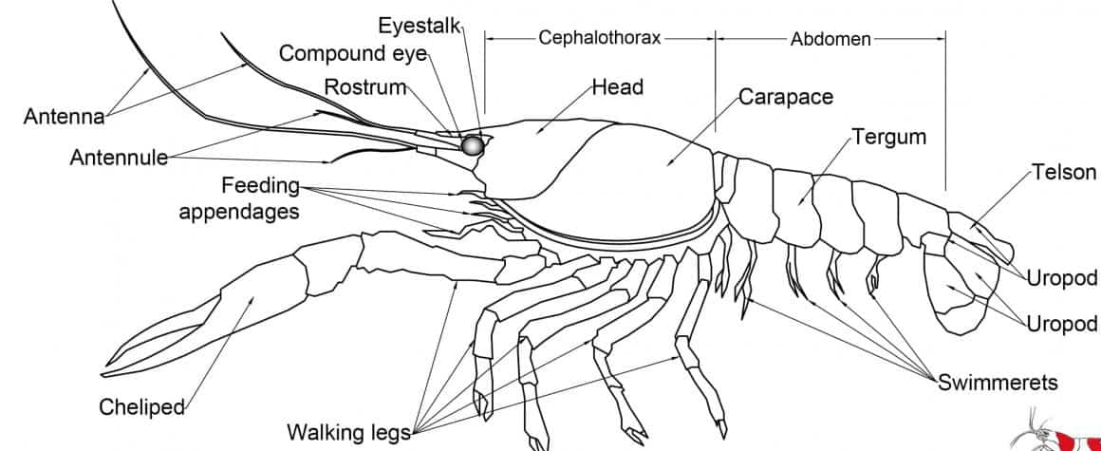
– Cheliped – eating/defense
– Walking legs – movement
– Swimmerets – reproduction
– Telson/uropods – tail fan – movement
– Antenna/antennule – sensory
– Compound eye - sensory
– Rostrum – protects eyes
– Cephalothorax – head and thorax combined
– Carapace – protects cephalothorax
– abdomen – movement/covers intestines

SELF-TEST QUESTIONS: PHYLUM MOLLUSCA

WHAT DO THE FOLLOWING TERMS MEAN?
Foot – body region / structure for movement (snail foot), burrowing (clam foot), or capturing prey (tentacles – squid foot)
visceral mass – body region below mantle which consists of internal organs
mantle – body region which covers the visceral mass
radula – rasping tongue like structure covered in tiny teeth

WHAT IS THE CORRECT TERM FOR THE FOLLOWING?
The “shell” of a squid – pen or quill
The class name for a snail – Gastropoda
The compound used by clams to make their shells – calcium carbonate

SHORT QUESTIONS
1. Discuss the structures and functions of the shells found in different mollusks. – Bivalvia have 2 shells connected by hinges and powerful muscles. Used for protection so they can filter feed. – Gastropoda may or may not have a shell. Snails have single, spiral shells used for protection where snail can move inside of its shell. Cephalopoda may have one large spiral shell like a nautilus or reduced interior shell like the pen in a squid. The pen gives squid rigidity so they can swim.
2. What is the function of the radula. – Feeding by scraping algae off rocks, tearing through flesh, or drilling through shells.
3. Discuss the variation of the dorsal and ventral surfaces in a squid. Dorsal – darker colour, pen visible. Ventral – lighter colour, siphon visisble

LONG QUESTIONS
Explain how the squid defends itself. When they are threatened, they can squirt dark inky fluid into the water. This confuses predators and allows the squid to escape.

SELF-TEST QUESTIONS: PHYLUM ECHINODERMATA

WHAT DO THE FOLLOWING TERMS MEAN?
Deuterostome – In early development, a hollow ball of cells called a blastula forms. A hole forms called a blastopore which will develop into the anus. In protostomes, this first hole develops into a mouth.
Blastopore – The initial hole that forms in the developing ball of cells (blastula) that goes on to become the start of the digestive structures.
Pentaradial – Radial symmetry based on 5 or multiple of 5 points
Madreporite – Also known as the sieve plate, it is the external structure that acts as the entrance to the water vascular system in a sea star

WHAT IS THE CORRECT TERM FOR THE FOLLOWING?
The opening of the water vascular system in a starfish – madreporite
The canal in each arm of a starfish that supplies water to the tubefeet – radial/lateral canal
The class to which brittlestars belong – Ophiuroidea
The name of the ridge along each arm of the starfish – ambulacral ridge

SHORT QUESTIONS
1. Explain what tubefeet are and how they work. – Part of the water vascular cavity. Acts like a suction cup. Can allow echinoderm to walk or pull open shells.
2. Discuss feeding in starfish. – Sea stars push their cardiac stomach out of their body and inside of a clam's shell for example to digest it. The stomach absorbs nutrients and moves back inside of the sea star's body.
3. Discuss feeding in sea urchins. – Have 5-part jaw-like structures to scrape algae from rocks or chew on kelp
4. Discuss the differences between protostomes and deuterostomes – Protostomes – blastopore develops into mouth, deuterostomes – blastopore develops into anus. Protosome examples: annelids, mollusks, arthropods. Deuterostome examples: echinoderms, chordates.

LONG QUESTIONS
Discuss the water vascular system of the echinoderms.
– Sing the song! Madreporite is connected to the stone canal, the stone canal is connected to the ring canal, the ring canal is connected to the radial canal, the radial canal is connected to the tube feet, and that's the water vascular system!

– The water vascular system is a fluid filled system which carries out many essential body functions including respiration, circulation, excretion, and movement.

TO THINK ABOUT
Explain why, of all the invertebrate phyla we have studied, the echinoderms are used as models for early embryological development of vertebrates?

– They are deuterostomes and therefore show similar embryological development patterns to vertebrates.

