Unit 2: Evolution – How Evolution - Macro Date: _____________
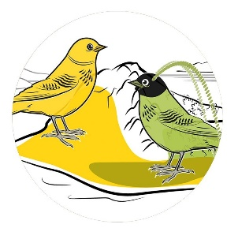
Objectives - By the end of the lesson you should be able to:
- Describe how macro-evolution is different from micro-evolution
- Describe the 3 patterns of speciation
- Explain a problem with speciation and the proposed solution
Macro-evolution: AKA Speciation
- __________________________: _______________________________
Recall:
- Species: population of organisms that are able to breed and produce viable, fertile offspring

- When a __________________________________________ (by a geographic barrier for example), speciation can occur over a long period of time as all of the small changes in the gene pool due to micro-evolution add up over time.

- Eventually the differences in the two populations are so great that the two populations can ___________________________________________________ to make viable, fertile offspring. We now have two different species. _______________ is said to have occurred.

Patterns of Speciation
1. __________________________________________ AKA Adaptive Radiation
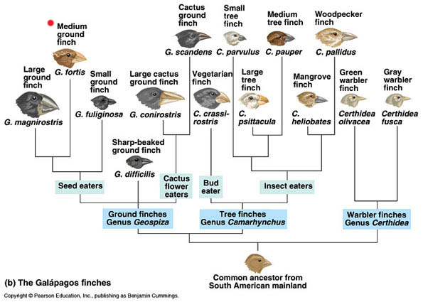
  - Occurs when small fragments of a populations ___________________________________ …..they adapt (evolve) to their new habitats

  - _________________________________________________

  - EX. ______________________________

2. _____________________________________________
- Occurs when _________________________________
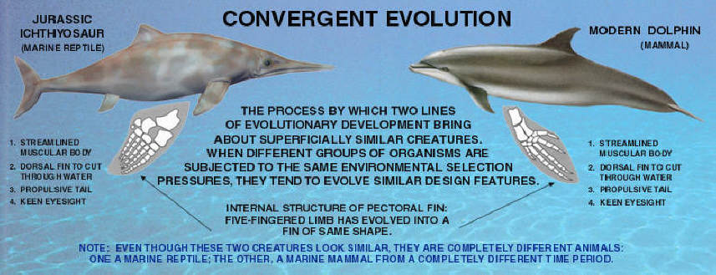
___________________ and adapt (evolve) so will display similar characteristics

- _________________________________ so DNA is not closely related
- EX. _____________________________

3. ____________________________________________
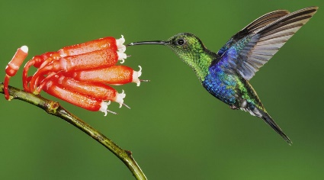
- Occurs when organisms are closer connected to one another by biological interactions _______ ____________________ . A change in one organism may be followed by a corresponding change in the other organism.
- EX. _________________________________

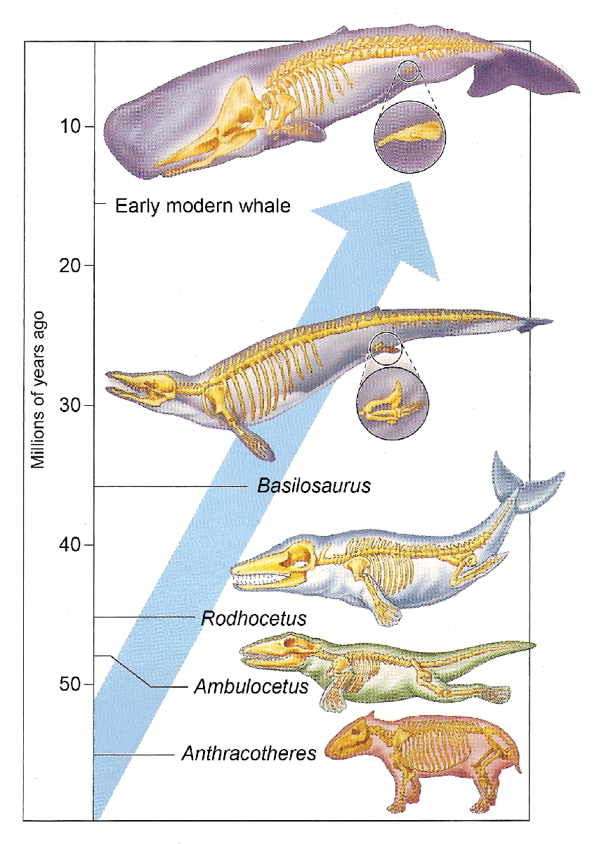
Potential Probelm
- There is a __________________________________________________________!
- How is it possible that can we jump from one species to another with no fossil record of it ever occurring?
- Why is fossil evidence so important??
Fossils are ____________________________________________________ …

Proposed Solution - _______________________________________
- Eldredge and Gould in 1972
- Proposed that “less fit but survivable” members of a population would be pushed to the periphery or to less desirable extremes of the species habitat.
- The _________________________________________________ (evolve) to the new harsh environment
- Re-introduction could happen and the peripheral population would _____________________________ ____________________________________________
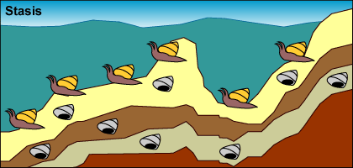
BUT WHY NO FOSSIL RECORD!??!?
EX: Mollusk Evolution by Punctuated Equilibrium
- ____________________ A population of mollusks is experiencing stasis, living, dying, and getting fossilized every few hundred thousand years. Little observable evolution seems to be occurring judging from these fossils

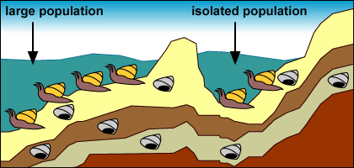
- ____________________: A drop in sea level ____________ and ________________________number of mollusks from the rest of the population.

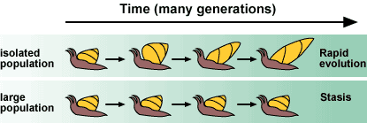
- _____________________: The small, isolated population experiences strong selection and _________________ because of the novel environment and small population size: The environment in the newly formed lake exerts new selection pressures on the isolated mollusks. Also, their small population size means that _________________ influences their evolution. The isolated population undergoes rapid evolutionary change.

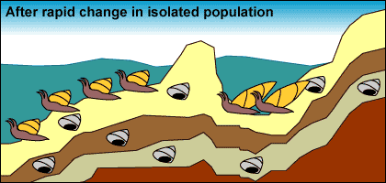
- ________________________: Few fossils representing transitional forms are preserved because of their relatively _________________ population size, the ______________ of change, and their ___________________________.

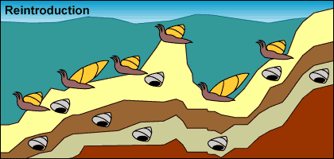
- _________________________: Sea levels rise, reuniting the isolated mollusks with their sister lineage.

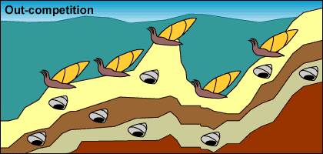
- _____________________________ : The isolated population _______________________________. Larger population size and a stable environment make evolutionary change less likely. The formerly isolated branch of the mollusk lineage may _________________________ their ancestral population, causing it to go extinct.

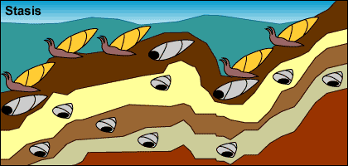
- ___________________________ : Larger population size and a larger range move us back to step 1: stasis with occasional fossil preservation.

- This process would produce the following pattern in the fossil record: 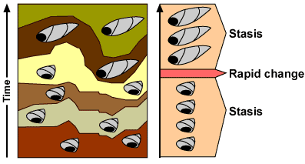
- We observe similar patterns in the fossil records of many organisms. For example, the fossil records of certain foraminiferans (single-celled protists with shells) are consistent with a punctuated pattern.
- 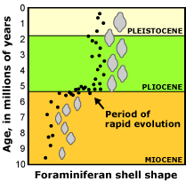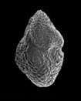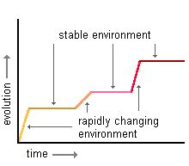

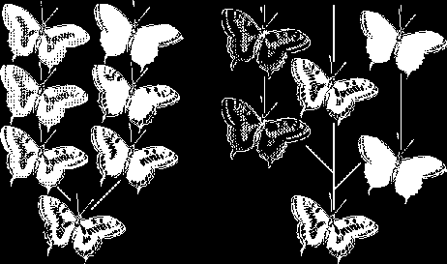
Comparison

__________________ ___________________

________________ ________________________

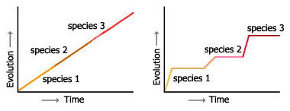
Which graph is showing Gradualism? Punctuated Equilibrium?

Which model of evolution could be easily used to explain a lack of intermediate fossils?

