Unit 2: Evolution – How Evolution - Micro Date: _____________
Objectives - By the end of the lesson you should be able to:
- Describe the 2 types of evolution
- Describe the 5 ways to change a gene pool (micro-evolution)
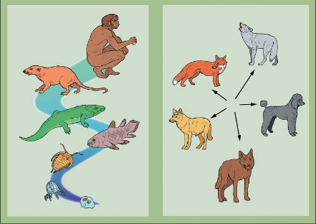
- Describe the 3 ways a population can change due to selection __________ _________
Evolution
- There are two basic types:
- ______________________: ___________________________
- ______________________: ___________________________
Species: population of organisms that are able to _______________ and produce ________________________ offspring
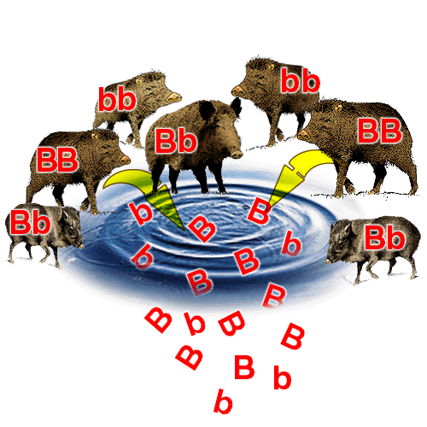
Gene Pools
- Gene Pool: _____________________________________________________
- Contains all ____________________________ for all genes
- There are 5 mechanisms (ways) of changing the gene pool of a population…..THIS IS MICRO-EVOLUTION!
Mechanisms of Micro-Evolution
5 ways to change a gene pool:

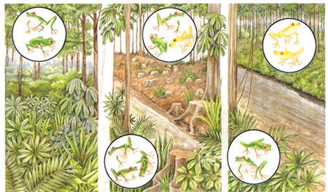

1. Natural Selection
- Those ___________________________________________________, survive, and pass on their genes to the next generation

2. Mutations
- Mutation: _______________________________________
- This change can be _____________________________________ and can change the gene pool
- Effects of Mutations: good, bad or neutral
  - The effect of a mutation is ___________________
  - There is much repetitious DNA
  - There is also lots of “non-coding” DNA
  - A mutation in coding DNA is usually harmful but a rare few produce a _____________________
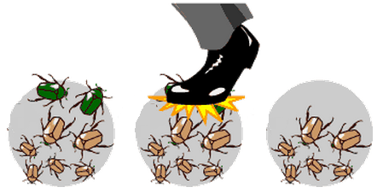
3. Genetic Drift
- There is a change in the gene pool as a __________________

4. Gene Flow
- The _________________________________________________________
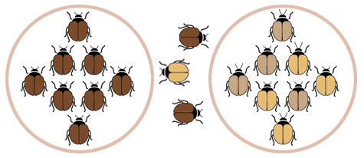
- This can __________________________________________ into a population (introduce a yellow frog)
or
- If gene flow stops or is restricted, populations that were once joined, _________________________
5. Sexual Selection (Non-Random Mating)
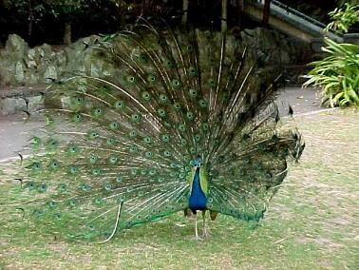
- Sexual Selection: based on _______________________________________ (colour, displays, territory, song, size etc)
- Organisms rarely mate randomly
- Examples:
  - __________________________: one male has many females
  - _______________________________: choosing those like you
Who’s The Fittest?
- Fittest in any population means the organism who ____________________________________________ ________________________________ (NOT who is in the best shape!)
- In elk, one dominant male may mate with 80% of fertile females but if he happens to be sterile he’s not “fittest”

Fitness and populations
- Populations are made of many variations of genes
- Those who contribute the most (the fittest!) have their genes ___________________________________ _______________________________________________
- So in each generation the genes that are the most represented depends on _________________________ _______________________________________________
Populations
- If NO evolution is occurring in a population, then these ____________________________________ __________________________________________________ from generation to generation.
- But, if we see _________________________________________________________ from generation to generation than we know that the population must be evolving!
- The most common genes can be represented in a graph
- Natural selection will act on the population to produce a new shape of graph

Populations - Effects of Natural Selection
1. _____________________ Selection
- Acts against the extreme variations in a population, so ____________________________________
- __________________________________________
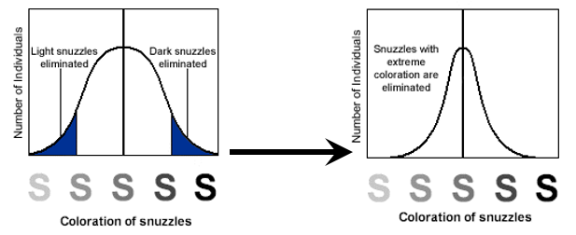

2. ______________________ Selection
- Occurs when ________________________________________________________________
- One phenotype is favored over the other
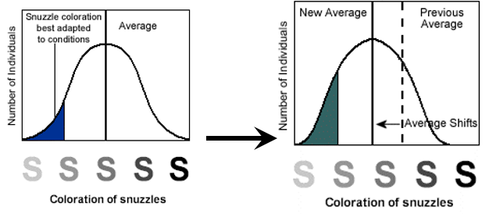

3. ________________________________________ Selection
- Occurs when ____________________________________________
