Name: _____________________ Date: __________________
Intro Bio Review
1. Identify the following compounds.
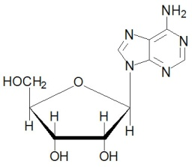
A. B.
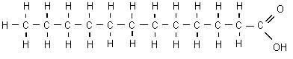

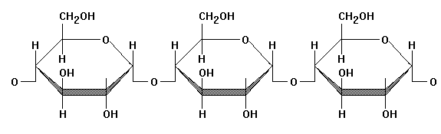
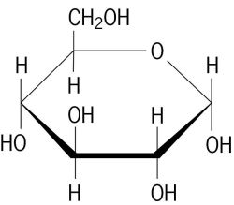
C. D. E. 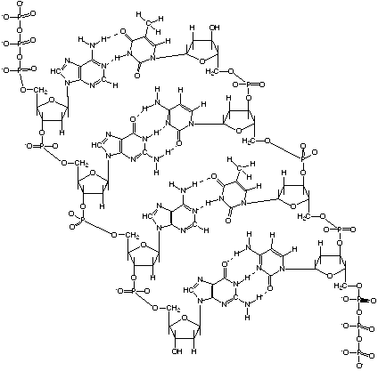

___ Fatty Acid ___ Nucleotide ___Starch (polysaccharide) ___ glucose ___ DNA

2. Give 2 functions of fats:

3. What is the main role of carbohydrates?

4. Give 2 functions of proteins in our body.

5. Give three structural differences between plant and animal cells

6. Describe and draw the process of making a protein.

7. Match the following organelles with the proper function.

___ produces fats and detoxifies A. Lysosome
___ provides structure and pathways for vesicles to be transported on B. Golgi
___ synthesis and transport for proteins C. RER
___ pulls apart chromatids during cell division D. SER
___ intracellular digestion E. Centrioles
___ packages and exports synthesized products F. Mitochondria
____ site of cellular respiration – energy production in form of ATP G. Cytoplasm
____ jelly that makes up the cell's interior H. Cytoskeleton

- What would happen to a cell if placed in the following solutions (describe and illustrate).

  - Isotonic solution:

  - Hypotonic solution:

  - Hypertonic solution:

- You want to determine the effects of a certain fertilizer on the growth of orchids grown in a greenhouse. Materials that are available to you include: greenhouse, 100 orchid plants, water, fertilizer, and soil. You want to know if the orchids will grow best with a weak concentration of fertilizer, a medium concentration of fertilizer, or a high concentration of fertilizer. How will you design an experiment to test different concentrations of this fertilizer?

What are the independent, dependent, and control variables? Which plants are the control group and experimental group?

