Biology 11 Kingdom Animalia - Introduction Name:
Date:
Animal Characteristics
- ____________________________
- _________________________ by ingestion.
- ___________________________ with a high degree of cell specialization.
Classification Criteria
1. Germ layers The word germ means grow - the germ layers in animals grow to form the
various tissues and organs
A. No Germ Layers
- animals develop no tissues or organs
B. _______________________
- Two germ layers: ectoderm and endoderm
- __________________: outer layer (forms skin and nervous system)
- __________________: inner layer (forms lining of digestive tract)
C. _______________________: three germ layers
- ______________________ grows between the ectoderm and endoderm.
- Forms muscle and most of remaining internal organs
- This is the highest level
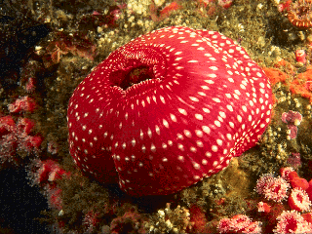
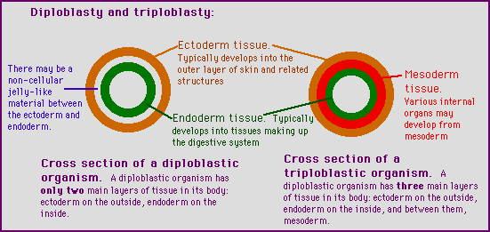
2. Symmetry (body axis)
A. ___________________________
- Can be divided into many planes through central axis
- These have a cylindrical shape
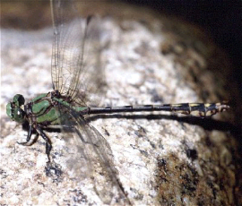
B._________________________________
- Can be cut into two equal halves only one way, through the mid dorsal line.

- Results in _____________________________________________________________

- Allows for ______________________________ (concentration of sense organs and nerve cells at the front end of the body)

3. Body Plan: type of body cavity
The evolution of a body cavity, called a Coelom, provided a place for organs and organ systems to grow
- ___________________________: no coelom
- poorly developed organs
B. ____________________________: false coelom
- Have a body cavity between endoderm and mesoderm layers
- No muscle around gut so no co-ordination of food through digestive tract
- Some organs systems develop in this space
C. ____________________________: true coelom
- Have a body cavity located between the mesoderm of the body wall and the new layer of mesoderm around the gut
- Allows for co-ordinated digestion
- __________________________________________
- Highest level of development
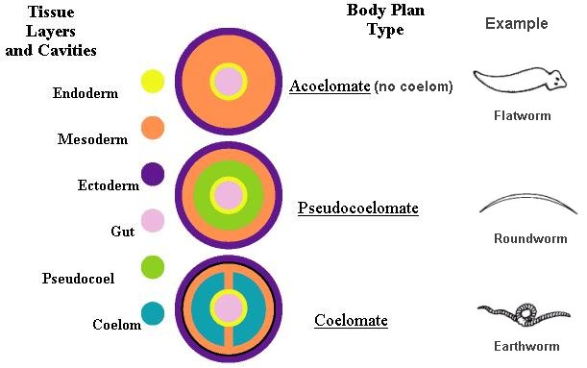
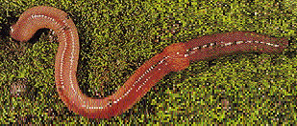
4. Segmentation leads to specialization and body regions
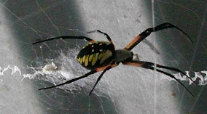
- Non Segmented: no specialized sections
- Segmented: _____________________________________
C. Segmented with specialization
- Body segments fuse together to become body regions which focus on one set of tasks

5. Animal Evolution
- We typically study animals in three groups which reflect their evolutionary history.
A. The Lower Invertebrates
- These phyla demonstrate a fairly linear evolution (simple biology)

- They include: __________________________________________________________

B. Higher Invertebrates:
i. The __________________________________
- This is one of two main branches of animal evolution
- Named this way due to embryo development
- They include the _________________________________________________
ii. The __________________________________
- These are the animals on the other great branch of animal evolution
- Include the ______________________________________________________
C. Vertebrates
- Represent the most highly evolved animals (Us!!)
