Introduction to Biology – The Study of Life
Date: Biological Specimen:
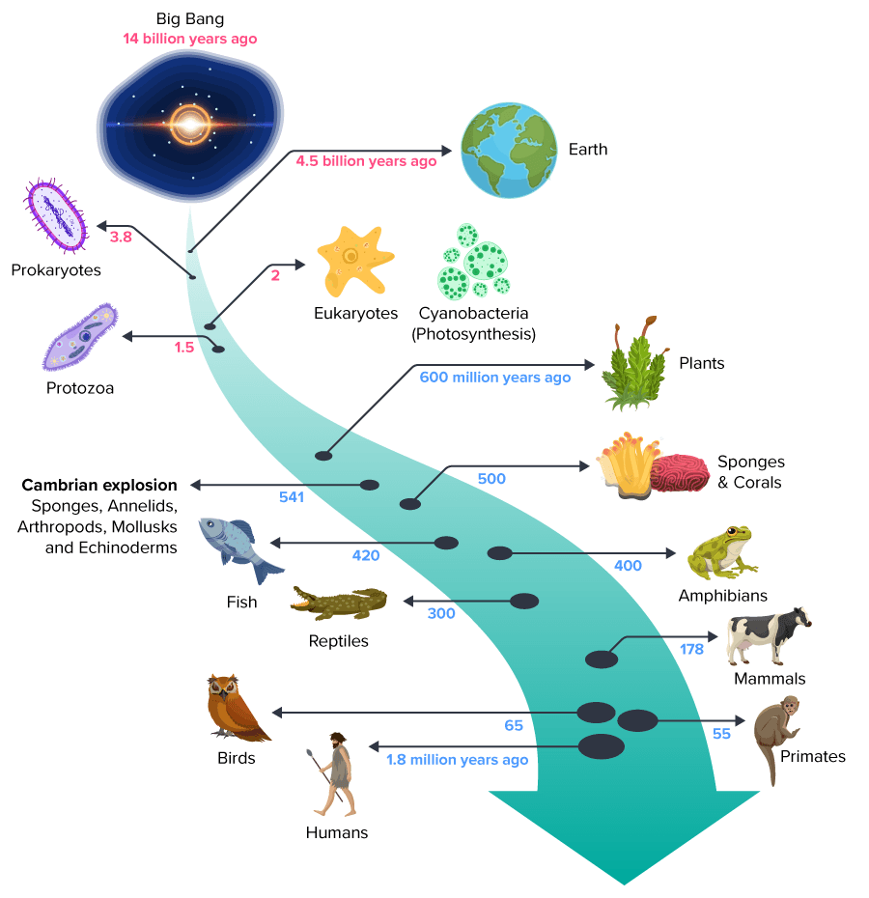
By the end of the lesson you should be able to:
- Describe the 8 characteristics of life
- Describe how life is organized
Life on Earth
- Life arose more than ____________________________
- First organisms (living things) were ________________
- Only life on Earth for millions of years
- Organisms changed over time (__________________)
- New organisms arose from older kinds
- Today there are millions of species that inhabit almost every region of Earth today
Characteristics of Life
- Biology is the scientific study of life.
- What defines life? Most biologists look for a set of general characteristics.
All life …
1) … is made up of at least one or more ___________________
2) … must obtain and use materials and ___________________
3) … _________________ and develops
4) … ____________________ itself
5) … _____________________ to its environment
6) … _________________________ - evolves - to survive in its environment
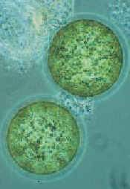
7) … maintains ______________________ (stable internal environments)
8) … is based on a universal _____________________
1) Life is Made Up of at Least One Cell
- __________________ are the basic unit of life
- All organisms are made of and develop from cells
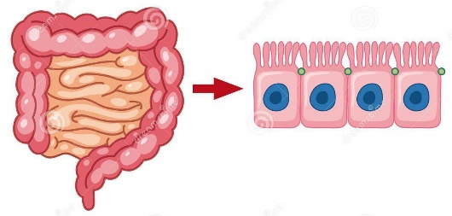
- Some composed of only a single cell (____________________) which is usually _____________________________ (eg. bacteria, amoeba, algae, paramecium)
- Most organisms are composed of many cells (________________________)
- Cells are different (undergo _______________________________)
- Cells are small and highly organized
- There is a close relationship between cell __________________ and _____________________

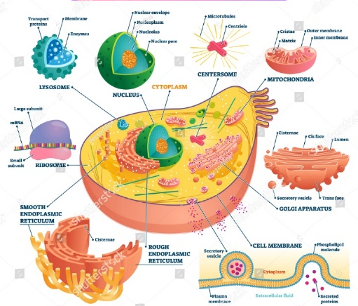
- Cells contain specialized structures (_________________________) that carry out the cell’s life processes
- Many different kinds of cells exist
- All cells surrounded by a _____________________________
- Contain a set of instructions called DNA (___________________________)
2) Life Must Obtain and Use Materials and Energy (Metabolism)
- Living things need energy to power cellular processes and materials to build new cells, grow and reproduce
- Set of chemical reactions that convert “food” into energy is called _________________ - Sum of all chemical processes
- Almost all energy comes from the ____________________ (directly or indirectly)
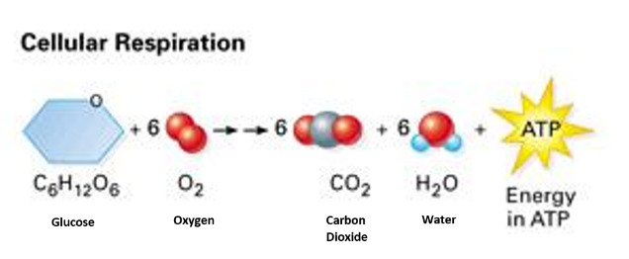
- ____________________________ is the process by which some organisms capture the energy from the sun (solar) and transform it into ____________________________ that can be used by living things
- _______________________________ is the process by which all organisms break down glucose (sugar) to produce the high energy molecule __________ (cellular energy) that can be used by the organism.
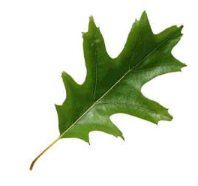
Autotrophs
  - Organisms that make their own food are called _______________
  - _________________________ – use solar energy (photosynthesis) to get energy
  - Convert H₂O and CO₂ into _______________ and __________________
  - ______________________ – use different chemical processes to get energy
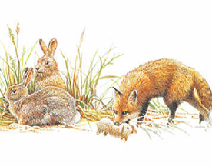
Heterotrophs
  - Organisms that must take in food to meet their energy needs are called _____________
  - Consume autotrophs (____________________), other heterotrophs (________________) or both (_____________________) for their energy needs
  - Complex chemicals are broken down and reassembled into chemicals and structures needed by organisms
3) Life Grows and Develops
Growth
- Growth is an increase in biomass that occurs as the result of _____________________ ___________________
- Cell division is the formation of two cells from a _________________________
- New cells enlarge as they mature
- When a cell grows to a size where its ____________________ isn’t big enough for its ____________________, the cell divides
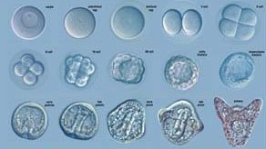
Development
- The process by which an adult organism arise is called ______________________
  - Repeated cell divisions and ______________________________
- Organisms grow and develop along a specific sequence based on the instructions present in their genetic code (DNA).
4) Life Reproduces Itself
- All species have the ability to reproduce
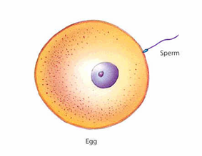
- Not essential to survival of individual but is essential for continuation of a species
Sexual Reproduction
  - Hereditary information from ______________________________ of the same species are combined
  - Egg and sperm ___________________ (fertilized egg)
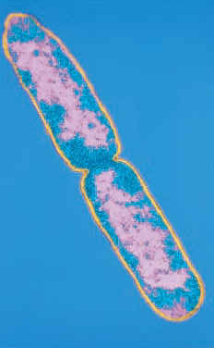
  - Zygote contains hereditary information from _____________________________
Asexual Reproduction
  - Hereditary information from __________, usually unicellular, organism that divides
  - Resulting cells contain ______________________________ information
  - Genetic information from ______________________
  - Populations of organisms adapt to their environment over time through the process of evolution
5) Life Responds to its Environment
- Livings things have the ability to respond to changes in their environment called _______________
- Detect and respond to changes in light, heat, sound, chemicals and mechanical contact
- Coordinates its responses
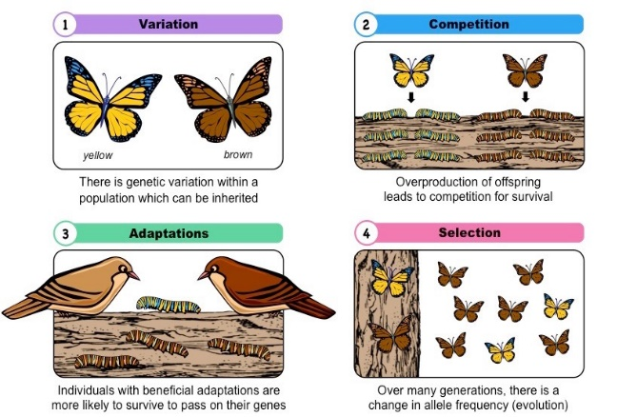
6) Life Adapts Over Time - Evolves - to Survive in its Environment
- Populations of organisms adapt to their environment over time through the process of ___________________
- _______________________________ are selected for and passed on to offspring. These are called ____________________________
- Driven by ________________________ or “survival of the fittest”
7) Life Maintains Homeostasis (Stable Internal Environments)
- Living organisms must maintain a specific range of internal conditions in spite of the outside changes. This balance is called ________________________
*Cells function best when these are in balance

- Homeo = same, steady Stasis = state
- Examples: - Water balance inside and outside of cell, Human body temperature
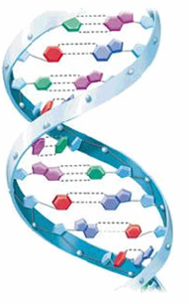
8) Life is Based on a Universal Genetic Code
DNA
- Genetic Information in all cells
- Deoxyribonucleic Acid
- DNA contains instructions for traits __________________
- Make the structures and complex chemicals necessary for life _________________
- DNA in every body cell (____________________________) is exactly alike
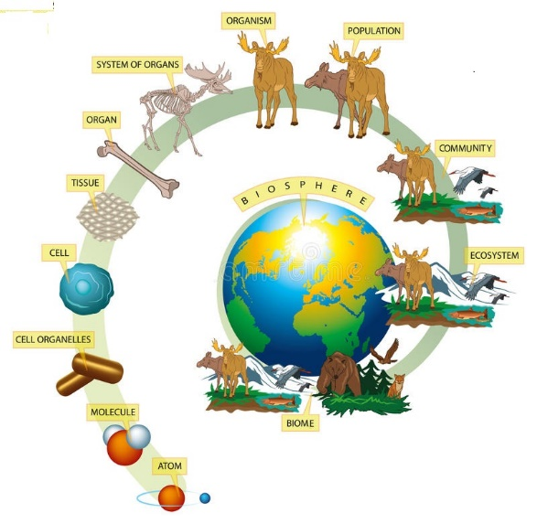
Organization of Life
- The ______________________ is the part of Earth that supports life.
- An ________________________ is a specific area within the biosphere with a common set of physical characteristics. - Climate, soil, landforms, etc.
- The biological _________________ is made of all populations living and interacting in one ecosystem.
- A _________________________ includes all members of a species that live in the same community.
- An ________________________ is an individual living thing.
- Organisms are made of organ systems and _________________, structures with a specific vital function.
- Each organ is made of a collection of _____________, which are groups of cells with similar structure and functions.
- The _______________ is the smallest unit of an organism that still demonstrates all the basic characteristics of life.
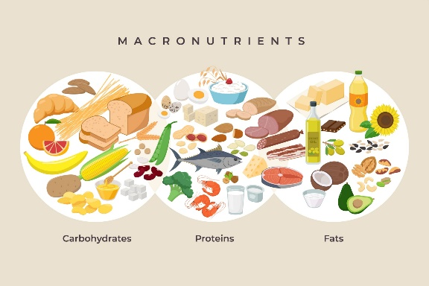
What is Life Made From?
- You are what you eat! This will be our next topic!

Can You …
- … describe the 8 characteristics of life?
- … describe how life is organized?

