Introduction to Science and the Scientific Method
Date: ______________ Super Scientist! (Name): ______________
What is science?
The goal of science is to investigate and understand the natural world, to explain events in the natural world, and to use those explanations to make useful predictions.
1. Science deals only with the natural world.
2. Scientists collect and organize information in a careful, orderly way, looking for ___________________ _____________________________ between events.
3. Scientists propose __________________ that can be ______________________ by examining evidence.
4. Science is an organized way of using ______________________ to learn about the natural world.
How is Science Done?
Science begins with an ______________________. This is the process of gathering information about events or processes in a careful, orderly way.
_______________ is the information gathered from making observations.
There are two types of data:
_________________ data are: ___________________ and are obtained by counting or measuring.

_________________ data are: ___________________ and involve characteristics that cannot be counted.
Hypothesis
- A hypothesis is a ___________________________________for a set of observations.
- A hypothesis must be stated in a way that makes it “testable”. The hypothesis is just a possible answer to a question, and it must be thoroughly tested.
Scientific Method
The scientific method is a series of steps used by scientists to solve a problem or answer a question.
The Steps to the Scientific Method
- Observation / Asking a Question
- Form a ___________________
- Design a _____________________________________ and collect data
- Record and Analyze Results
- Draw ______________________
- Re-test

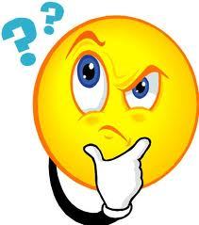
Step 1:
Observation / Asking a Question
A problem or a question must first be identified.
How much water can a root hair absorb?
Why does a plant stem bend toward the light?
What effect does temperature have on heart rate?
Step 2: Form a Hypothesis
Hypothesis: A ________________________ explanation to the question or problem. It is simply a prediction and has not yet been proven or disproven. It must be stated in a way that is testable.
A statement is considered “testable” if evidence can be collected that either does or does not support it.
Step 3: Designing a Controlled Experiment
1. The factors in an experiment that can be changed are called ____________________. Some example of variables would be: changing the temperature, the amount of light present, time, concentration of solutions used.
2. A controlled experiment works with ___________________________________. If several variables were changed at the same time, the scientist would not know which variable was responsible for the observed results.
3. In a “controlled experiment” only one variable is changed at a time. All other variables should be unchanged or “controlled”.
4. An experiment is based on the comparison between a ________________ group with an ________________ group.
a) These two groups are identical except for one factor.
b) The control group serves as the _________________________. It is the same as the experiment group, except that the one variable that is being tested is removed.
c) The experimental group shows the effect of the variable that is being tested.
Example: In order to test the effectiveness of a new medicine, 50 volunteers are selected and divided into two groups. One group will be the control group and the other will be the experimental group. Both groups are given a pill to take that is identical in size, shape, colour and texture.
Describe the control group.

Describe the experimental group.

What variables are kept constant?

What variable is being changed?

There are two variables in an experiment:
a) The _________________________ variable is the variable that is deliberately changed by the scientist.
b) The _________________________variable is the one observed during the experiment. The dependent variable is the data we collect during the experiment. This data is collected as a result of changing the independent variable.
c) In the above example, what is the independent variable?
d) In the above example, what is the dependent variable?
Fair Experiments:
e) In order to make this experiment FAIR, what are some controls (also called constants) that must be kept the same?

Step 4: Recording and Analyzing Results
1. The data that has been collected must be __________________ and _________________ to determine whether the data are reliable.
2. Does the data support or not support the hypothesis?
Step 5: Drawing Conclusions
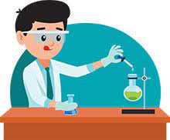
The evidence from the experiment is used to determine if the hypothesis is ______________________________.
Experiments must be __________________ over and over. When repeated, the results should always be the same before a valid conclusion can be reached.
Forming a Theory
A theory may be formed after the hypothesis has been tested many times and is supported by substantial evidence.
Theory: A broad and comprehensive statement of what is thought to be true.
A theory is supported by considerable ___________________________________.
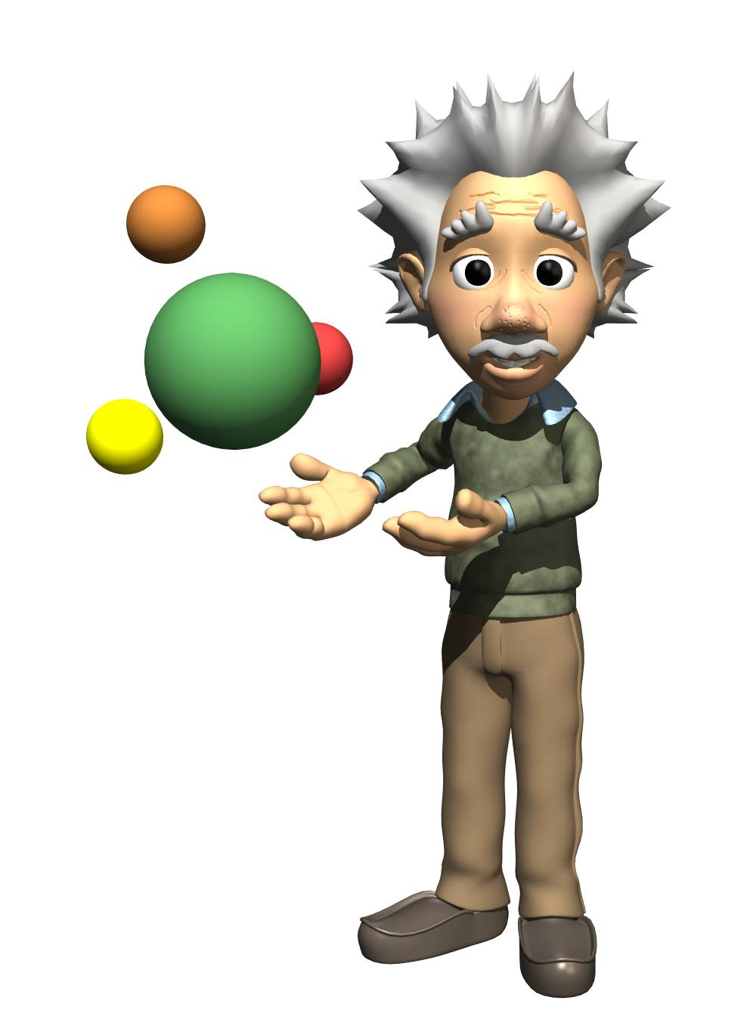

Practice Problem
You want to determine the effects of a certain fertilizer on the growth of orchids grown in a greenhouse. Materials that are available to you include: greenhouse, 100 orchid plants, water, fertilizer, and soil. You want to know if the orchids will grow best with a weak concentration of fertilizer, a medium concentration of fertilizer, or a high concentration of fertilizer. How will you design an experiment to test different concentrations of this fertilizer?

A. State your hypothesis:

B. How will you set up a controlled experiment?

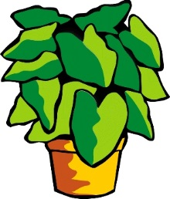
Group 3
Group 4
Group 2
Group 1

C. What is the control group D. What is the experimental group
in this experiment? in this experiment?

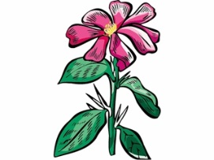

E. What variables must be kept constant in this experiment (control variables)?

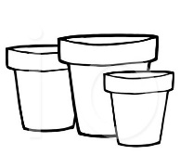
- All plants

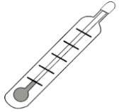
- All plants

- All plants

- All plants

F. What variable is being changed in this experiment (independent variable)?

G. After one month of measuring the orchids (dependent variable), the following data is obtained:

Group 1 (Control Group): Grew to an average height of 15 cm.
Group 2 (Weak concentration): Grew to an average height of 35 cm.
Group 3 (Medium concentration): Grew to an average height of 28 cm.
Group 4 (High concentration): Grew to an average height of 10 cm.

Is your hypothesis supported or refuted by these results?

What is your conclusion based on these results?

Analysis Questions:

A. Why is it important to have a large sample size in any experiment?

B. Why is it important to repeat the experiment many times?

C. What is the importance of the control (group)?

D. How is a theory different than a hypothesis?

E. Why is it so important that a scientist accurately describes the procedure used in the experiment?

F. What is the difference between the independent and the dependent variables in an experiment?

G. In a “controlled experiment”, why must all of the variables, except one, be kept constant throughout the experiment?

H. You have probably heard the expression “it’s just a theory” or “here’s my theory” in everyday language. Does the word ‘theory’ in science have the same meaning as in everyday conversation?
