Name: ___________________________________ Date: _____________________

Life and Its Major Molecules

By the end of the lesson you should be able to:
- Describe the 8 characteristics of life
- Recognize the structure of the 4 molecules of life
- State the function and give examples of the 4 molecules of life

The 8 Characteristics of Life
1. All life is made up of at least _____________________________
2. All life must obtain and use __________________
3. All life ___________________ - increasing its biomass
4. All life ____________________________
5. All life ______________________________ to its environment
6. All life ________________________________________
7. All life maintains __________________ (_______________________________)
8. All life ends

4 Molecules of Life
- Cytoplasm is made of 4 types of molecules
1. ______________________________________________________
2. ______________________________________________________
3. _______________________________________________________
4. _______________________________________________________
These molecules are composed mostly of four elements: C, H, O & N

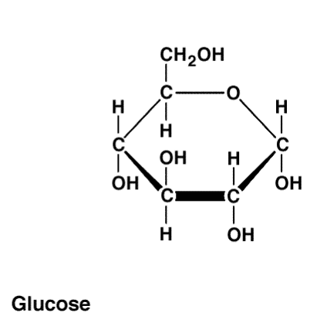
Carbohydrates
- Function: __________________for the cell and _________________

- There are 3 types:
1. Monosaccharides
2. Disaccharides
3. Polysaccharides

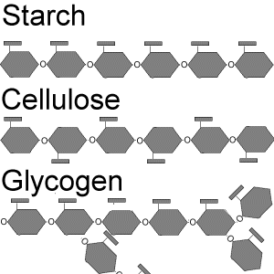
- __________________________________________ are a single unit of sugar
- If two monosaccharides are combined together, the result is called a ____________________________
- If there are many monosaccharides combined, the resulting molecule is a _______________________ . ___________________________ is an example of a structural carbohydrate at it forms plant cell walls
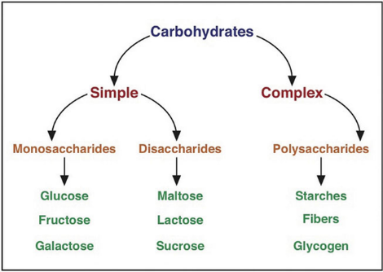
Examples of Carbohydrates
- Monosaccharides: _______________________, fructose, galactose
- Disaccharides: sucrose, ______________________, maltose
- Polysaccharides: starch, chitin, glycogen, _________________

Lipids (Fats)
- There are 3 types:
1. ____________________________: long term energy storage
2. __________________________: used to make cell membranes
3. __________________________: hormones

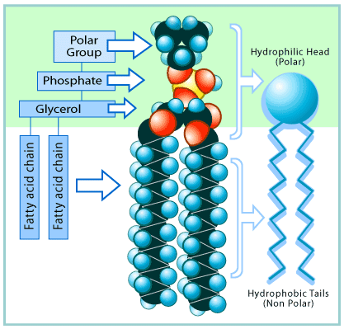
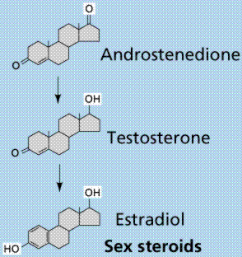
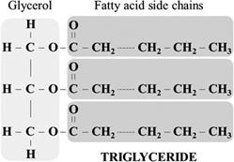

Proteins
- Proteins are _________________________ for muscle, cell structures, enzymes, immune system etc …
- Proteins are made up of smaller units called ________________________________
- The amino acids link together to form a chain
- These long chains of amino acids _______________________________________
- The differences between proteins is the sequence of the amino acids and how they are folded up
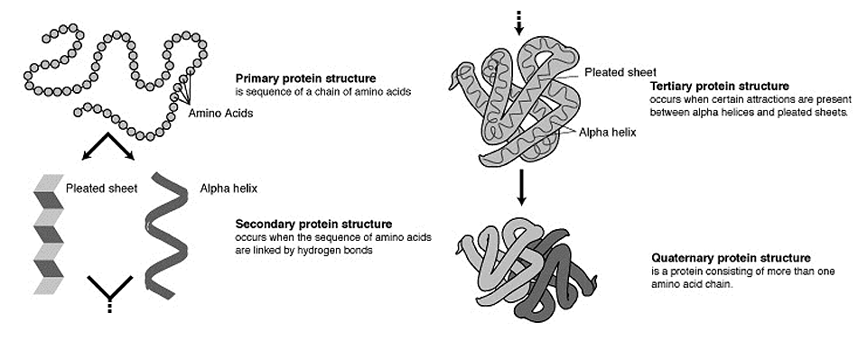

Nucleic Acids
- Nucleic acids contain _______________________________________.

- There are two types of nucleic acids: __________________________

- A nucleic acid is made up of small molecules called _____________________ which include a base (ACTG&U), a sugar and phosphate group.

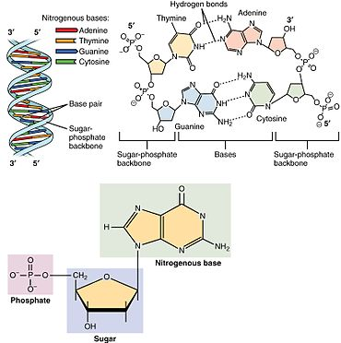
- Deoxyribonucleic Acid (DNA)
Largest molecule on earth!

Contains all the genetic information (a
____________) to build a living organism

Fits into the nucleus and is twisted into a
double stranded helix

- Ribonucleic Acid (RNA): there are 3 types
1. Messenger RNA (mRNA) a _________
______________________ from the DNA
that exits the nucleus
2. Transfer RNA (tRNA)
3. Ribosomal RNA (rRNA) (makes ribosomes)

- All are ________________________________ and help DNA make proteins
- Has a U base instead of the T base

__________________________________________________ (ATP)

This is the ____________________________________ molecule of life

There are 3 phosphate molecules bonded together

The last two have a lot of energy ____________________
