Life Sciences 11 *Daphnia* Heart Rate LAB Name:

**Purpose:** to investigate the effect of various chemicals on the heart rate of *Daphnia*

**Materials:**

1. *Daphnia* in culture liquid (per table)
2. Transfer pipette
3. A clean depression slide
4. Compound microscope
5. A small container for “used” *Daphnia*
6. 1% ethanol in a dropper bottle

**Method:**

Part 1: Introduction:

A *Daphnia* is a tiny crustacean (related to shrimp) that has a clear outside skeleton (carapace) and jointed legs. Like other arthropods, its heart is on its back.

The environment challenges each living thing to respond. It includes the air, the water, heat and light, and the chemicals which enter our bodies. Because *Daphnia* are ECTOTHERMS (cold-blooded), their body temperature changes with the surrounding environment. Since chemical reactions are speeded up in warmer temps, what would you predict the effect of temperature changes would be on their rate of metabolism (and heart rate)?

I PREDICT THAT:

______________________________________________________________________

Chemicals which enter their bodies can also change their heart rate by interfering with the chemicals that nerves use to transmit signals. Chemicals that speed up heart rate are known as stimulants, whereas chemicals that slow down the heart rate are known as depressants.

Part 2: Procedure

1. Keep the light for your microscope OFF as much as possible to avoid overheating your *Daphnia!*
2. Using a clean pipette, carefully transfer a *Daphnia* and ONE drop of liquid onto a slide. Keep

the drop small so that the *Daphnia* can’t swim out of your field of view.

1. Place the slide under the microscope and focus on the *Daphnia* so that you can see the beating heart. REMEMBER: its heart is on its back!
2. Count the number of heart beats that occur in 10 seconds. Have your lab partner time 10 seconds for you as you count heartbeats. You want to make your measurements quickly, so

that the *Daphnia* does not become stressed in the small volume of water.

1. Record the number of heart beats in the data table on the next page. Multiply the number by 6 to get the number of beats per minute.
2. Take at least three separate heart rate measurements for each individual *Daphnia* and calculate the average of the three measurements. REMEMBER: if the three numbers are NOT within 10% of each other, repeat your trials!
3. When you have finished recording the heart rate in water (the CONTROL solution), add ONE

DROP of the 1% ethanol solution to the slide. Turn the light OFF and wait 30 seconds.

1. Turn the light back on and count the number of heart beats for 10 seconds again, repeating at least 3 times. Multiply each count by 6 to get the heart rate per minute. Record results in a data table!
2. Rinse the *Daphnia* into the “used” container

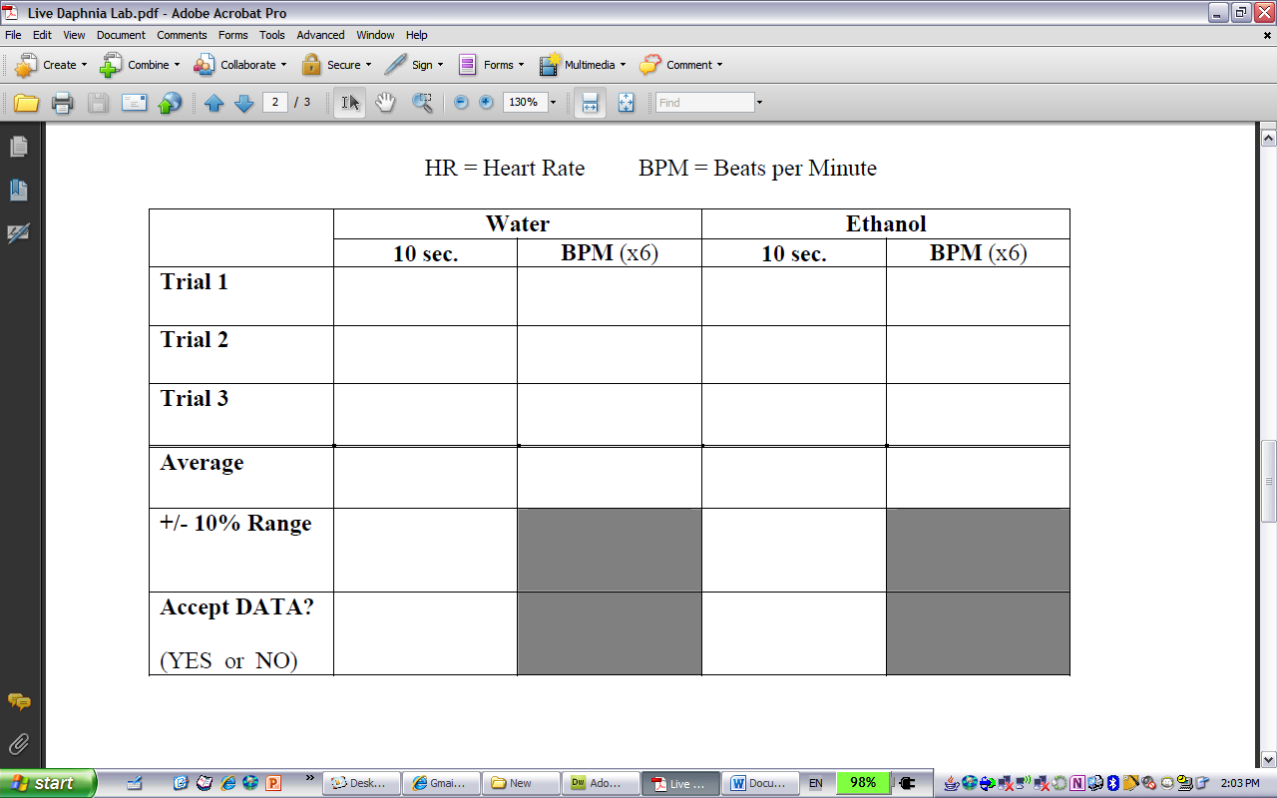

**Analysis**:

1. Average BPM in Water: _______________________
2. Average BPM in Ethanol: _______________________
3. Did the ethanol increase or decrease the heart rate? ____________________
4. Did the data support your hypothesis? ______________________________________
5. Would you classify the ethanol as a stimulant or a depressant? _________________________
6. In the introduction, you made a prediction about how a change in temperature would affect the Daphnia’s heart rate. Below, write it out as a hypothesis, then write a procedure to test it:

HYPOTHESIS:

PROCEDURE: