Meiosis Summary
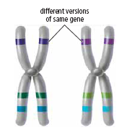
- Meiosis I
  - Matching chromosome pairs (homologous chromosomes)
move to opposite poles of the cell - two daughter cells result.
- Meiosis II
  - Sister chromatids of each chromosome are pulled apart - the end result is four haploid cells, each with half the number of chromosomes. These develop into gametes.
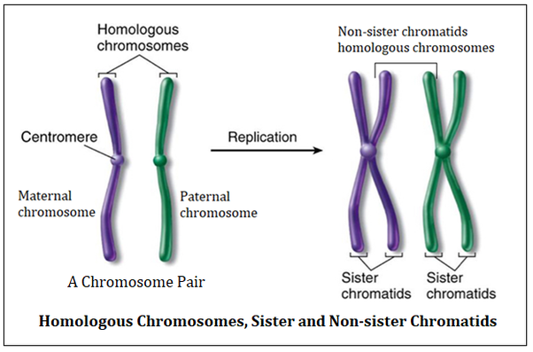
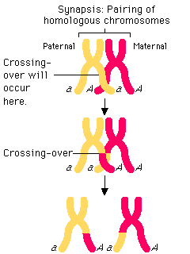
Variation Producing Events of Meiosis
- Crossing Over
  - In meiosis I, chromatids of chromosome pairs can cross over each other and exchange DNA segments - this increases genetic possibilities and produces more variation.
- Independent Assortment
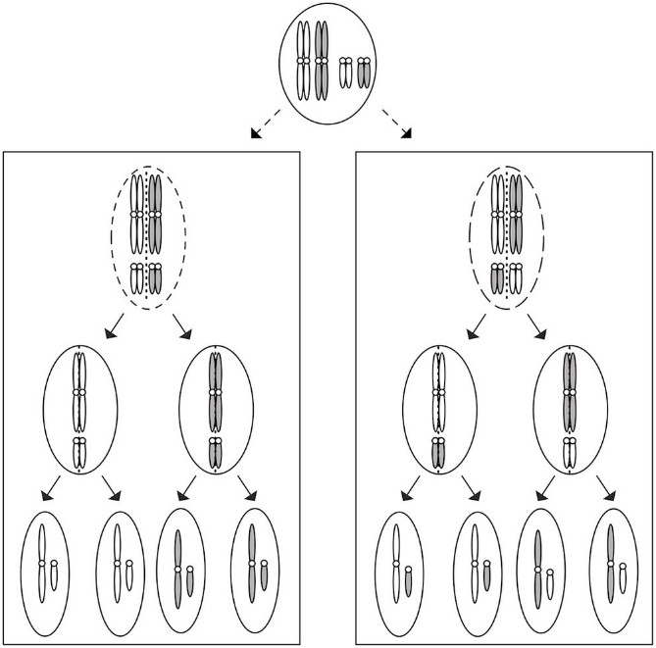
  - The pairs of chromosomes in meiosis I separate independently, creating many different combinations of chromosomes in the daughter cells.

Meiosis Overview

