Microscopes
Date: Majestic Magnifier:
Parts of a Light Microscope
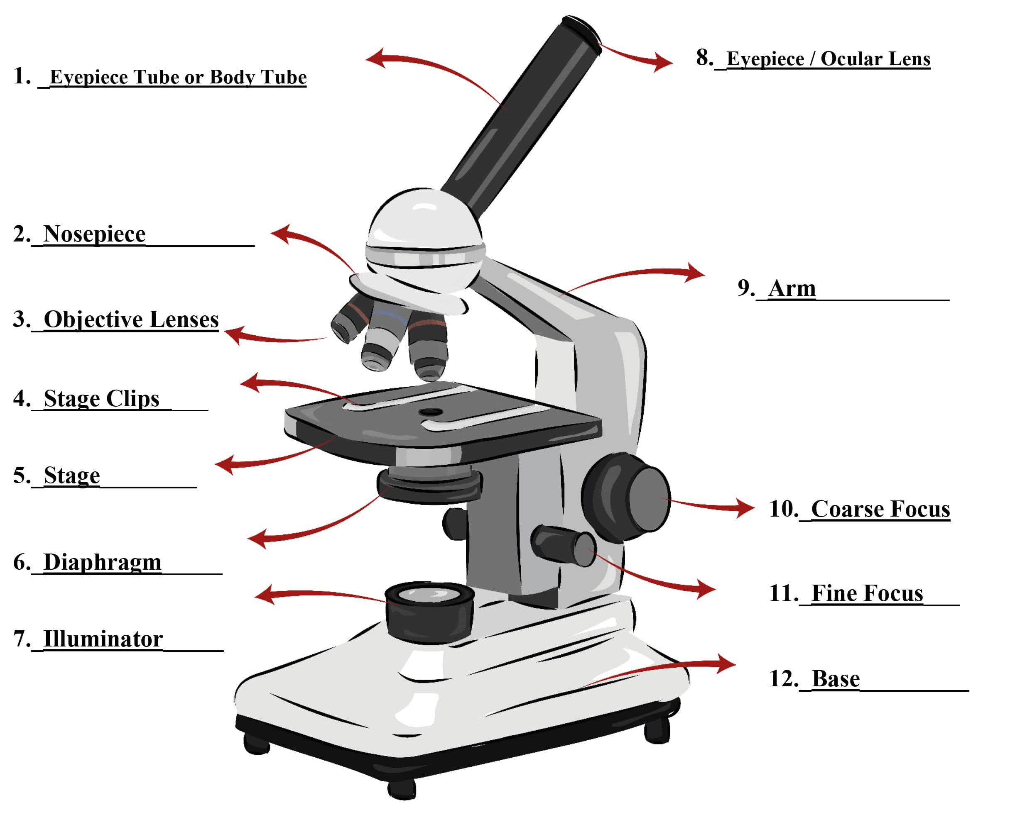.
Procedure:
1. Draw or cut out a small "letter e" and place it on a slide. Add a drop of water and cover it with a coverslip.
2. Place the slide of the “letter e” on the stage of the light microscope so that the letter is over the hole and is right side up as you look at it with the naked eye.
3. Use the scanning objective (low power) to view the letter and use the coarse knob to focus.
4. Draw the “e” as it appears in your viewing field. You should draw it to scale, meaning it should take up as much of the circle in your drawing as it does when you view it.

5. Switch to the medium power objective (this is the medium sized one). You should hear it click into place. Look in the microscope, the ‘e’ should still be visible, but it will be bigger and it might be blurry. Use the coarse knob to bring it back into focus.
You may also want to move the slide to re-center the ‘e”.
6. Switch to the high power objective (this is the longest one). Now when you look into the microscope you probably won’t see the “e.” At this magnification, you are just seeing a part of the “e” and the ink used to print it. At high power, you will need to focus, but this time, only use the FINE ADJUSTMENT KNOB. You should only need to rotate it a little bit to bring the slide back into focus, so turn the knob slowly. Do not use the coarse knob (large) with high power!
Draw the “e” as it now appears in the viewing field.
Scanning Objective (Low Power) Medium Power
_______ x Magnification _______ x Magnification
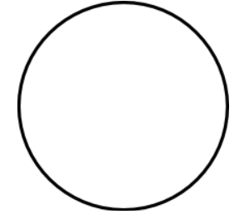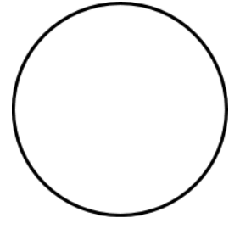
High Power _______ x Magnification
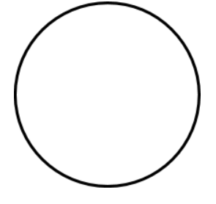
e e e e e e e e e e e e

e e e e e e e e e e e e

e e e e e e e e e e e e

e e e e e e e e e e e e

e e e e e e e e e e e e

e e e e e e e e e e e e

e e e e e e e e e e e e

e e e e e e e e e e e e

e e e e e e e e e e e e

e e e e e e e e e e e e

e e e e e e e e e e e e

e e e e e e e e e e e e

e e e e e e e e e e e e

