Compound Light Microscopes
Date: Majestic Magnifier:
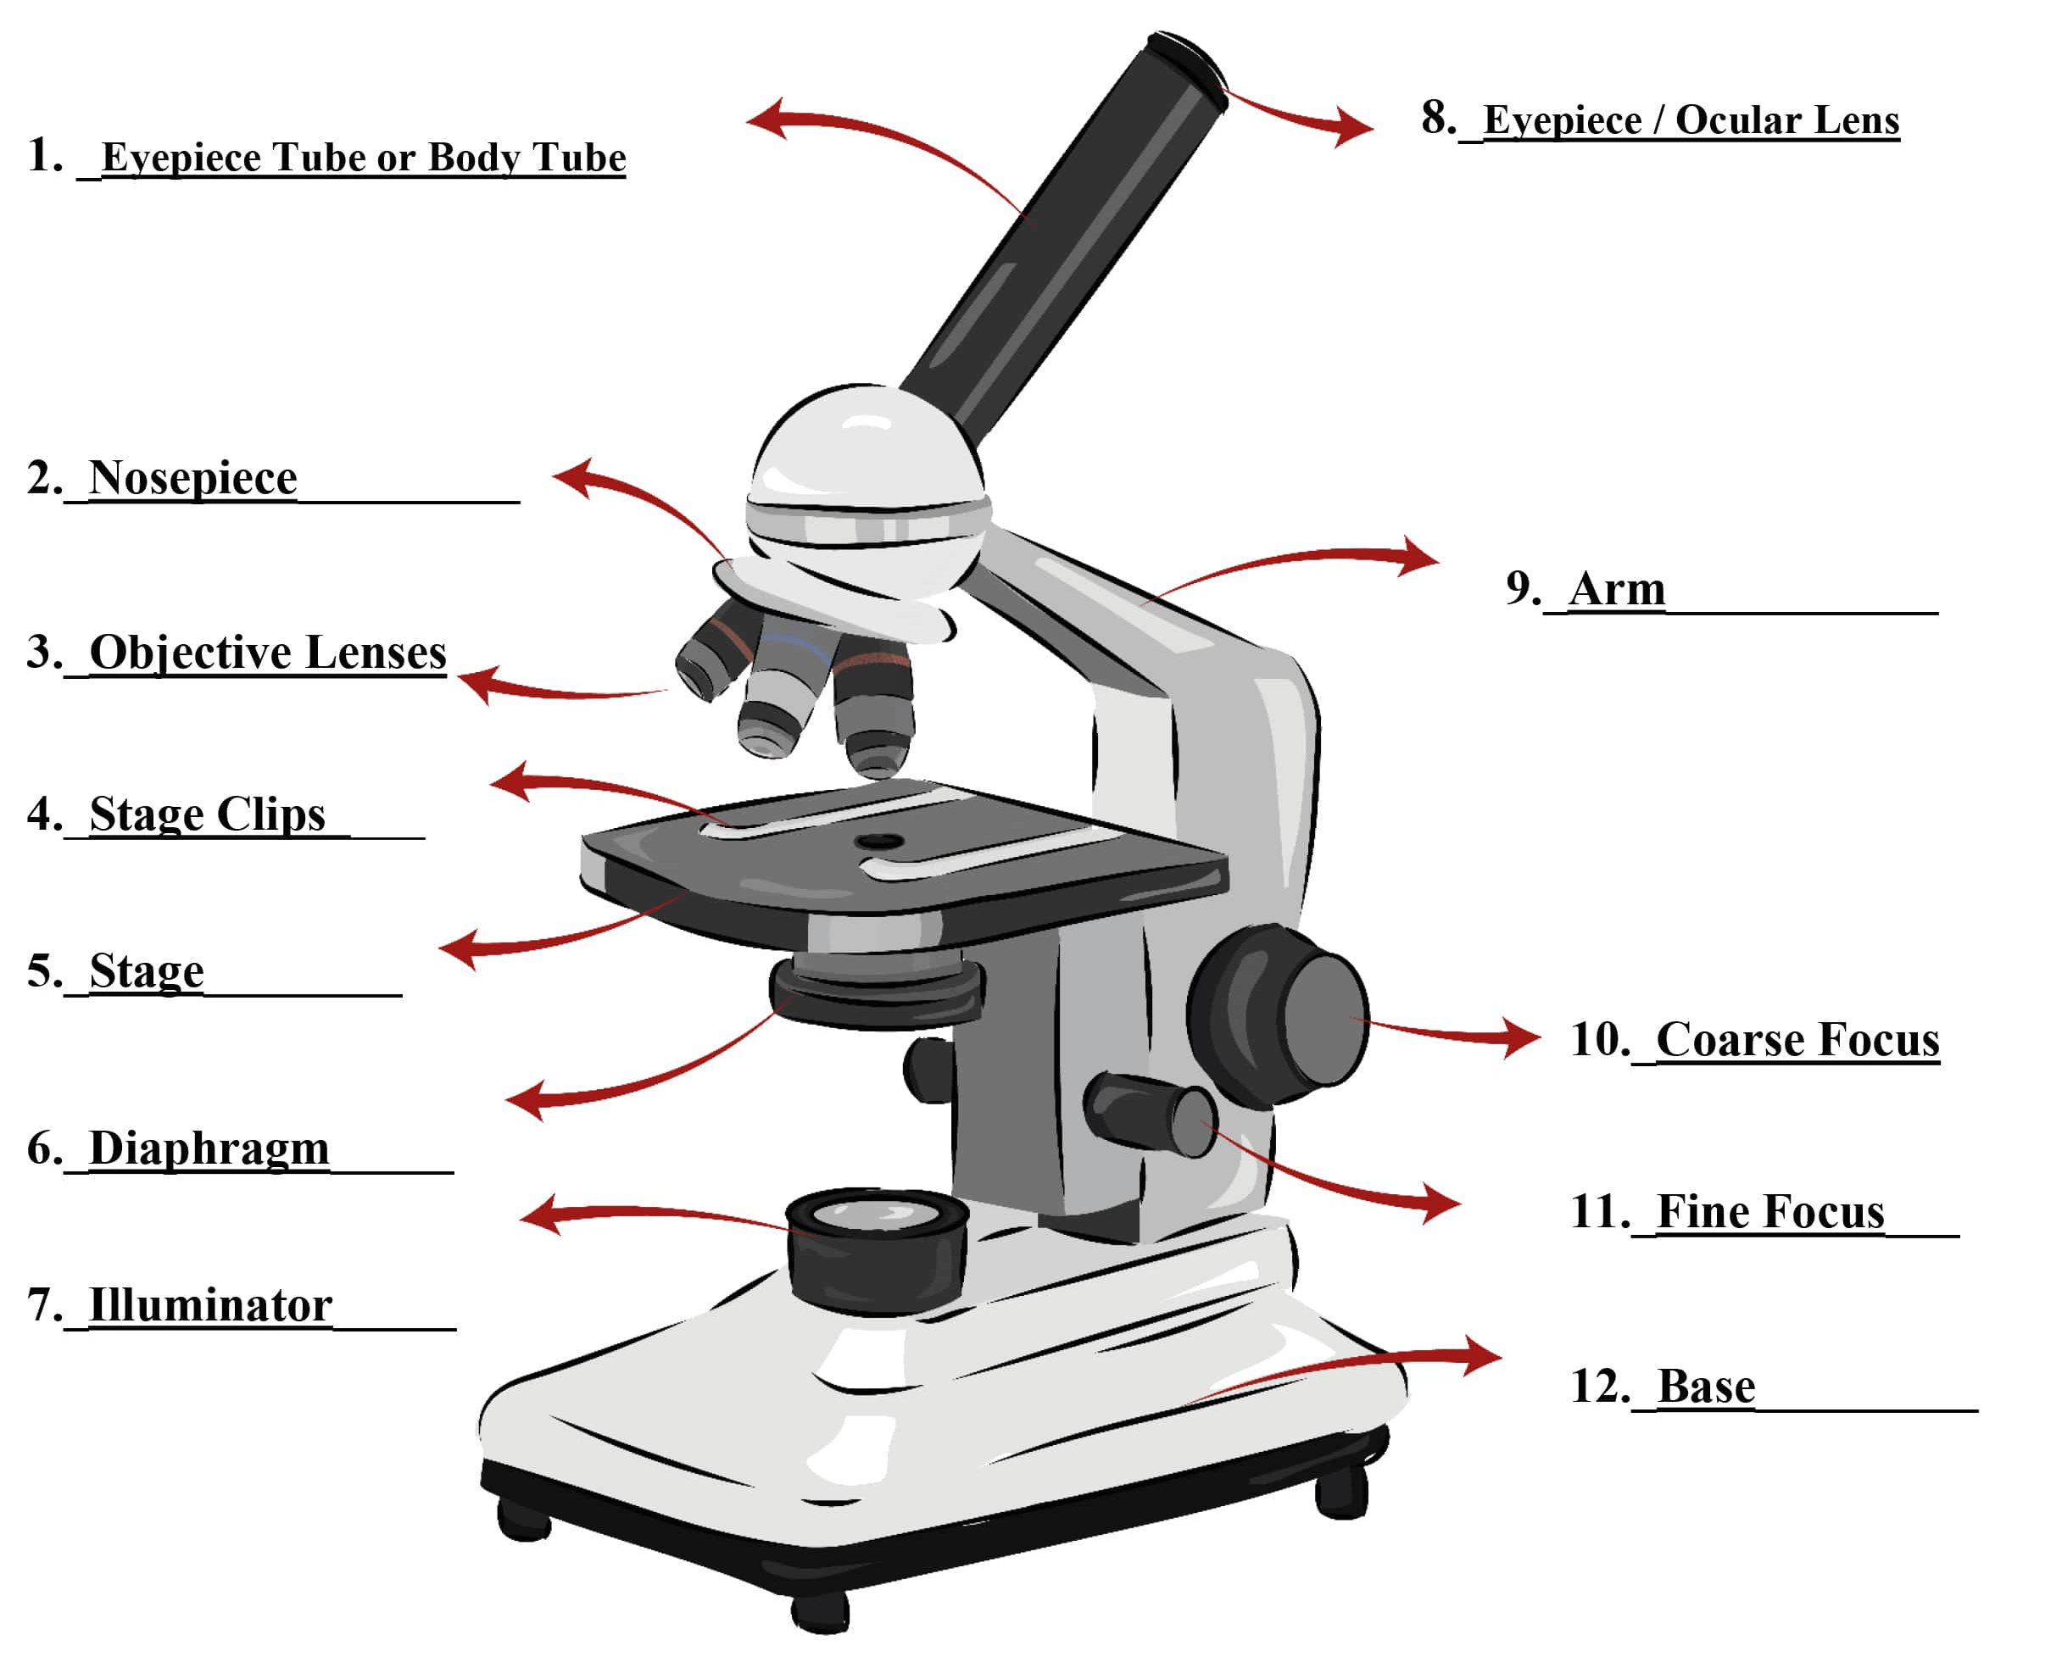
Parts of a Compound Light Microscope

Some Math: The total magnification using the lenses can be determined by multiplying the objective lens with the ocular lens. Find the total magnification using each objective lens.
 | Objective Lens
 | Scanning Power (4x) | Low Power (10x) | High Power (40x)
Eyepiece/Ocular Lense (10x)
Procedure:
1. Draw or cut out a small letter "e" and place it on a slide. Add a drop of water and cover it with a coverslip.
2. Place the slide of the letter "e” on the stage of the microscope so that the letter is over the hole and is right side up as you look at it with the naked eye.
3. Use the scanning objective to view the letter and use the coarse knob to focus.
4. Draw the “e” as it appears in your viewing field. You should draw it to scale, meaning it should take up as much of the circle in your drawing as it does when you view it.
5. Move the slide to the left while viewing the "e" through the lens. Which direction does the "e" appear to move? __________________. What if you move the slide up? ___________________
5. Switch to the low power objective (this is the medium sized one). You should hear it click into place. Look in the microscope - the "e" should still be visible, but it will be bigger, and it might be blurry. Use the coarse knob to bring it back into focus. You may also want to move the slide to re-center the "e”. Draw the “e” as it now appears in the viewing field.
6. Switch to the high-power objective (this is the longest one – or second longest if your microscope has an oil immersion lens). Now when you look into the microscope you probably won’t see the “e”. At this magnification, you are just seeing a part of the “e” and the ink used to print it. At high power, you will need to focus, but this time, only use the FINE ADJUSTMENT KNOB. You should only need to rotate it a little bit to bring the slide back into focus, so turn the knob slowly. Do not use the coarse knob (large) with high power! Draw the “e” as it now appears in the viewing field.
Scanning Objective Low Power High Power
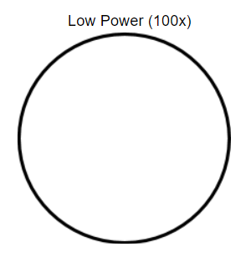
_______ x Magnification _______ x Magnification _______ x Magnification

High Power
_______ x Magnification

Random Specimens
Choose 2 specimens from the box of "common things". Use the circles below to sketch your specimens under SCANNING and LOW power. You may practice focusing with the high power, but you do not need to sketch it on high power. Exercise caution, some slides are too thick for high power! Label your specimens from the name written on the slide and write the magnification.
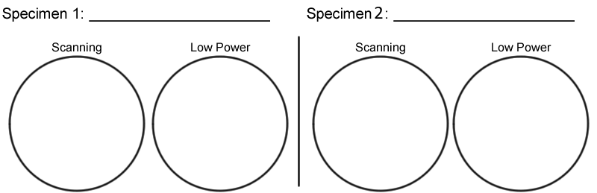
Magnification: _____ _____ _____ _____
Depth of Focus
Obtain a slide with three different coloured threads on it. View the slide under scanning and then low power. You should note that you can only focus on one coloured thread at a time. Figure out which thread is on top by lowering your stage all the way, then slowly raising it until the thread comes into focus. The first thread to come into focus is the one on top.
Which colour thread is on top? _____________
Which colour thread is in the middle? ______________
Which colour thread is on the bottom? ____________

True or False?
Answer true or false to each of the statements.
__________ You should carry the microscope with two hands – one under the base and the other on the arm.
__________ On high power, you should use the coarse adjustment knob. __________ If the image is blurry, going to a higher power will help.
__________ The fine focus knob visibly moves the stage up and down.
__________ Images viewed in the microscope will appear upside down.
__________ The low power objective has a greater magnification than the scanning objective.
__________ The type of microscope you are using is a scanning microscope.
__________ For viewing, microscope slides should be placed on the objective.
__________ In order to switch from low to high power, you must rotate the revolving nosepiece.
__________ If a slide is thick, only parts of the specimen may come into focus.
__________ The diaphragm determines how much light shines on the specimen. __________ The total magnification of a microscope is determined by adding the ocular lens power to the objective lens power.
One of the most challenging tasks in this exercise is focusing using the high power objective. If your lab partner says they can't find the "e" on high power, what suggestions would you make to help them learn to use the microscope. Be specific and clear and answer this question in complete sentences.

Human Cheek Cells

Date: Cheeky Cellfie:

Materials

- Glass microscope slides
- Plastic cover slips
- Paper towels or tissue
- Plastic pipette or dropper
- Cotton swabs or toothpicks
- Methylene Blue solution (0.5% to 1% (mix approximately 1 part stock solution with 4 parts of water))

Procedure
- Place one small drop of methylene blue solution at the centre of a clean slide. Concentrated methylene blue is toxic if ingested
- Take a clean toothpick or cotton swab and gently scrape the inside of your mouth.
- Smear the toothpick or cotton swab in the methylene blue drop for 2 to 3 seconds.
- Place a coverslip on top.
- Remove any excess solution by allowing a paper towel to touch one side of the coverslip.
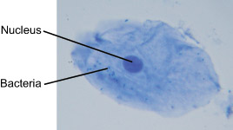
- Place the slide on the microscope under scanning power and find a cell. Then view at higher magnification.

Methylene blue stains negatively charged molecules in the cell, including DNA and RNA. This dye is toxic when ingested and it causes irritation when in contact with the skin and eyes.
The cells seen are squamous epithelial cells from the outer epithelial layer of the mouth. The small blue dots are bacteria from our teeth and mouth. If you are lucky, you may see tiny bacteria moving across the slide!

Observations:
Sketch the cell at low and high power. Label the nucleus, cytoplasm, and cell membrane of a single cell. Draw your cells to scale.
Low Power High Power
Magnification: Magnification:
___________ ___________

e e e e e e e e e e e e

e e e e e e e e e e e e

e e e e e e e e e e e e

e e e e e e e e e e e e

e e e e e e e e e e e e

e e e e e e e e e e e e

e e e e e e e e e e e e

e e e e e e e e e e e e

e e e e e e e e e e e e

e e e e e e e e e e e e

e e e e e e e e e e e e

e e e e e e e e e e e e

e e e e e e e e e e e e

