Date: Mitosis Summary Name:

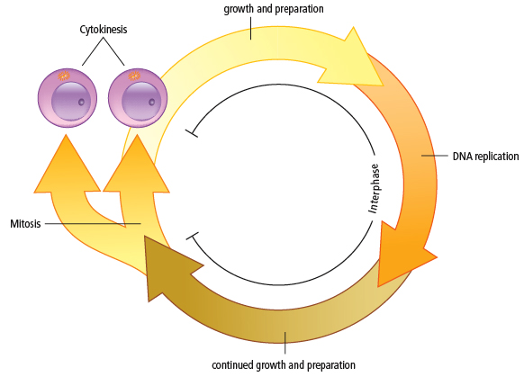
Three stages in the cell cycle:

1. Interphase: cell carries out normal functions.

2. Mitosis: nucleus contents duplicated and divided into two equal parts.

3. Cytokinesis: separation of two nuclei and cell contents into two daughter cells.

Parts of the Cell Cycle

Interphase
- Interphase - the longest cell cycle stage (lasts 15 hrs. – months).
  - cell performs normal functions and grows.
  - 95% of a cell's life is in interphase.
- In late interphase, DNA copies itself in the process of replication.
- DNA is in its long loose chromatin form so that DNA can be copied into RNA for proteins to be made in preparation for cell division.
- At the end of interphase, the cell grows and makes proteins in preparation for mitosis and cytokinesis.
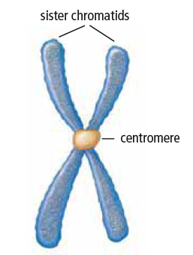
Chromosomes
- As the nucleus prepares to divide, replicated DNA in interphase joins
to form sister chromatids joined by a centromere.

Mitosis Overview:
- Mitosis is the shortest stage of the cell cycle where the nuclear contents divide and two daughter nuclei are formed.
- It occurs in 4 stages:
  - Prophase
  - Metaphase
  - Anaphase
  - Telophase
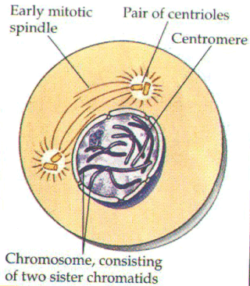
Mitosis - Prophase
- Chromosomes start to coil and become visible.

- Pairs of centrioles start to separate.

- The nuclear membrane disappears.

- Spindle fibres start to form between the centriole pairs.

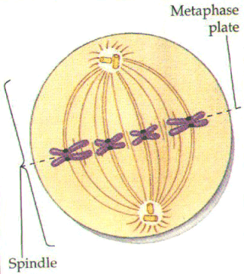
Mitosis - Metaphase
- Centriole pairs move to opposite ends of the cell.

- Spindle fibers are still attached to the centriole pairs.

- Replicated chromosomes line up along the middle of the cell and are attached to the spindle fibers.

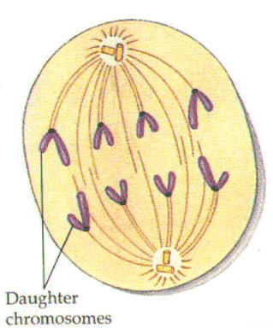

Mitosis - Anaphase
- The pair of sister chromatids split at the centromere and move to opposite ends of the spindle.

- Movement of the chromosomes towards the opposite ends
of the cell membrane is aided by the spindle fibres.

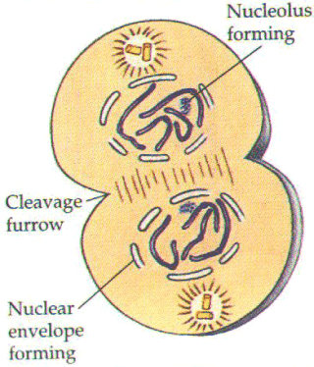
Mitosis - Telophase
- Nuclear membranes form around the two new sets of chromosomes.

- The spindle fiber disappears.

- Chromosomes start to uncoil (chromatin) and become less visible.

- Cell starts to make a groove (cleavage furrow) in the middle to eventually split into two identical cells.

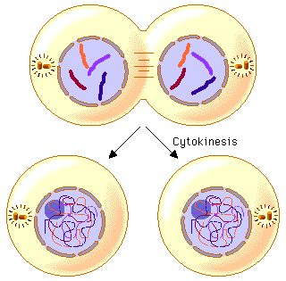
Cytokinesis
- The division of material outside of the nucleus.

Occurs after telophase.

- Divides the organelles and other substances in the cytoplasm into roughly two equal halves.

- # chromosomes in daughter cell equal to the # chromosomes in parent cell.

- Daughter cells are identical to parent cell.

