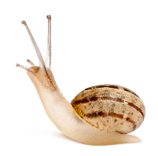
Phylum Mollusca: The Soft Bodies Name: Date:
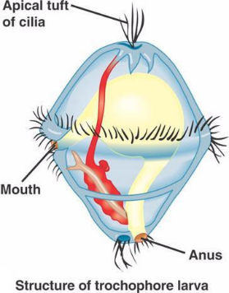
What is a Mollusk?
- Name comes from the Latin word ‘molluscus’ which means ‘soft’
- Mollusks typically have an internal or external shell
- Studies show that mollusks share common ancestor of annelids because of their ______________________
- Example animals include _______________________________________________
- Mollusks are the second largest phyla in the Animalia kingdom
- There are three defining characteristics
  - _________________________________
  - _________________________________
  - Tissue layer called “______________________” covers the visceral mass
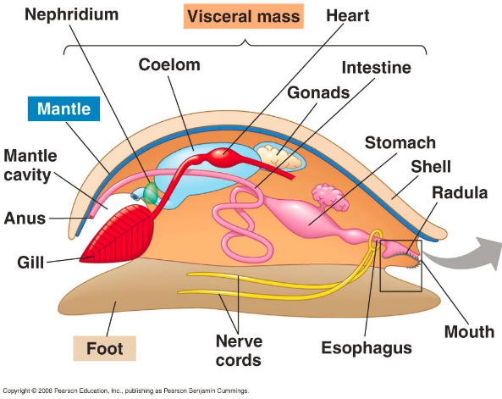
**Many also have a shell although they are lost in some species
Body Plan
- The ___________________________
  - This ‘foot’ can take many forms, including
    - flat structures for crawling
    - Spade-shaped for burrowing
    - Tentacles for capturing prey
- ________________________________
  - A thin layer of tissue that covers most of the mollusks body
- _____________________________
  - Below the mantle which contains the internal organs
- _______________________
  - Is made by ______________________________________ that secrete calcium carbonate
  - Ones that do not have a shell has simply been reduced or lost (ie. Slugs)
Feeding
- Because mollusks are so diverse, they feed in a variety of different ways. Some are herbivores, carnivores, filter feeders, detrivores, or parasites
- Some mollusks, like snails and slugs, have a ___________________________
- A radula is a tongue shaped structure with ________ ________________________________ attached
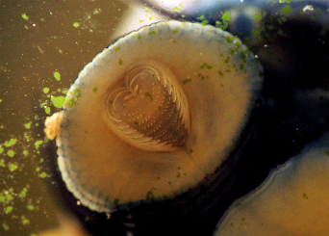
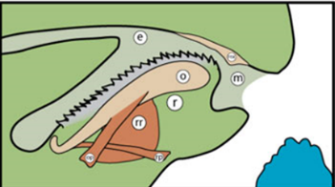
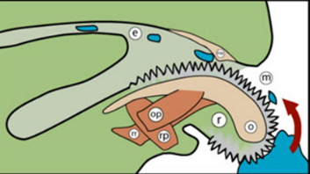
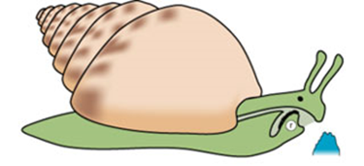
  - These radula are used to scrape algae off rocks, drill through shells and tear up and swallow prey’s soft tissue

- Octopi and sea slugs use their sharp jaws to eat prey. Some octopi produce poisons
- Clams, oysters, and scallops filter feed using the water around them
- In clams and other mollusks, water is filtered over the gills for respiration but also for feeding. A _________________________structure allows food particles to get stuck on the mucus of the gills
- There are tiny cilia that then move the food into the mouth.
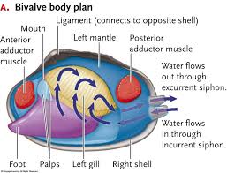
Respiration
- Aquatic mollusks such as snails, clams, and octopi typically _______________________________ inside their mantle cavity
- Slugs on the other hand, use their mantle cavity that has a large surface area lined with blood vessels - must be kept moist for diffusion!

Circulation
- Oxygen and nutrients are delivered to all parts the body by a circulatory system
- Their system is either open or closed
- Open - ________________________________________________through blood vessels into a large __________
- This sinus allows the diffusion of oxygen and carbon dioxide with the gills

- Open circulatory systems work well with _________________________________ (snails and clams) because they don’t require a lot of oxygen
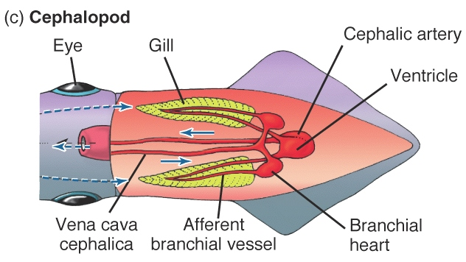
- ________________________________ mollusks, like octopi and squid, require more oxygen quickly and therefore have a closed circulatory system

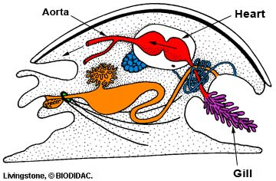

Excretion
- Cells of the body release nitrogen-containing waste into the blood to form ammonia
- ___________________________________________ act like a kidney and remove ammonia from the blood and release it out of the body
Response
- The complexity varies in the phylum Mollusca
- Clams and other two-shelled mollusks have simple nervous system because they are fairly inactive burrowing in sand and mud
- They have ______________________ (chemical receptors & eyespots), few nerve cords and small ganglia
- In contrast, _____________________________________________________________
- A ________________________________________________________________________________ for longer periods and can be more intelligent than some vertebrates
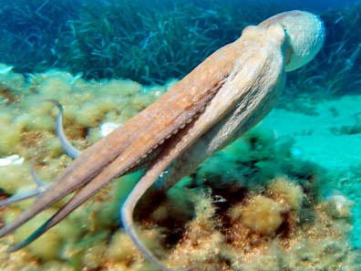
- Octopi can perform complex tasks like opening a jar
Movement
- Mucus secreted at the base of the foot for animals like snails
- Octopi use jet propulsion to draw water into their mantle and ________________ ________________________________________
Reproduction
- Snails and two-shelled mollusks reproduce sexually by external fertilization
- Once fertilized, the egg becomes a ____________________________________________
- In tentacle mollusks and certain snails, fertilization takes place inside of the female
- Some can be hermaphroditic

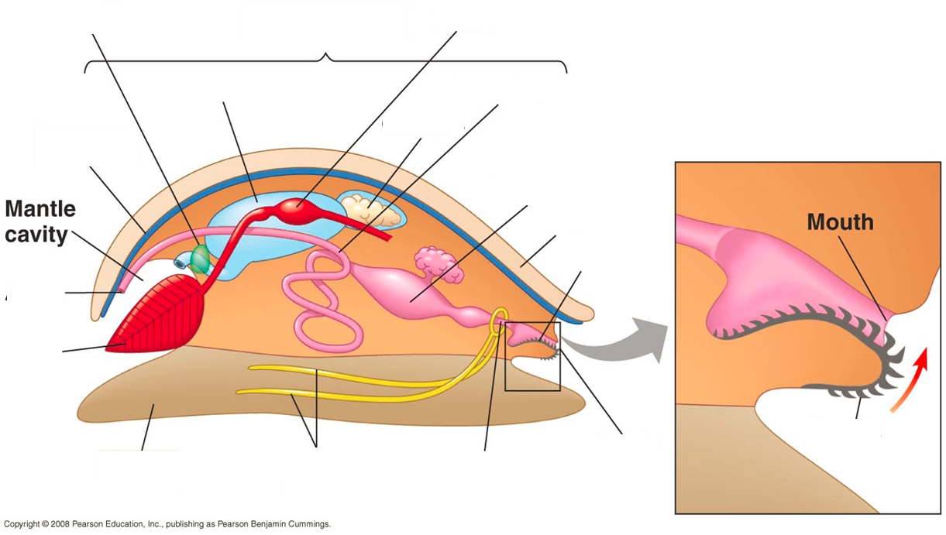

Groups of Mollusks
Class____________________
- Gastropoda = _________________________
- Largest class.
____________________________________
- Live in fresh, salt water, and land
- Contains single spiral shell
- Well-developed senses
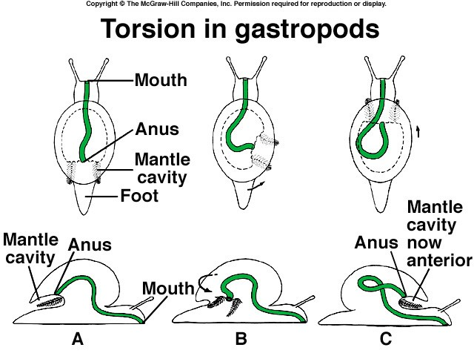
- Includes _________________________________

___________________ & nudibranchs

- ______________ rotation of digestive system

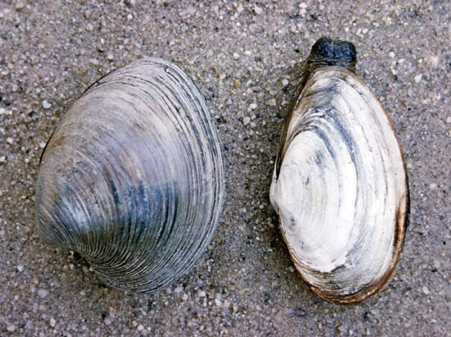
Class _________________
- Contain ____________________________

- __________________________

- Use ______________ for respiration & filter feeding

- Includes: _____________, _______________, scallops, mussels

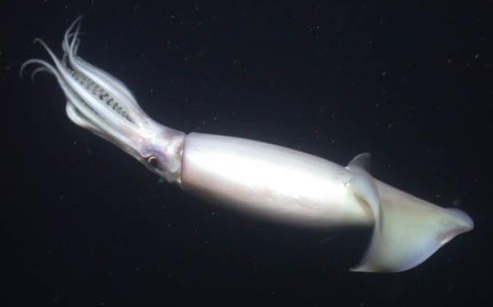
Class__________________
- These are the most highly evolved invertebrates

- Have ______________________

- ___________________________

- Very _______________________ - largest invertebrate

- Shell greatly reduced

- Includes __________________, ________________________, cuttlefish and nautilus
