Life Sciences 11 Mollusca Quiz Name:

/16

- What are the 3 body regions that all Molluscs have in common? (3 marks)

- Compared to nematodes, how are mollusks more advanced? (3 marks)

- Name the 3 classes in Phylum Mollusca and give an example animal of each. (3 marks)

- What is the name of the type of larva that Molluscs and Annelids have in common? (1 mark) _______________

- What is the name of the tongue-like structure used by snails to scrap off algae? (1 mark) ___________________

- What is structure #4? ____________________________ What is its function? (2 marks)

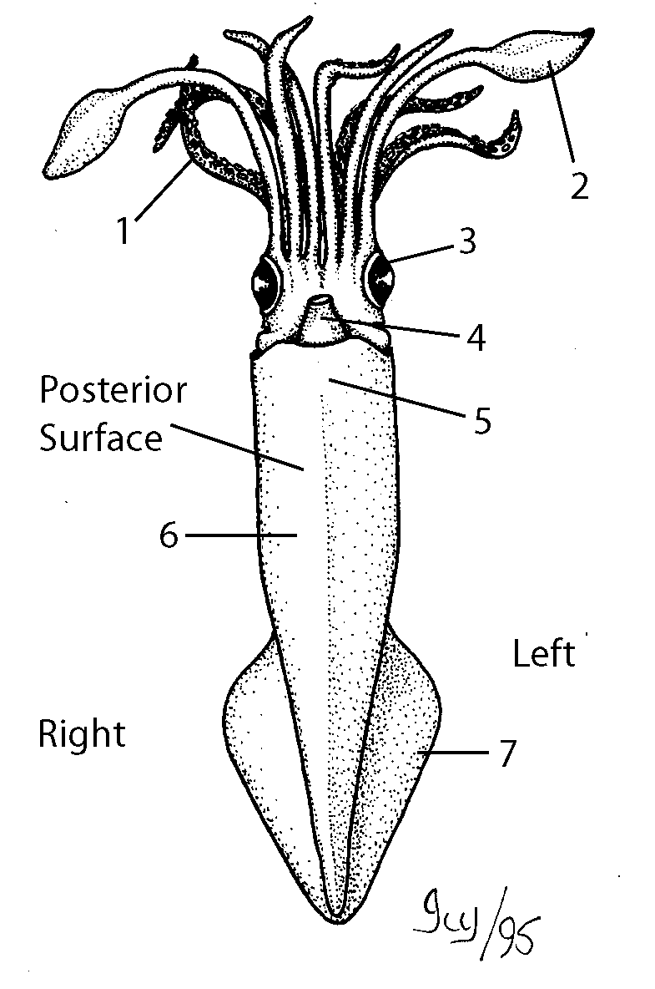

- What is structure #10? ____________________ What is the function? (2 marks)

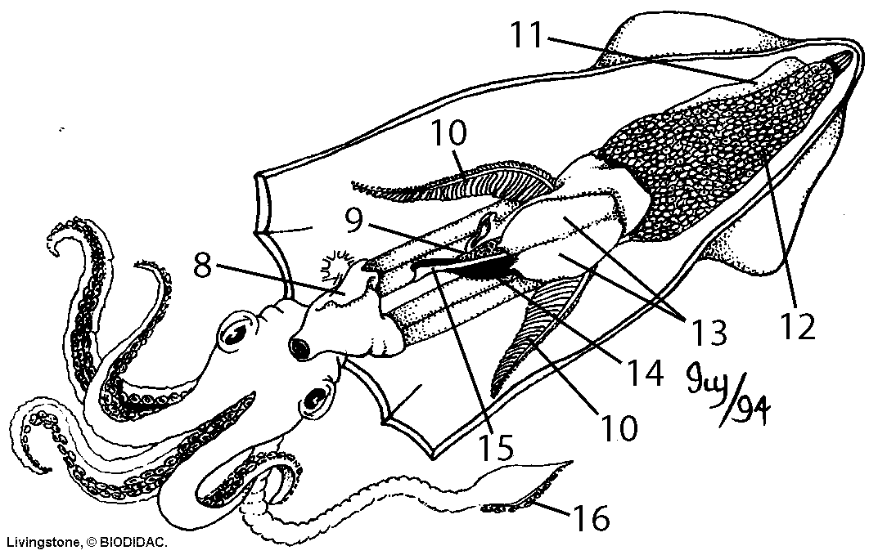

- Does this squid appear to be male or female? How can you tell? (1 mark)

