Mollusca Reading Assignment
Name: Date:
Use your textbook to answer the following questions (pages 701 – 706)
- What does the Latin word molluscus mean?

- How are mollusks defined on page 701?

- What type of larvae do many aquatic mollusks have?

- Why might annelids be close relatives of mollusks?

- What three parts are present in all mollusks and what is the function of each?

- What two structures enable mollusks to feed effectively? What are examples of mollusks that would use each type of feeding structure?

- What are two structures that are used in mollusk respiration?

- What types of circulatory system might a mollusk have? Describe each type of circulatory system.

- Why would an octopus or squid require a closed circulatory system? Explain.

- What structure is used for excretion?

- Explain why a clam and an octopus have such different nervous systems.

- Describe three ways that different mollusks can reproduce.

- There are four classes of mollusks that you will need to know. In the table below, write the name of three of the classes, give two example of each, and describe their defining characteristics.
Class Name
Examples
General Characteristics
- What are two ecological roles of mollusks?

- Describe a new use that scientists have found for mollusks.

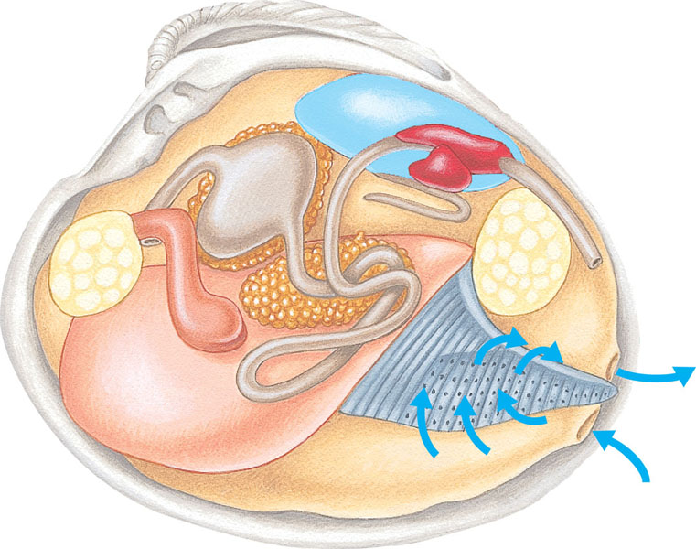
- Label this clam diagram with the following terms: incurrent siphon, excurrent siphon, gills, mantle cavity, foot, intestine, adductor muscle (x2), mouth, shell, stomach, coelom, heart, nephridium, and anus

