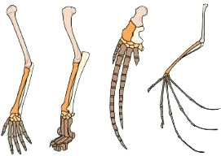
1. The image illustrates what evolutionary concept?
A. embryological similarities
B. variation among species
C. vestigial structures
D. homologous structures
2. Which of the following is NOT a component of the Theory of Evolution by Natural Selection?
A. competition for food and space
B. variation among species
C. inheritance of acquired characteristics
D. survival and reproduction
3. A structure that seems to serve no purpose in an organism is called: (reading guide)
A. homologous
B. vestigial
C. dichotomous
D. fossilized
4. In science, theories are:
A. an educated guess
B. a known fact
C. absolute and unchangeable
D. the best explanation for a set of data or observations
5. A group of mice becomes separated by the formation of a river. Over time, the northern mice became smaller and whiter, while the southern mice became larger and browner. This is an example of:
A. divergence
B. homology
C. gigantification
D. industrial melanism

6. Lamarck is to Inheritance of Acquired Characteristics by Use/Disuse as Darwin is to ________________
A. divergence of related species
B. homologous structures
C. Descent with Modification by natural selection
D. speciation by common descent
7. Any variation that can help an organism survive in its environment is called a(n):
A. adaptation
B. characteristic
C. competition
D. vestigial structure
8. The strongest evidence for change over a long period of time comes from:
A. geography
B. fossils
C. embryo studies of living species
D. direct observation of living species
9. The dog breeds we have today were developed through: (reading guide)
A. natural selection
B. artificial selection (selective breeding)
C. sexual selection
D. acquired selection
10. The finches on the Galapagos Islands were similar in form except for variations of their beaks. Darwin observed that these variations were useful for:
A. attracting a mate
B. defending territory
C. building nests
D. gathering food
11. In a certain population, disruptive selection is occurring. In this population, which is most likely to survive?
A. organisms with average traits
B. organisms with extreme traits
C. organisms that sexually select
D. organisms that are small

12. This picture illustrates what type of selection?
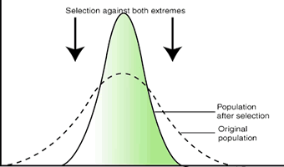
A. sexual
B. disruptive
C. directional
D. stabilizing
13. In a population of woolybeasts, individuals with long snouts tend to survive better on an island that has burrowing termites. Over time, the woolybeast population consists of individuals with extremely long snouts. This is an example of:
A. stabilizing selection
B. directional selection
C. disruptional selection
D. allopatric speciation
14. Any characteristic that can help an organism survive and/or reproduce can be called a(n):
A. gene
B. species
C. adaptation
D. specialization
15. Which of the following is NOT necessary for evolution to occur by natural selection?
A. selection pressure on certain traits
B. variation within the species
C. inheritance of characteristics
D. all of these ARE necessary
16. What model of evolution suggests that species stay the same for a long period of time, then change abruptly due to mutations in key genes?
A. good genes hypothesis
B. Gradualism
C. punctuated equilibrium
D. fossilization
17. Female guppies tend to choose brightly colored mates. Over time, the population of guppies becomes more colorful. This is an example of:
A. artificial selection
B. natural selection
C. disruptive selection
D. sexual selection
18. Speciation is said to have occurred when:
A. two populations become geographically isolated
B. one population moves to a different area
C. enough differences accumulate between two populations that they can no longer interbreed
D. gene mutations accumulate
19. Darwin surmised that a few finches migrated to the Galapagos from the mainland. These finches gave rise to the many species of finches on the islands today. This is an example of:
A. divergence (adaptive radiation)
B. convergence
C. gene flow
D. genetic drift
20. Which type of evolution is shown here?
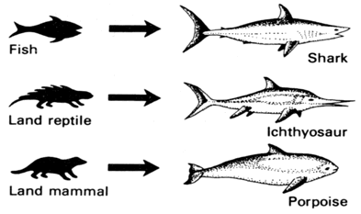 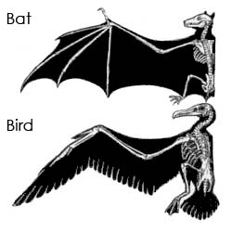
A. divergence (adaptive radiation)
B. convergence
C. gene flow
D. genetic drift

- D
- C
- B
- D
- A
- C
- A
- B
- B
- D
- B
- D
- B
- C
- D
- C
- D
- C
- A
- B
1. D | 6. C | 11. B | 16. C
2. C | 7. A | 12. D | 17. D
3. B | 8. B | 13. B | 18. C
4. D | 9. B | 14. C | 19. A
5. A | 10. D | 15. D | 20. B

1. | 6. | 11. | 16.
2. | 7. | 12. | 17.
3. | 8. | 13. | 18.
4. | 9. | 14. | 19.
5. | 10. | 15. | 20.

1. | 6. | 11. | 16.
2. | 7. | 12. | 17.
3. | 8. | 13. | 18.
4. | 9. | 14. | 19.
5. | 10. | 15. | 20.

1. | 6. | 11. | 16.
2. | 7. | 12. | 17.
3. | 8. | 13. | 18.
4. | 9. | 14. | 19.
5. | 10. | 15. | 20.

1. | 6. | 11. | 16.
2. | 7. | 12. | 17.
3. | 8. | 13. | 18.
4. | 9. | 14. | 19.
5. | 10. | 15. | 20.

1. | 6. | 11. | 16.
2. | 7. | 12. | 17.
3. | 8. | 13. | 18.
4. | 9. | 14. | 19.
5. | 10. | 15. | 20.

1. | 6. | 11. | 16.
2. | 7. | 12. | 17.
3. | 8. | 13. | 18.
4. | 9. | 14. | 19.
5. | 10. | 15. | 20.

