Phylum Nematoda: The Roundworms Name: Date:
What is a roundworm?
- Are slender, _____________________, ___________________________ worms with tapering ends
- Their habits range as far north in polar regions to the tropics
- There are two groups: ________________________ and ____________________________
- Most species are free-living, inhabiting soil, salt flats, aquatic sediments, and water
- Many others are parasitic and live in the hosts that include almost every kind of plant or animal
- A single rotting apple can contain up to 90,000. Your garden at home contains millions!
Body Plan
- Like flatworms, nematodes develop from three germ layers - _________________________
- Roundworms have a body cavity that is located between the endoderm and mesoderm, therefore it is not fully surrounded in mesoderm tissue (such as muscle) and is known as a ____________________.
  - A psuedocoelomate is an organism with a “_______________________________”
- Unlike flatworms, the roundworms have a ______________________________________________ with two separate openings, a mouth and an anus.
- This body plan is referred to as a ___________________________________________________ structure, with the inner tube being the digestive tract and the outer tube being the body wall.
- The development of an anus allows digestive wastes to exit through a different opening.
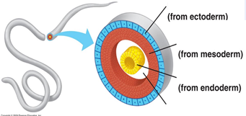
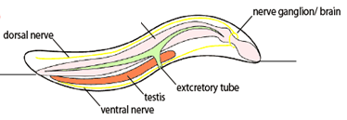
- Free-living nematodes are more complex than parasitic nematodes
Feeding - Digestion
- Typically have a complete digestive system with a _______________________________________
- Free-living nematodes often play an important role in ecology – they are ______________________
- Parasitic roundworms feed on _________________________________________ food from their host
Respiration, Circulation and Excretion
- Similar to flatworms, roundworms exchange gases and excrete metabolic waste through their body walls
- They have no internal transport system therefore ______________________________________ on the movement of nutrients and wastes.
Response
- Simple nervous systems with ______________________________
- Several nerves extend from the ganglion in the head and run the length of the body
- These nerves transmit several types of sense organs and movement
- Sense organs can vary between nematodes but some have specialized structures that ___________ ________________________________________________________________.
Movement
- Roundworms have muscles that extend the length of their bodies
- Together with the fluid in their psuedocoelom, these muscles function as a ______________________
- Aquatic roundworms contract these muscles to move like a snake through water
- Soil-dwellers push their way through the soil by thrashing around
Reproduction
- Reproduce ___________________________________________________________________
- Internal fertilization – the male deposits sperm inside the females reproductive tract.
- _______________ typically have a ‘hooked’ end to grasp the females
- Parasitic worms have complex lifecycles which often involve one or two hosts
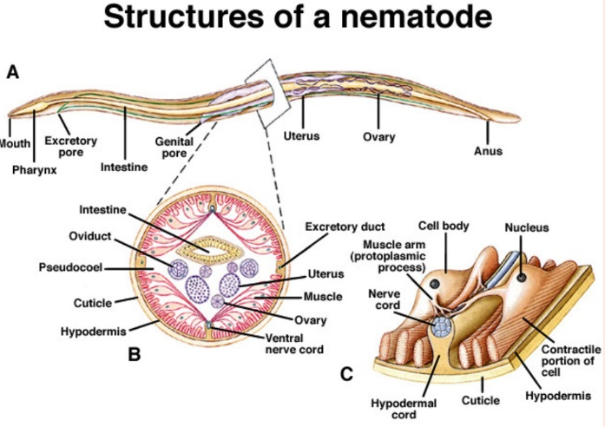

Parasitic Nematodes
- Some of the worst worm parasites are members of phylum Nematoda. Some examples of very harmful nematodes include:
  - Intestinal roundworms such as _______________________ lumbricoides
  - ______________ that enter between your toes and hook into your intestines to suck your blood
  - ________________________________ that crawl out your anus at night
  - Trichinella which causes ____________________________ in your muscles
  - _____________________________ which cause elephantiasis
  - And the ________________________________ (AKA Dracunculus) which causes … well, you will see! (if you don’t close your eyes)
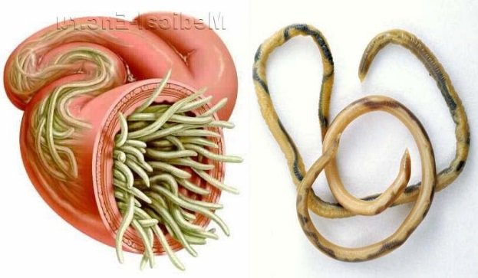
1. Ascaris sp. the Intestinal Roundworm
- Most common worldwide worm parasite - over 1 billion people have it
- Lives in small intestine but travels through the body to lungs as a juvenile
- Cause __________________________ as they absorb digested food from the host’s small intestine, nausea, vomiting, abdominal pain or coughing and gagging during the part of the lifecycle where they are in the lungs
- Commonly spread by ____________________________________________________
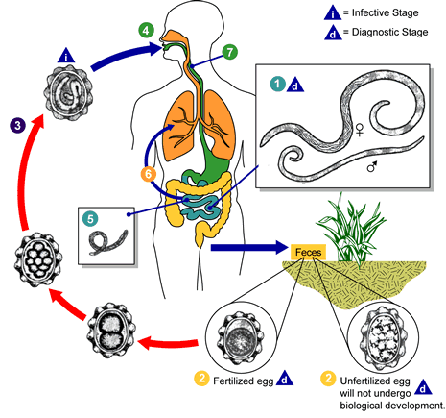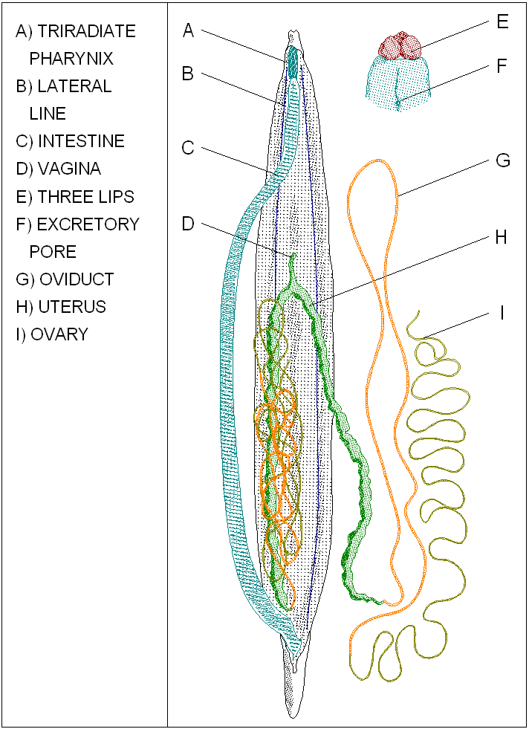
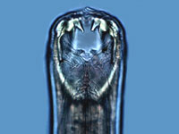
2. Hookworm
- Human hookworm (Necator sp.) __________________________ from inside of intestine
- A single worm can drain 20 ml of blood per day
- Most serious in children as can lead to physical and mental retardation
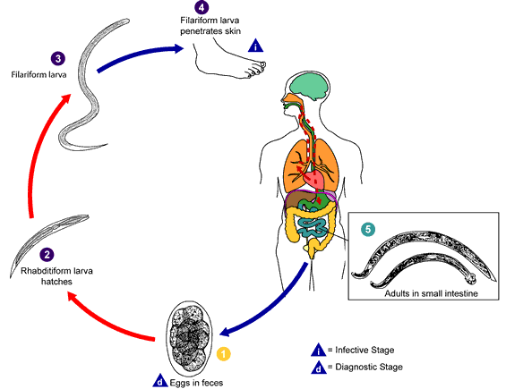
- _________________________________________

3. Pinworm (Enterobius sp.)
- Lives in lower bowel
- __________________________________________________
- Secretes irritating toxin to get person to scratch
- Re-infection is oral
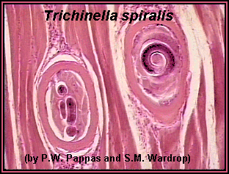
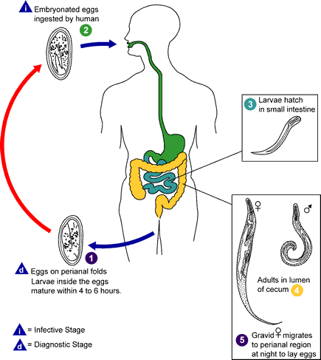
4. _____________________________
- From _____________________________________________________
- Causes Trichinosis by invading muscles and organs forming painful cysts
5. Filarial Worm
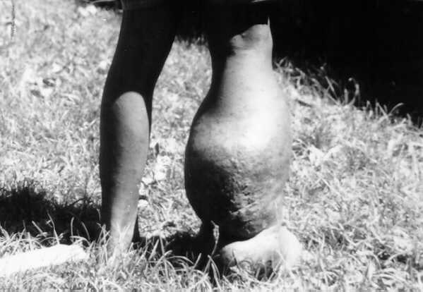
- Small nematode that lives in human ______________________ ________________
- As a result, fluids can’t drain so accumulate resulting in severe, grotesque swelling below where the worm is
- Causes _________________________________________

6. The Guinea Stick Worm (____________________________ sp.)
- In Africa only
- Enters while a person is ______________________________________________________________ and grows into a painful open wound
- No cure - is ______________________________________________ - one turn per day
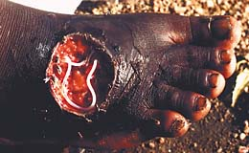
- Contains deadly toxin if broken it can kill its victim

