Phylum Platyhelminthes: The Flatworms Name: Date:

The Flatworms - _____________________________________

- Soft, flattened worms that have tissues and internal organ systems
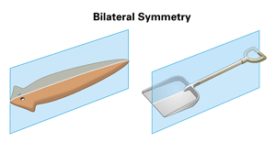
- They are the simplest animal to have ____________________________________
- ____________________________________
- ___________________________________

Symmetry
- Platyhelminthes have bilateral symmetry
- This means they have two well formed sides that can be identified as ______________________
- With bilateral symmetry we start to see the development of cephalization
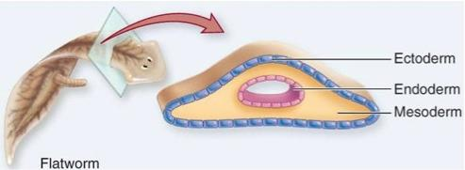
- Most Platyhelminthes exhibit enough cephalization to have what we know as a ‘____________’

Germ Layers
- Platyhelminthes are known as ________________
  - _____________________________________________
- Flatworms are known as __________________________, meaning ‘_________________________'
- No coelom forms from the mesoderm layer
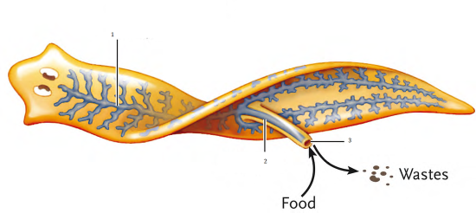
Feeding
- ________________________________ flatworms have organ systems for digestion, excretion, response, and reproduction
- ______________________________ are typically simpler in structure than their free-living relatives
  - Eg. _________________________
- Free-living flatworms can be carnivorous that feed on tiny aquatic animals or scavenge on dead animals
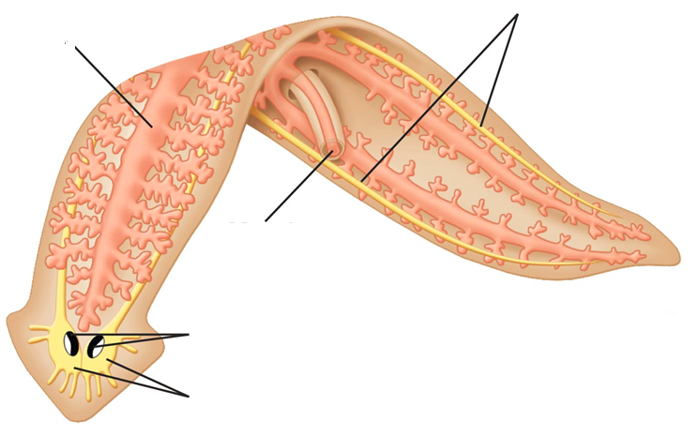
- Like Cnidarians, flatworms have a ____________________________________________, a mouth, through which both food and wastes pass through.
- There is a muscular tube, called the ______________________________________
- The pharynx extends out of the mouth and then pumps food into the digestive cavity
- Digested food then diffuses from the ____________________________________into body tissues.
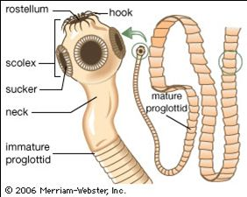
Parasitic Feeding
- Parasitic worms feed on blood, tissue fluids, or pieces of cells within the host’s body
- Therefore, they do not have a complex digestive system.
  - Eg. Tapeworms – have no digestive tract at all and absorb pre-digested nutrients from the host through their body wall.

Respiration, Circulation and Excretion
- Because flatworms bodies are so flat and thing, many of them do not need a circulatory system to transport nutrients around their bodies
- Flatworms rely on ________________________________________________ to their internal tissues
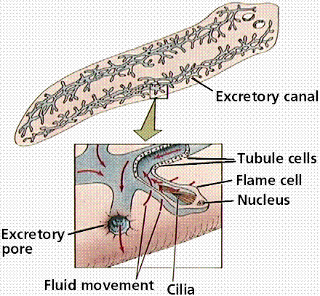
- Flatworms have no gills or other respiratory organs, no heart, blood vessels or blood.
- Some flatworms have __________________________ that function in excretion
- Flame cells are specialized cells that _______________ ___________________________________such as ammonia and excess water from the body
- Many flame cells are joined together to form a network of tubes that empties into the outside environment through tiny pores in the animal’s skin

Response
- Flatworms have more complete structures for detecting and responding to external stimuli than those of cnidarians and sponges
- In free-living flatworms, a head encloses several ________________________________________
- Two long nerve cords run from the ganglia along both sides of the body, creating a _______________
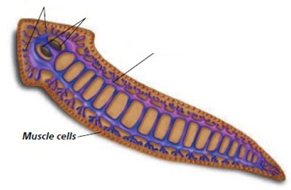
- Along with the nerve ladder, flatworms can have an eyespot, or a group of cells called _____________ that can _________________________________________ in their environment
- They also have cells that can detect external stimuli like chemicals in the water and direction of water flow
- These cells are usually scattered throughout the body
- Parasitic flatworms typically lack these features

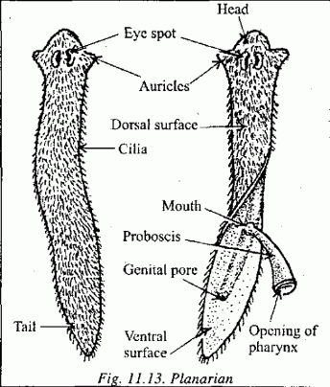
Movement
- Free-living flatworms typically move in two ways
  - ______________________________ on their epidermal cells help them glide through water and over bottoms of streams and ponds
  - Muscle cells controlled by the nervous system allow them to twist and turn

Reproduction
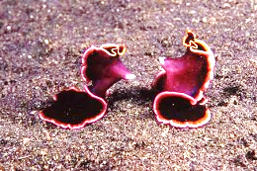
- Most flatworms are __________________________________
- They reproduce both sexually and asexually
- Asexually – _____________________________ and grow into a new organism
- Sexually – they join up with another flatworm and deliver sperm to one another
- ________________________________
- Parasitic flatworms have a complex sexual reproduction cycle
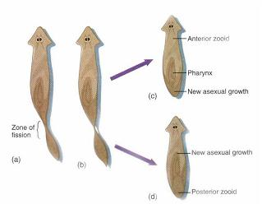
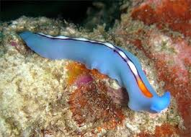
Groups of Platyhelminthes

- ______________________________________
  - Includes the Planaria, a fresh water flatworm
  - Named due to the turbulence in the water their cilia cause when they swim
  - Also includes many marine varieties

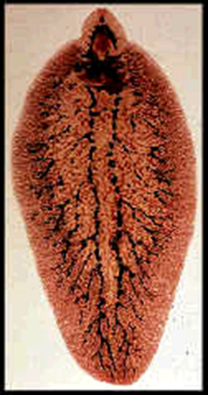
- ________________________________________
  - Includes the parasitic flukes
  - Include liver, blood, lung, heart, and intestinal flukes
  - Many have _________________________________ like this liver fluke (i.e. sheep, cow, fish etc)
  - Fasciola hepatica (Liver Fluke)

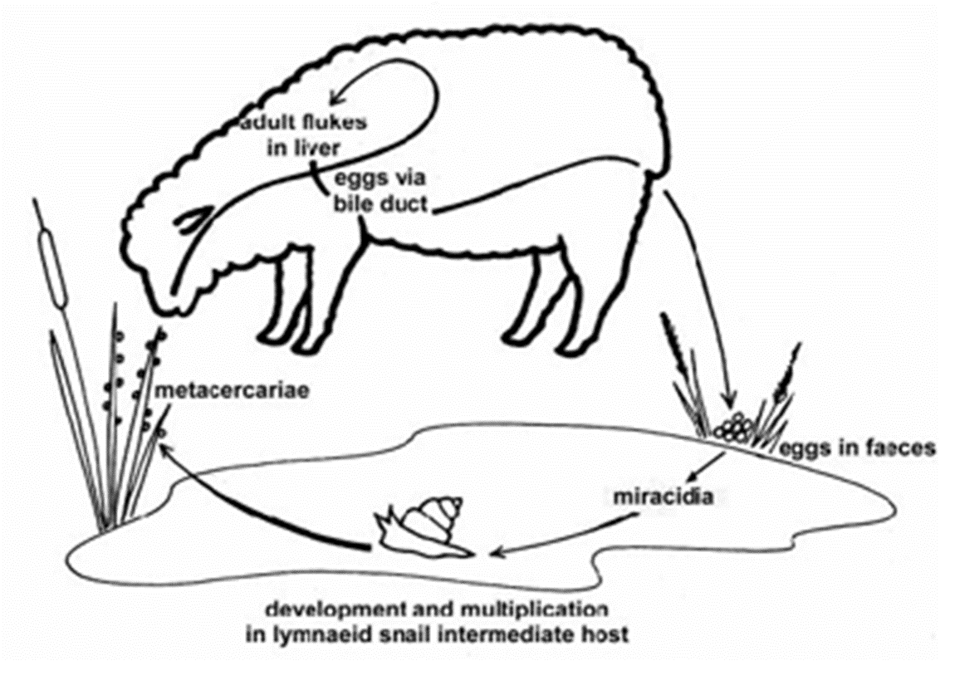
Liver fluke life cycle

- ____________________________________________
  - Classical _________________________________
  - highly evolved to its habitat such as _________________________________________
  - Human tapeworms can grow up to 20 m long!
