Phylum Porifera: The Sponges Name: Date:
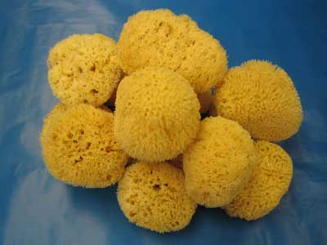
Phylum Porifera
- Porifera = ‘pore bearers’
- One of the simplest and most unusual animals
- Have been on earth for at least 540 million years
- Most of them live in the ocean – sessile
- Most commonly used by humans for natural sponges for bathing
- They are considered animals because they are multicellular, ____________________________ and their cells have _______________________________________
- This phylum represents the first experiment in multi-cellularity for animals
- There are specialized cells, but they do no work cooperatively together - not tissues
- _________________________________________ animals
- Have changed little since they evolved

Body Plan
- Sponges are __________________________________, have no front or back ends, and no left or right sides
- Think of a large cylindrical water pump
- _____________________________ (collar cells) are specialized cells that use flagella to move water through the sponge
- Water exits the sponge through the ________________________________, large hole at the top
- This movement of water is for feeding, respiration, circulation, and excretion
- _______________________ (amoebocytes) are motile cells which have a variety of functions including delivering nutrients to other cells and creating eggs for sexual reproduction
- Sponges have a simple skeleton
- In harder sponges, the skeleton is make up of spiny ____________________
- A spicule is a spike-shaped structure made up of chalklike calcium carbonate or glass-like silica
Spongin Spicule
- Softer sponges have an internal skeleton made up of _____________________________, a network of flexible protein fibres
Feeding, Respiration, Circulation, and Excretion

- The movement of water through their bodies is to carry out body functions
- Sponges are ___________________________________________ which means they filter food particles from the water using their choanocytes.
- Oxygen from the water ________________________________________ and waste products like ______________________________________________________________________ into the central cavity and out the osculum
Response
- Sponges do not have a _______________________________________ that would allow them to respond to their environment however, some sponges create toxins that are unpalatable or poisonous to potential predators.
Reproduction
- Sponges can reproduce either sexually or asexually
  - Sexual - __________________________________________________________
  - Larvae are motile and move to a different location
  - Asexual – __________________________ a new sponge clone forms on the side and
eventually forms a clone
- __________________________: in unfavourable conditions, the sponge can surround archaeocytes in spicules forming a gemmule which can survive the harsh conditions then regrow the sponge
