1. Q: Describe how water moves through a sponge.
A: The water is brought into the body of the sponge by many small channels along its sides called ostia (singular ostrum – holes inside a porocyte AKA pore cell). The water travels into the body, where it is pushed through the body by the flagella of collar cells. The nutrients are removed, and the remaining water is sent out through the osculum on top of the sponge.
2. Q: What important role does water play in the survival of a sponge?
A: Sponges rely on ocean currents to carry their sperm to the eggs of other sponges to reproduce. They need water to bring nutrients into their bodies, and at the same time, remove any waste produced by the sponge. It also aids in circulation (movement of nutrients) and respiration (gas exchange).
3. Q: How do sponges reproduce?
A: Sponges can reproduce either sexually or asexually with either internal or external fertilization.

The sponge releases the sperm and eggs, and ocean currents carry the sperm to other locations with other sponges to become fertilized. The sperm may encounter an egg in the water (external fertilization) or inside another sponge (internal fertilization). The larvae grows from a zygote which lands on the ocean floor and begin to grow into new sponges.
Sponges reproduce asexually by budding or by producing gemmules (made of spicules and amoebocytes) in times of unfavourable conditions.

4. Q: What material(s) gives a sponge its support and structure?
A: Most sponges contain spicules, small triangular structures made of glass like material. These are scattered throughout the body of the sponge, and are made of a naturally occurring glass-like silica. They act as the skeleton of the sponge. Sponges that are softer and stretchy contain spongin. The spongin is made out of collagen, which gives it the stretchiness. These softer sponges are used as natural bath sponges.

5. osculum – C
Spicules – B
Pores – A
Choanocyte – E
Amoebocyte – D

6. Q: Describe and draw how a sponge feeds
A:
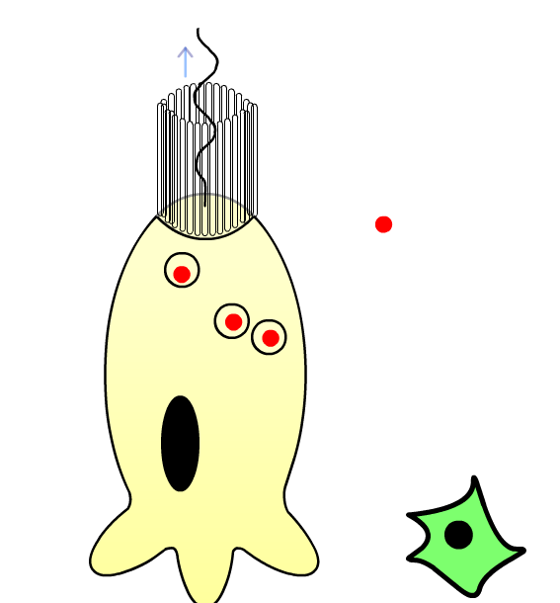

7. Q: What triggers a sponge to produce gemmules?
A: Unfavourable conditions – change in temperature, pH, salinity … response is to make a gemmule to survive the conditions even if the sponge doesn't

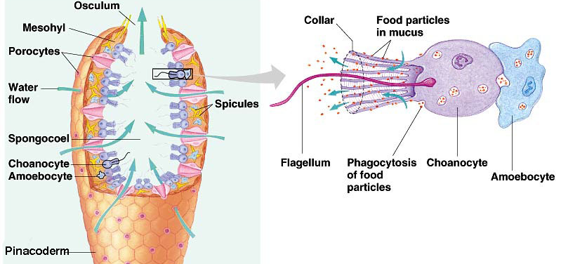
8. Q: Draw a sponge and label all the structures

