Biology 11 The Pteridophytes Name:

Objectives: By the end of the lesson you should be able to:
- Compare and contrast bryophytes and pteridophytes
- Describe the life cycle of a pteridophyte
- Give some examples of pteridophytes

Introduction;
- As the earth’s climate became ________________, nature selected for appropriate _______________________
- This led to the evolution of the _______________________________ (_________________________________)
- In order to develop effective conducting and support tissues, plants selected for having a dominant ________________________instead of the _____________________________…why?
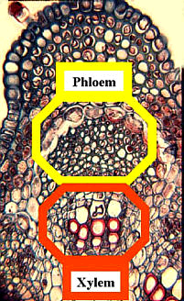
- The first vascular plants were better suited to land than the ___________________________ but were still not fully adapted

What is Vascular Tissue?
They are the “___________________________” of plants:
- _____________________: to conduct ________________from roots to shoots
- _____________________: to conduct the _________________________________________________ from shoots to roots

Benefits of Vascular Tissue:
- ___________________________________________ to plant tissue
- Movement of ________________________________________________
- Plants can be _______________________
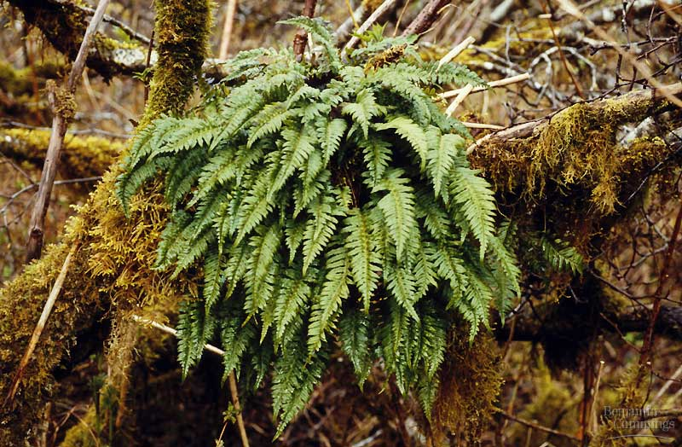
First Vascular Plants:
- ______________________________________: the ferns
  - _____________________
    - __________________transport system
    - ___________________ , _______________, roots, leaves
  - swimming sperm
    - ___________________________sperm
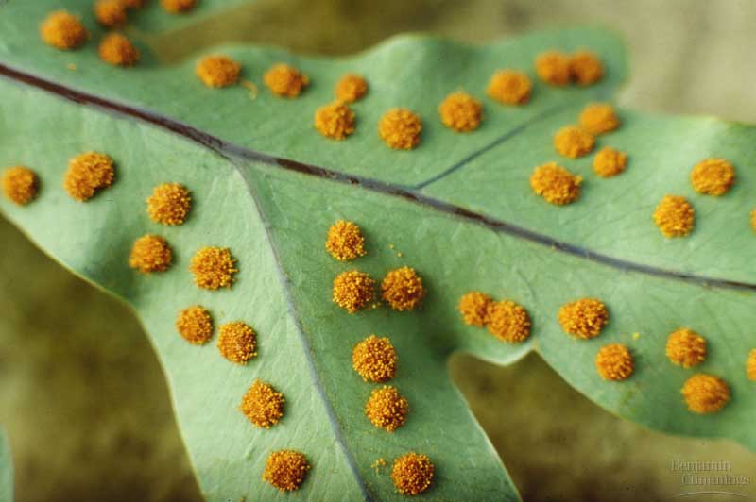
  - life cycle dominated by ______________________________ stage
    - leafy fern plant you are familiar which is _____________________________
    - fragile _____________________________
  - _______________________ for reproduction
    - ___________________cells which sprout to form ________________________________

Pteridophyte Basics:
- They utilize the ______________________________________________________ life cycle
- They _____________ produce ___________________(thus they are called the “____________________________________________________________”)
- The sperm must swim from the ________________________to the_________________________________
- They have roots, which ________________________________________________________________________ up the stem to the _____________________, which are photosynthetic.
- They produce ________________ to reproduce.
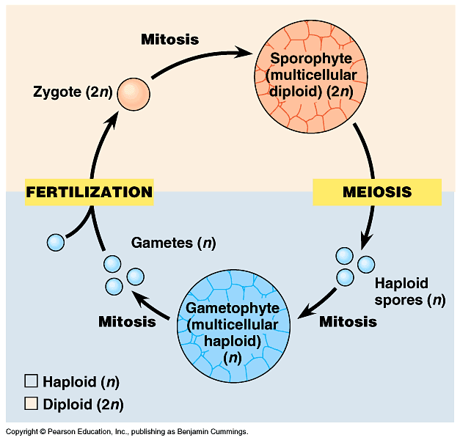
Pteridophyte Life Cycle:
diploid
haploid
produces male
& female gametes

The Sporophyte Generation:
- The _____________________________________ (dominant stage) develops _____________________________________________________.
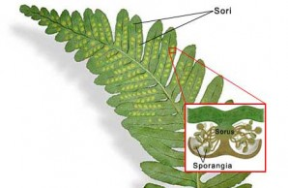
- These spores are in containers called ____________________________ which group into clusters called ____________________________.
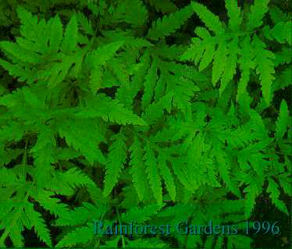

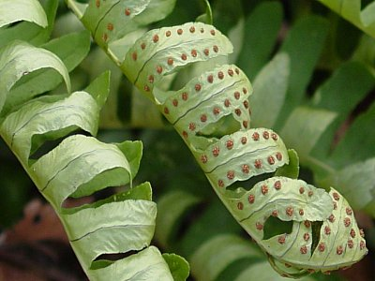
Fern Fronds (not called________________________!)
Fern sporophyte showing __________ on underside

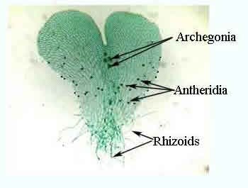
The Gametophyte Generation:
  - Fern gametophyte (_____) is thin, __________________________ structure called a ____________________
  - The developing gametophyte first grows a set of root-like ____________________ then flattens into the heart shaped mature gametophyte
  - It’s very small and produces the gametes
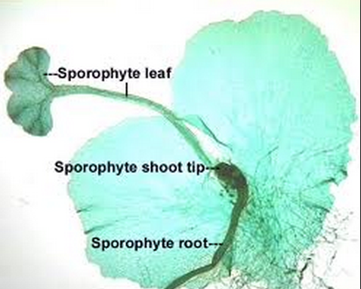
  - Grows independently of the sporophyte

- Sperm from the _______________________ swims to the ___________________________ to fertilize an egg.
- The ______________________________________________ begins to grow.

Examples:
List 3 examples from the next few slides:
1.
2.
3.
Fossil Fuels:
- Despite their shortcomings, the ferns quickly spread all over the world forming vast forests of _____________________ much like those seen in New Zealand today
- These fed the mighty _________________________who were also dominant on land at this time
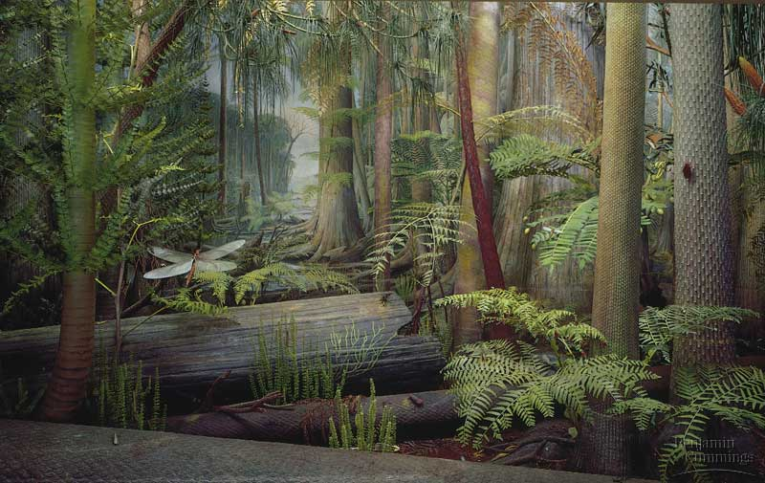

Carboniferous forest – 290-350 mya

- Forests of seedless plants ________________________________________________

