Biology 11 Rat Dissection Name:

**Purpose:** to investigate the internal and external structure of a chordate!

**Materials:**

Rat specimen

Dissecting tray

Dissecting kit

**Method:**

1. Name your rat! ______________________

Part 1: External Anatomy

1. Obtained your rat and observe the general characteristics. Key terms are highlighted in grey. **The rat's body is divided into six anatomical regions:**  cranial region - head cervical region - neck pectoral region - area where front legs attach thoracic region - chest area abdomen - belly pelvic region - area where the back legs attach.
2. Note the hairy coat that covers the rat and the sensory hairs (whiskers) located on the rat's face, called **vibrissae**.
3. The mouth has a large cleft in the upper lip which exposes large front **incisors**. Rats are gnawing mammals, and these incisors will continue to grow for as long as the rat lives.
4. Note the eyes with the large **pupil** and the **nictitating membrane** found at the inside corner of the eye. This membrane can be drawn across the eye for protection. The **eyelids** are similar to those found in humans.
5. The ears are composed of the external part, called the **pinna**, and the **auditory meatus**, the ear canal.
6. Locate the **teats** on the ventral surface of the rat. Check a rat of another sex and determine whether both sexes have teats.
7. Examine the **tail**, the tails of rats do not have hair. Though some rodents, like gerbils, have hair on their tails.
8. Locate the **anus**, which is ventral to the base of the tale.
9. Determine whether your rat is male or female by looking near the tail for the male or female genital organs.

Part 2: Skinning the Rat

1. You will carefully remove the skin of the rat to expose the muscles below. This task is best accomplished by making a small incision with your scalpel and the using your probe to separate the connective tissues that connects the skin to the first layer of muscles. **Do not cut into the muscles!**
2. You can start at the incision point where the latex was injected and continue toward the tail. Use the lines on the diagram to cut a similar pattern, avoiding the genital area. Gently peel the skin from the muscles, using scissors and a probe to tease away muscles that stick to the skin.
3. **Identify the following muscles:** 
   1. **Biceps brachii** - located on the anterior surface of the humerus (arm). Action: flexes lower arm
   2. **Biceps femoris** - located on the side of the thigh, in two bundles. Action: flexes the lower leg
   3. **External Oblique** - located on the sides of the abdomen. Action: flexes body wall.
   4. **Pectoralis Major/Minor** - located in chest area. Action: adducts arm (draws it forward)

Part 3: Skeletal System

1. Exposing the bones of the leg.Carefully tease away the biceps femoris and gastrocnemius on one leg to expose the 3 leg bones: **Tibia**, **Fibula**, and **Femur** and the small **patella** (kneecap).
2. You can also see the **ligaments** around the knee that attach the bones of the lower leg to the femur and the achilles tendon which attaches the gastrocnemius to the ankle. Remove the muscles from one arm to reveal the ulna, radius, and humerus. Note the size of the radius.

Part 4: Digestive System

1. Use scissors to cut through the abdominal wall of the rat following the incision marks in the diagram for Part 2. Be careful not to cut too deeply and keep the tip of your scalpel pointed upwards. Do not damage the underlying structures.
2. Locate the **diaphragm**, which is a thin layer of muscle that separates the thoracic cavity from the abdominal cavity. The diaphragm is a helpful directional marker.
3. 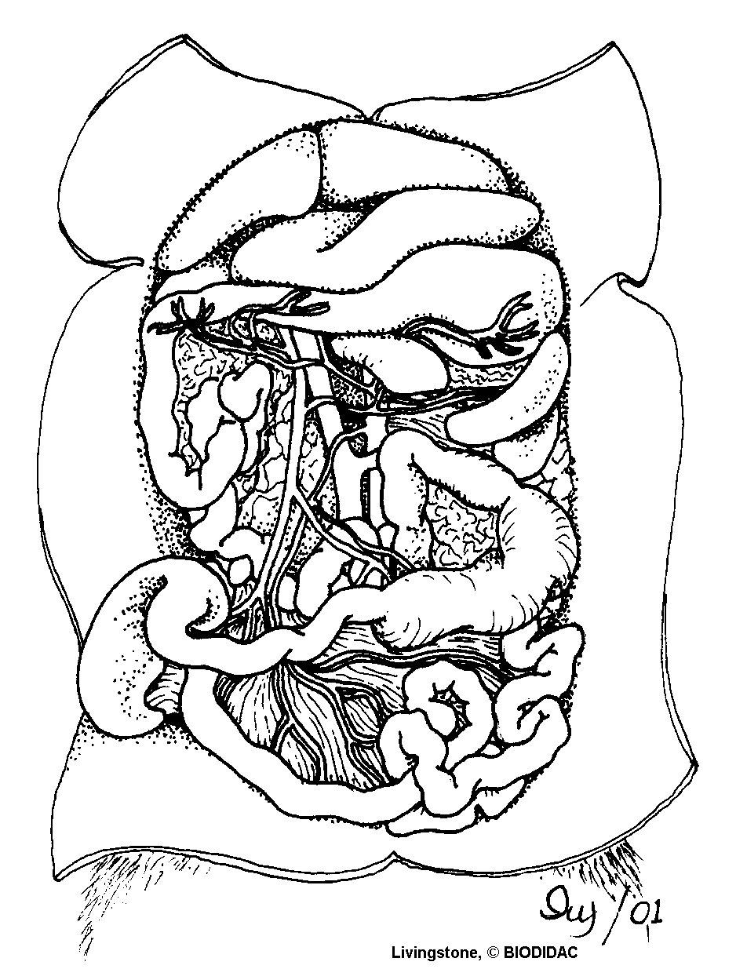**DO NOT REMOVE OR CUT THE HEART!** The **heart** is centrally located in the thoracic cavity. The two dark colored chambers at the top are the **atria** (single: atrium), and the bottom chambers are the **ventricles**. The heart is covered by a thin membrane called the **pericardium**. (We will come back to the heart later.)

**Liver**

**(many lobes)**

**Stomach**

**Spleen**

**Inferior Vena Cava**

**Large Intestine**

**Small Intestine**

**Small Intestine**

**Secum**

**Mesentery**

Part 5: Abdominal Organs

1. The **coelom** is the body cavity within which the viscera (internal organs) are located. The cavity is coverd by a membrane called the peritoneum.
2. Locate the **liver**, which is a large, dark colored organ suspended just under the diaphragm. The liver has many functions, one of which is to produce bile which aids in digesting fat. The liver also stores glycogen and transforms wastes into less harmful substances. Rats do not have a gall bladder which is used for storing bile in other animals.
3. The **esophagus** runs through the diaphragm and moves food from the mouth to the stomach. It is distinguished from the trachea by its lack of cartilage rings.
4. Locate the **stomach** on the right side (usually) just under the liver. The functions of the stomach include food storage, physical breakdown of food, and the digestion of protein. The opening between the esophagus and the stomach is called the cardiac sphincter. The outer margin of the curved stomach is called the **greater curvature**, the inner margin is called the **lesser curvature**.
5. The **spleen** is about the same color as the liver and is attached to the greater curvature of the stomach. It is shaped like a banana and is associated with the circulatory system and functions in the destruction of blood cells and blood storage. A person can live without a spleen, but they're more likely to get sick as it helps the immune system function.
6. The **pancreas** is not a clearly identifiable organ but a thin membrane that overlays the stomach and spleen. The pancreas produces digestive enzymes that are sent to the intestine via small ducts (the pancreatic duct). The pancreas also secretes insulin which is important in the regulation of glucose metabolism. Find the pancreas by looking for a thin, membrane looking structure that has the consistency of cottage cheese.
7. The **small intestine** is a slender coiled tube that receives partially digested food from the stomach (via the pyloric sphincter). The term “small” refers to its diameter, not its length. It consists of three sections: **duodenum**, **ileum**, and **jejunum**. The small intestine leads to the cecum.
8. The **cecum** is a pouch that connects the large and small intestines. Food is temporarily stored in the cecum while helpful bacteria digest the cellulose found in plant cells. Most herbivores such as the rat have a large cecum. Humans and other omnivores and carnivores have a much smaller cecum which is referred to as the appendix.
9. Use your scissors to cut the mesentery (connective tissue and network of blood vessels that connects the small intestine) of the small intestine, but do not remove the small intestine from its attachment to the stomach and rectum. If you are careful you will be able to stretch it out and untangle it so that you can see the relative lengths of the large and the small intestine.
10. Locate the **large intestine**, which is the large greenish tube that extends from the small intestine and leads to the anus. The large intestine is also known as the **colon**. This is where the finals stages of digestion and water absorption occurs and it contains a variety of bacteria to aid in digestion.
11. Locate the **rectum** - the short, terminal section of the colon between the descending colon and the anus. The rectum temporarily stores feces before they are expelled from the body.



Part 6: Excretory Systems

1. Locate the Kidneys. Note the veins and arteries that connect with the kidneys.
2. Remove one of the kidneys and cut it lengthwise. Notice the very fine veins and arteries within. Blood is filtered through the kidneys approximately once every 45 minutes.
3. The small yellowish glands embedded in the fat atop the kidneys are the **adrenal glands** which secrete adrenaline into the blood during times of crisis.

Part 7: Reproductive Systems

MALE:

1. The major reproductive organs of the male rat are the **testes** (singular: testis) which are located in the **scrotal sac**. Cut through the sac carefully to reveal the testis. On the surface of the testis is a coiled tube called the **epididymus**, which collects and stores sperm cells. The tubular **vas deferens** moves sperm from the epididymus to the **urethra**, which carries sperm though the penis and out the body.
2. The lumpy brown glands located to the left and right of the urinary bladder are the **seminal vesicles**. The gland below the bladder is the **prostate gland** and it is partially wrapped around the penis. The seminal vesicles and the prostate gland secrete materials that form the seminal fluid (semen).

FEMALE:

1. The short gray tube lying dorsal to the urinary bladder is the **vagina**. The vagina divides into two **uterine horns** that extend toward the kidneys. This duplex uterus is common in some animals and will accommodate multiple embryos (a litter). In contrast, a simple uterus, like the kind found in humans has a single chamber for the development of a single embryo.
2. At the tips of the uterine horns are small lumpy glands called **ovaries**, which are connected to the uterine horns via **oviducts**. Oviducts are extremely tiny and may be difficult to find without a dissecting scope.

Part 8: The Circulatory System

1. The general structure of the circulatory system of the rat is almost identical to that of humans. Pulmonary circulation carries blood through the lungs for oxygenation and then back to the heart. Systemic circulation moves blood through the body after it has left the heart.
2. Your rat specimen has been double injected with latex to help you identify veins and arteries. **Veins carry used blood (blue) back to the heart and lungs**. The lungs re-oxygenate the blood and the heart pumps it back to the rest of the body. In the human body, these veins are not the same bright blue that you see in your rat. However, if you look at your arm, you can see some bluish veins very close to the skin. Look in your rat specimen for the veins listed on page 2
3. The arteries in your rat are stained red for easy identification. Find the arteries listed on page 2
4. After completing the procedures above dealing with veins and arteries, remove the heart from the pericardial sack. You will need to sever the arteries and veins connecting the heart to the circulatory system. **Do this slowly and carefully so that you do not cut more than is necessary.** Leave as much of the veins and arteries attached to the heart as possible.



1. Identify the aorta, left and right atrium, and left and right ventricle. Carefully insert your probe into these opening and work it into the center of the heart.
2. Finally, make an incision between the left and right ventricles with your scalpel. Try to locate the bicuspid and semilunar valves which open and close the ventricles.



**Analysis:**

1. These are the structures that you are expected to identify. Check each one off as you identify it.

**Muscular System**

* Biceps brachii (arm)
* Biceps femoris (leg)
* External Oblique (chest/stomach)
* Pectoralis Major/Minor

**Skeletal System**

* Tibia
* Fibula
* Femur
* Ulna
* Radius
* Humerous

**Digestive System**

* Liver
* Esophagus
* Stomach
* Small intestine
* Large intestine

**Excretory/Reproductive System**

* Kidneys
* Ovaries (female only)
* Testes (male only)

**Thoracic Cavity**

* Heart
* Lungs
* Diaphragm
* Trachea

**Circulatory System**

* Vena Cava
* Renal Artery
* Right/Left external jugular
* Aortic arch
* Right/Left subclavian
* Right/Left femoral

1. The sphincter is a circular muscle. Why is it this shape and what does it do?
2. Why is there a difference in the diameter and length of the small and large intestine?
3. The liver is the largest organ in the body (after the skin), what are its functions?
4. In each of the cavities there is a membrane that covers both the wall of the cavity and the organ it contains, what is the function of these membranes?
5. What is the function of the spleen?
6. What is the function of the diaphragm?
7. What distinguishes the atria from the ventricles?
8. Why is the wall of the left ventricle of the heart thicker than that of the right?
9. What similarities exist between the male and female reproductive systems?
10. What do the kidneys do?