Science as a Process – Spontaneous Generation
Date: Proficient Processor (Name):
Science is a process that uses logic and evidence in a systematic and organized way to answer questions about the natural world. Scientists continually build upon the work of others to develop a deeper understanding of the world around us. The disproving of the hypothesis of spontaneous generation is a classic example in biology of this scientific process.
- Asking a Question
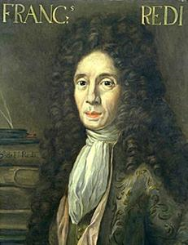
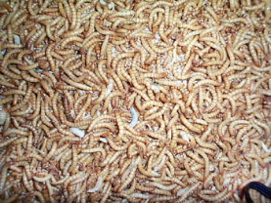
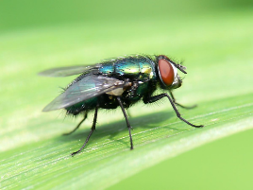
Many years ago, people wanted to know how living things came into existence. They asked:
How do organisms come into being?
- Forming a Hypothesis
One early hypothesis was spontaneous generation.
For example, most people thought that maggots spontaneously appeared on meat.
In 1668, Francesco Redi, an Italian scientist, noticed that flies land on meat that is left uncovered and that maggots would later appear on the meat. He proposed a different hypothesis: that maggots came from eggs that flies laid on meat. Rotting meat cannot be transformed into flies.
- Performing a Controlled Experiment
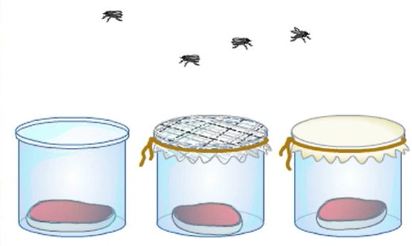
Redi's Experiment:
Experimental Group:
Control Group:
Independent Variable:
Dependent Variable:
Controls:

- Recording and Analyzing Results
What were Redi's results?

- Drawing a Conclusion
Scientists use the data from an experiment to evaluate a hypothesis and draw a valid conclusion. What was Redi's conclusion?
Did everyone agree with Redi's findings? What did some scientists argue?

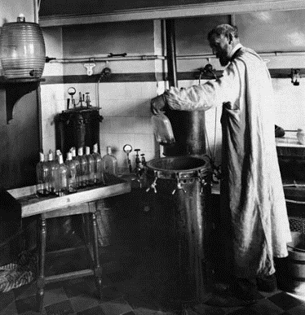
A key assumption in science is that experimental results can be reproduced because nature behaves in a consistent manner. When on particular variable is manipulated in a given set of variables, the result should always be the same. In keeping with this assumption, scientists expect to test one another's investigations. Thus, communicating a description of an experiment is an essential part of science. Today's researchers often publish a report of their work in a scientific journal. Other scientists review the experimental procedures to make sure that the design was without flaws. They often repeat experiments to be sure that the results match those already obtained, or modify and improve the experiments to further scientific knowledge. In Redi's day, scientific journals were not common, but he communicated his conclusion in a book that included a description of his investigation and its results.

- Retest
In 1864, French scientist Louis Pasteur, improved upon Redi's work with his experiment which conclusively disproved the hypothesis of spontaneous generation. His hypothesis was that if cells arise from nonliving substances, they will appear in sterile broth.
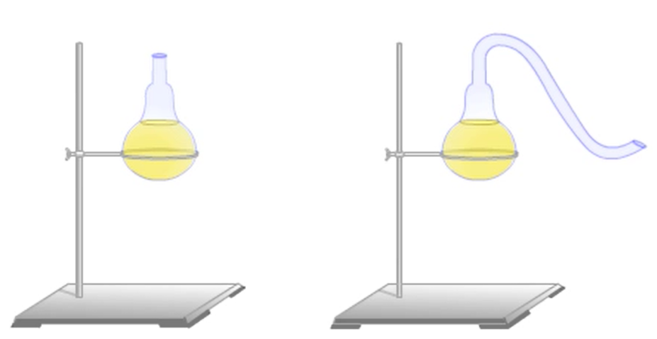

Experimental Group:
Control Group:
Independent Variable:
Dependent Variable:
Controls:

Explain Pasteur's results and his conclusion.

