- What skill is a scientist using when she listens to the sounds that whales make?
  - interpreting data
  - making observations
  - drawing conclusions
  - making a hypothesis

- Examples of skills used in science include ______ and __________.
  - clues, detectives
  - observations, measurements
  - facts, jokes
  - passing gas, belching

- What is the correct order of the steps in the scientific method.
  - Ask a question, analyze results, make a hypothesis, test the hypothesis, draw conclusions, communicate results.
  - Make a hypothesis, test the hypothesis, analyze the results, ask a question, draw conclusions, communicate results.
  - Ask questions, make a hypothesis, test the hypothesis, analyze results, draw conclusions, communicate results.
  - Ask a question, make a hypothesis, test hypothesis, draw conclusions, analyze results, communicate results.

- Which question would be the best question to perform an experiment?
  - How many giraffes live in Africa?
  - Who made the first microscope?
  - How long ago did dinosaurs live on the Earth?
  - Does the amount of salt in water affect the temperature at which it boils?

- Which of the following is NOT a rule when writing a hypothesis?
  - It must be true
  - It is a prediction
  - It is testable
  - It is an if/then statement

- A factor in an experiment is called a(n):
  - observation
  - variable
  - hypothesis
  - procedure

- Numbers, facts, figures and other evidence learned through observation and testing are called:
  - questions
  - data
  - questions
  - hypothesis

- In an experiment, you must have _________ independent variable(s).
  - one
  - two
  - three
  - any number

- The list of steps involved in performing an experiment are like the steps in a recipe. It is called the ___________.
  - Conclusion
  - Scientific Steps
  - How to do the experiment list
  - Procedure

- An experiment that tests only one factor at a time by using a comparison of a control group and an experimental group is called ____________________?
  - a dependent variable
  - an independent variable
  - a theory
  - a controlled experiment

- Which of the following hypotheses is written correctly?
  - If I freeze a tennis ball, then it will not bounce as high.
  - If I heat up a tennis ball it will bounce high.
  - Frozen tennis balls will not bounce as high.
  - If a tennis ball is frozen, it won't bounce as high as one that is not frozen.

- The process of obtaining information by using the senses is called a/an
  - inquiry
  - scientific method
  - observation
  - conclusion

- A series of steps designed to help you solve problems and answer questions
  - scientific method
  - hypothesis
  - experiment
  - observation

- In an experiment, the one variable that is changed is called the
  - dependent variable
  - independent variable
  - experimental variable
  - controlled variable

- In an experiment, the factor that we measure/observe is called the
  - independent variable
  - controlled variable
  - dependent variable
  - conclusion

- A scientist hypothesizes the temperature at which an alligator's egg is incubated will determine whether the alligator will be male or female. The independent variable is
  - the male alligators
  - the gender of the alligator
  - the temperature
  - the incubator

- A scientist hypothesizes the temperature at which an alligator's egg is incubated will determine whether the alligator will be male or female. The dependent variable is
  - the temperature
  - the size of the baby alligators
  - the incubator
  - the gender of the baby alligators

- A scientist conducted an experiment to determine how the amount of salt in a body of water affects the number of plants that can live in the water. In this experiment the independent variable is
  - the number of plants in the water
  - the amount of salt in the water
  - the water
  - the temperature of the water
- A scientist conducted an experiment to determine how the amount of salt in a body of water affects the number of plants that can live in the water. In this experiment the dependent variable is
  - the number of plants in the water
  - the amount of salt in the water
  - the water
  - the temperature of the water

- All the things in an experiment that must be the same to make it fair are called
  - controlled variables or constants
  - independent variables
  - dependent variables
  - controlled experiments

- In science, an educated guess is called a/an
  - Conclusion
  - Observation
  - Hypothesis
  - Question

- When you decide whether or not the data supports the original hypothesis, you are
  - forming a hypothesis
  - making observations
  - asking questions
  - drawing conclusions

- When a scientist shares her findings with other scientists, she is
  - communicating results
  - experimenting
  - analyzing data
  - making a hypothesis

- In which step(s) of the scientific method do we want to use graphs
  - asking questions
  - make a hypothesis
  - analyze data/communicate results
  - perform an experiment

- The final part; what you found out in the end, a summary of reasonable inferences is a/an
  - question
  - controlled experiment
  - hypothesis
  - conclusion

- Which of the following is important when creating a graph in science.
  - Labels
  - Titles
  - Neatness
  - all of these

- A scientist who wants to study the effects of fertilizer on plants sets up an experiment. Plant A gets no fertilizer, Plant B gets 5 mg of fertilizer each day, and Plant C gets 10 mg of fertilizer each day. Which plant is the control group?
  - Plant A
  - Plant B
  - Plant C
  - All of them

- A scientific procedure undertaken to make a discovery, test a hypothesis, or demonstrate a known fact is a/an
  - Hypothesis
  - Experiment
  - Law
  - theory

- A way of solving problems that uses a series of logical steps is called
  - the scientific method
  - experimental guidelines
  - standard procedures

- 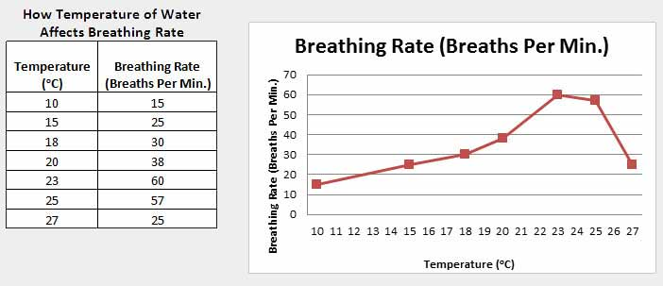
- What is the independent variable in this experiment?

- What is the dependent variable in this experiment?

Answer Key
- B | 7. B | 13. A | 19. A | 25. D
- B | 8. A | 14. B | 20. A | 26. D
- C | 9. D | 15. C | 21. C | 27. A
- D | 10. D | 16. C | 22. D | 28. B
- A | 11. A | 17. D | 23. A | 29. A
- B | 12. C | 18. B | 24. C | 30a) Water temperature  b) Breathing rate

Names: _______________
 | 7. | 13. | 19. | 25.
 | 8. | 14. | 20. | 26.
 | 9. | 15. | 21. | 27.
 | 10. | 16. | 22. | 28.
 | 11. | 17. | 23. | 29.
 | 12. | 18. | 24. | 30a)  b)

Names: _______________
 | 7. | 13. | 19. | 25.
 | 8. | 14. | 20. | 26.
 | 9. | 15. | 21. | 27.
 | 10. | 16. | 22. | 28.
 | 11. | 17. | 23. | 29.
 | 12. | 18. | 24. | 30a)  b)

Names: _______________
 | 7. | 13. | 19. | 25.
 | 8. | 14. | 20. | 26.
 | 9. | 15. | 21. | 27.
 | 10. | 16. | 22. | 28.
 | 11. | 17. | 23. | 29.
 | 12. | 18. | 24. | 30a)  b)

