Scientific Method
Name: Date:
Problem
You want to determine the effects of a certain fertilizer on the growth of orchids grown in a greenhouse. Materials that are available to you include: greenhouse, 100 orchid plants, water, fertilizer, and soil. You want to know if the orchids will grow best with a weak concentration of fertilizer, a medium concentration of fertilizer, or a high concentration of fertilizer. How will you design an experiment to test different concentrations of this fertilizer?

A. State your hypothesis:

B. How will you set up a controlled experiment?

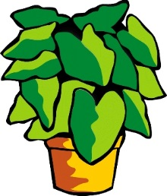
Group 3
Group 4
Group 2
Group 1

C. What is the control group D. What is the experimental group
in this experiment? in this experiment?

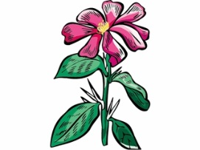

E. What variables must be kept constant in this experiment (control variables)?

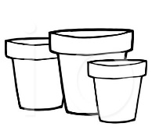
- All plants

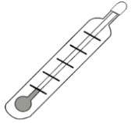
- All plants

- All plants

- All plants

F. What variable is being changed in this experiment (independent variable)?

G. After one month of measuring the orchids (dependent variable), the following data is obtained:

Group 1 (Control Group): Grew to an average height of 15 cm.
Group 2 (Weak concentration): Grew to an average height of 35 cm.
Group 3 (Medium concentration): Grew to an average height of 28 cm.
Group 4 (High concentration): Grew to an average height of 10 cm.

Is your hypothesis supported or disproved by these results?

What is your conclusion based on these results?

