Name: Date:

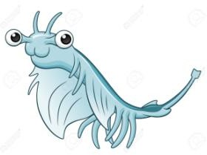
Effect of Salinity on the Hatching Viability of Brine Shrimp Background Information
Brine shrimp (Artemia sp.) are small crustaceans found in various saltwater lakes around the world. They are not found in oceans because there are too many predators. Their development is easy to observe with a microscope. Unique characteristics make them an interesting model for studies of natural selection and adaptations.
Under ideal conditions, female brine shrimp produce eggs that hatch quickly into live young. However, when conditions become less conducive, the shrimp instead produce cysts—encased embryos that cease development until conditions are again favorable. When this happens, this stage is called diapause. When the temperature or dissolved oxygen level becomes too low, or the salinity (salts) in the water is too high, each egg laid is covered with a hardened, brown covering called a chorion. The chorion may keep the embryo viable for many years in a dry, oxygen-free environment. The brine shrimp used in this activity are stored in this dormant stage. Once the cysts are incubated in saltwater, the embryos quickly resume their development and hatch.
After the cyst breaks open, the brine shrimp remains attached to the shell, surrounded by a hatching membrane. This stage is known as the umbrella stage. The hatching membrane remains attached to the cyst for a number of hours until the young brine shrimp, known as a nauplius, emerges. During the first larval stage, the nauplius subsists on yolk reserves until it molts (loses its exoskeleton). During the second stage, the nauplius begins to feed on algae. The nauplius progresses through approximately 15 molts before reaching adulthood in 2 to 3 weeks.

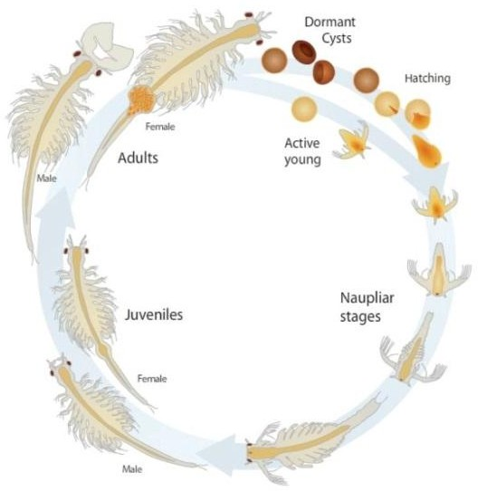
Brine shrimp populations are greatly influenced by environmental factors such as salinity. The hatching viability can be measured by determining how many individuals hatch out of their cysts in different conditions. Given the relatively short development time from cyst to nauplius (24-48 hours), the use of brine shrimp in this study is a fast and easy way to observe how some individuals of a population may be better adapted to develop and survive in different environmental conditions.

Predict which solutions will have the highest and lowest hatching viability and state reasons for your prediction.

Problem/Question
State the problem being investigated in this experiment:

Hypothesis
State the hypothesis to be tested in this experiment:

Materials
Brine shrimp eggs (cysts) Sharpie marker
4 petri dishes Distilled water
Different solutions of salt water Paintbrush
4 microscope slides Disposable pipets
4 small pieces of double-sided tape Graduated cylinder Dissecting microscope or magnifying glass

Procedure

Day 1:

1. Label 4 petri dishes: 0%, 2.5%, 5%, 10%
- Measure 30 mL of each solution and pour it into the appropriately labeled petri dish.
- Lightly touch the paintbrush to the side of the dish containing the brine shrimp eggs. Your goal is to collect only approximately 20-30 eggs on the brush. You do not want to cover the tip of the brush in eggs. (Reminder: You will have to count each and every egg!)
- Dab the paintbrush onto the tape on the microscope slide. Repeat for the remaining 3 microscope slides.
- Examine the first slide under the dissecting microscope and count the number of eggs on the slide and record in Table 1 under Day 0.
- Place this slide into the petri dish labeled 0% Salt Solution. Be sure to put it tape side up.
- Repeat Steps 7 and 8 for the remaining 3 slides until you have prepared 4 microscope slides of eggs, recorded the numbers in Table 1, and placed each slide in its appropriate salt solution.
- Allow the dishes to sit at room temperature until next class.

Day 2

- Examine each petri dish with a dissecting microscope.
- Count the number of swimming brine shrimp in each solution. With a pipette, gently catch them and move them into a beaker. Record the number of swimming shrimp in Table 1.
- Count the number of un-hatched eggs and record this number in Table 1.
- NOTE: Use a separate pipette and beaker for each petri dish.

(We will calculate and record the Hatching Viability Percentages)

Lab Write Up and Analysis

Calculate Hatching Viability

- Use the following equation and your data to calculate the hatching viability of the brine shrimp for each salt solution:

Hatching Viability = Number of Brine Shrimp Swimming
Initial Number of Eggs in Petri Dish

- Round your answers to the nearest hundredth and record the data in the data table provided.

Table 1: Hatching Viability of Brine Shrimp in Varying Levels of Salinity

 | 0 hours (Day 1) | Day 2
%  Salt | # Eggs | # Dead or  partially hatched | #  Swimming | Hatching  Viability Percentage
0%
2.5%
5%
10%

Analysis

- State the problem being investigated in this experiment.

- Identify the independent and dependent variables.

- State the hypothesis. Provide reasoning to support the hypothesis.

- Based on your data, in which petri dish did you observe the highest and lowest hatching viability? Did the results support your prediction?

- Brine shrimp will survive in the environments that are best adapted to. In this experiment, brine shrimp adaptations to salinity were being tested. Looking at your answer to Question 4, explain why you think a particular salt solution yielded the best and worst hatching viability compared to their natural environment.

- Identify two conditions that were controlled in this experiment. Why was this important?

