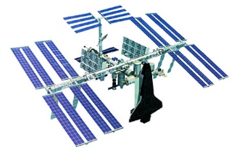
Space Seeds

Name:

Date:
The year is 2075. Earth's climate continues to change, making the Earth more and more inhospitable. The human population has surpassed 20 billion and the strain on Earth's resources is evident as widespread hunger and disease grip the planet. An Orion spacecraft with astronauts aboard is heading to Mars to begin colonization to help alleviate pressure on Earth.
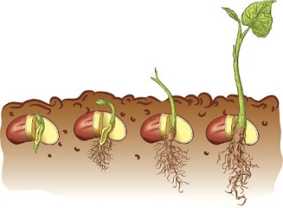
On the outside of the spacecraft are several storage units for supplies and other important equipment. The stowage units are sealed and have pressure and temperature conditions similar to those inside the spacecraft.
The astronauts suddenly hear an alarm indicating a problem with one of the external storage units. They perform a spacewalk a few days later to investigate the problem and find that one of the storage units has been punctured by a micrometeorite. It is the storage unit that contains the tomato seeds to be used to grow food on Mars.
The hole in the storage unit is sealed up, but the seeds were exposed to the harsh space environment (-80 ºC and almost no atmospheric pressure) for several days. Although the storage unit has been repaired, the astronauts are now wondering "How will this affect the seeds that will be used to grow tomatoes on the surface of Mars?"

What Could Happen to the Tomato Seeds?

Problem: How does exposure to the space environment or space-like conditions affect the number of tomato seeds that germinate?

Hypothesis:

Results:
Seed Type  (eg. V or W) | Date  (YY/MM/DD) | Day Number | Total # Germinated | Notes and Comments  Examples: Time of day that observations were made, changes in room conditions (e.g., room temperature)

V

W

V

W

V

W

V

W
Seed Type  (eg. V or W) | Date  (YY/MM/DD) | Day Number | Total # Germinated | Notes and Comments  Examples: Time of day that observations were made, changes in room conditions (e.g., room temperature)

V

W

V

W

V

W

V

W

V

W

We will send our results to the research team conducting this study and will learn which seeds actually went to space and which didn't, allowing us to draw a conclusion from our data.
Percent Germination of Group T in Class | Percent Germination of Group U in Class | Percent Germination of Group T Across Canada | Percent Germination of Group U Across Canada

Seeds __________ went to space.
Discussion:
- What is the independent variable in this experiment? How do you know?

- What is the dependent variable in this experiment? How do you know?

- What controls did you use in this experiment?

Conclusion:

