Name: ____________________ Date: _____________________
Cell Biology Study Guide
Keywords:

- Scientific method
- Hypothesis
- Theory
- Controlled experiment
- Independent variable
- Dependent variable
- Constant/control variable
- Experimental group
- Control group
- Quantitative data
- Qualitative data
- Unicellular
- Multicellular
- Differentiation
- Homeostasis
- Photosynthesis
- Cellular respiration
- ATP
- Autotrophic
- Heterotrophic
- Sexual reproduction
- Asexual reproduction
- Biosphere
- Biome
- Ecosystem
- Abiotic
- Biotic
- Community
- Population
- Organism
- Organ system
- Organ
- Tissue
- Cell
- Organelle
- Carbohydrate
- Lipid
- Protein
- Nucleic acid
- Monomer
- Polymer
- Monosaccharide
- Disaccharide
- Polysaccharide
- Glycerol & fatty acids
- Triglyceride
- Phospholipid
- Steroid
- Amino acid
- Nucleotide
- Prokaryotic
- Eukaryotic
- Endosymbiotic theory
- Cell membrane
- Cytoplasm
- Hydrophobic
- Hydrophilic
- Nucleus
- Nucleoplasm
- Nuclear pore
- Nucleolus
- Rough endoplasmic reticulum
- Smooth endoplasmic reticulum
- Ribosome
- Golgi body
- Vesicle
- Vacuole
- Mitochondria
- Chloroplast
- Cell wall
- Flagella
- Cilia
- Centriole
- Cytoskeleton
- Lysosome
- Transcription
- Translation
- Diffusion
- Osmosis
- Solution
- Solute
- Solvent
- Selectively permeable
membrane
- Concentration gradient
- Isotonic
- Hypertonic
- Hypotonic

Key Concepts:
- 8 characteristics of life
- 4 biological molecules
  - Subunits, diagrams, examples
- Cell structures and their functions, diagrams
  - Prokaryotic vs Eukaryotic
  - Be able to draw and label a cell – both plant and animal
- Protein synthesis:
  - Trace the pathway from DNA to a complete protein
- Mitosis and Meiosis:
  - Know the similarities, differences, results, phases and reasons for each
- Diffusion and Osmosis: similarities and differences
  - Tonicity: iso, hyper and hypo
- Eggcellent Experiment
- Scientific Method

Name: _____________________ Date: __________________
Cell Biology Review
- Identify the following compounds.
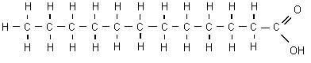
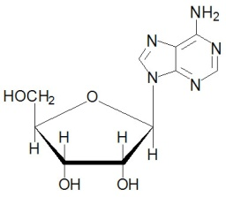
A. B.

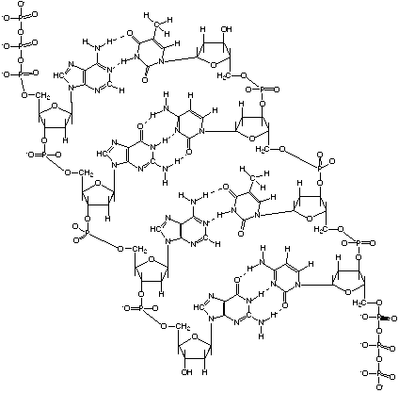
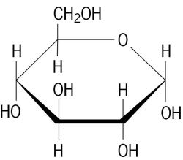
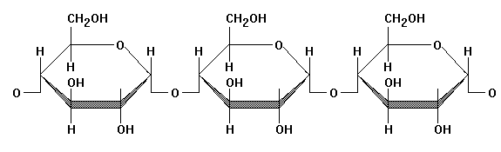
C. D. E.

___ Fatty Acid ___ Nucleotide ___Starch (polysaccharide) ___ glucose ___ DNA

- Give 2 functions of fats:

- What are 3 functions of carbohydrates? Give an example of a carbohydrate molecule that does each function.

- Give 2 functions of proteins in our body.

- Give four structural differences between plant and animal cells

- Match the following organelles with the proper function.

___ produces fats and detoxifies A. Lysosome
___ provides structure and pathways for vesicles to be transported on B. Golgi
___ synthesis and transport for proteins C. RER
___ pulls apart chromatids during cell division D. SER
___ intracellular digestion E. Centrioles
___ packages and exports synthesized products F. Mitochondria
____ site of cellular respiration – energy production in form of ATP G. Cytoplasm
____ jelly that makes up the cell's interior H. Cytoskeleton

- Draw a Venn diagram or t-chart to compare the similarities and differences between prokaryotes and eukaryotes.

- What would happen to a cell if placed in the following solutions (describe and illustrate).

  - Isotonic solution:

  - Hypotonic solution:

  - Hypertonic solution:

- You want to determine the effects of a certain fertilizer on the growth of orchids grown in a greenhouse. Materials that are available to you include: greenhouse, 100 orchid plants, water, fertilizer, and soil. You want to know if the orchids will grow best with a weak concentration of fertilizer, a medium concentration of fertilizer, or a high concentration of fertilizer. How will you design an experiment to test different concentrations of this fertilizer?

What are the independent, dependent, and control variables? Which plants are the control group and experimental group?

- Here is a 2N diploid skin cell. How many chromosomes do you see? Draw the all the steps of mitosis (include interphase and cytokinesis as well) to divide this cell into the identical cells at the bottom of the page. Give a brief description of major events that occur in each phase.
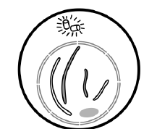

- Here is a 2N diploid sex cell in the male testis. How many chromosomes do you see? Draw the all the steps of meiosis (include interphase and cytokinesis as well) to divide this cell into the 4 unique gametes at the bottom of the page. Give a brief description of major events that occur in each phase.
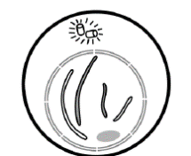

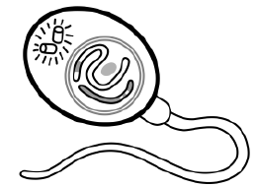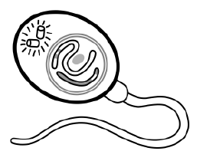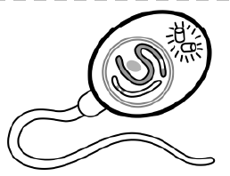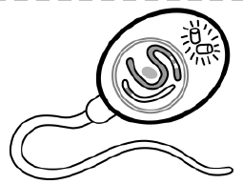

- Draw and explain the protein synthesis pathway:

- Explain the 8 characteristics of life. Drawings may help with your explanations!

