Name: _____________________ Date: __________________
Cell Biology Review
1. Identify the following compounds.
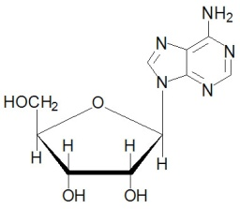
A. B.
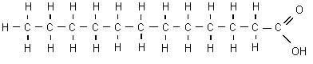

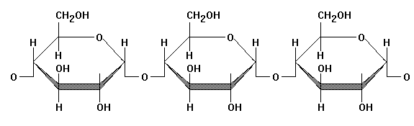
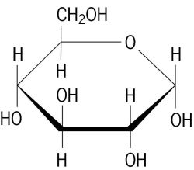
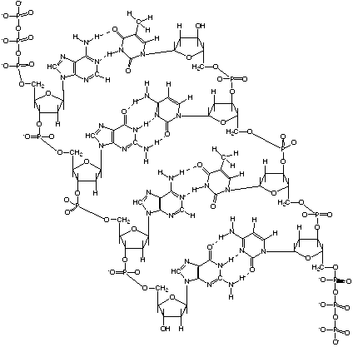
C. D. E.

_A_ Fatty Acid __B_ Nucleotide __C_Starch (polysaccharide) __D_ glucose __ E_ DNA

2. Give 2 functions of fats: long term energy storage (triglycerides), cell membranes (phospholipids), hormones (steroids)

3. What are 3 functions of carbohydrates? Give an example of a carbohydrate molecule that does each function.
Short term energy, short term energy storage, structure.
Monosaccharides such as glucose and disaccharides such as lactose are used in cellular respiration to make ATP (cellular energy). Polysaccharides such as starch (plants) and glycogen (animals) are used for short term energy storage. Polysaccharides such as chitin (bug exoskeletons) and cellulose (plant cell walls) are structural.

4. Give 2 functions of proteins in our body. Build muscle, bone, enzymes

5. Give four structural differences between plant and animal cells. The 4 C's: plant cells have Cell walls, Chloroplasts and large Central water vacuole. Animal cells have Centrioles, plants do not.

6. Match the following organelles with the proper function.

__D_ produces fats and detoxifies A. Lysosome
__H_ provides structure and pathways for vesicles to be transported on B. Golgi
__C_ synthesis and transport for proteins C. RER
__E_ pulls apart chromatids during cell division D. SER
__A_ intracellular digestion E. Centrioles
__B_ packages and exports synthesized products F. Mitochondria
__F_ site of cellular respiration – energy production in form of ATP G. Cytoplasm
__G_ jelly that makes up the cell's interior H. Cytoskeleton

Prokaryotic | Both | Eukaryotic
No nucleus | DNA | Nucleus
No membrane-bound organelles | Cytoplasm | Membrane-bound organelles
Simple | Cell membrane | Complex
Not compartmentalized | Ribosomes | Compartmentalized
Smaller |  | Larger
Bacteria |  | Plants, animals, fungus, protists
Single room apartment |  | Mansion

- What would happen to a cell if placed in the following solutions (describe and illustrate).
  - Isotonic solution:
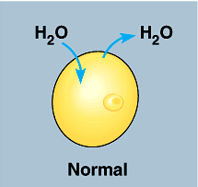
Equal [solute] in both solution and in cell. Equal [water] in both solution and in cell. Water flows equally into and out of cell. No net movement of water.

  - Hypotonic solution:
[Low solute] / [high water] in solution. [High solute] / [low water] in cell. Solute cannot cross the semi-permeable membrane so water flows down its concentration gradient from [high] to [low] in order to achieve equilibrium. There is a net movement of water into the cell causing it to swell or even burst (lysis).
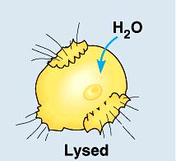

  - Hypertonic solution:
[High solute] / [low water] in solution. [Low solute] / [high water] in cell. Solute cannot cross the semi-permeable membrane so water flows down its concentration gradient from [high] to [low] in order to achieve equilibrium. There is a net movement of water out of the cell causing it to shrink or shrivel.
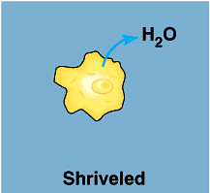

- You want to determine the effects of a certain fertilizer on the growth of orchids grown in a greenhouse. Materials that are available to you include: greenhouse, 100 orchid plants, water, fertilizer, and soil. You want to know if the orchids will grow best with a weak concentration of fertilizer, a medium concentration of fertilizer, or a high concentration of fertilizer. How will you design an experiment to test different concentrations of this fertilizer?
25 plants get no fertilizer, 25 plants get weak concentration, 25 medium, 25 high concentration. Measure plant height at the end of experiment.
What are the independent, dependent, and control variables? Which plants are the control group and experimental group?

IV: fertilizer concentration DV: plant height
Control group: 25 plants receiving no fertilizer Experimental group: 75 plants receiving different concentrations of fertilizer
Controls/constants: Same amount of sunlight, same soil pH, same type of soil, same size of pots, same amount of water, same humidity, etc.

- Mitosis
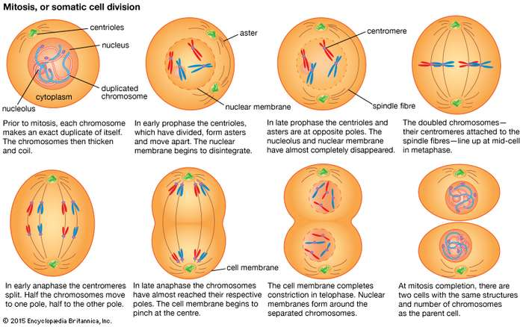

- Meiosis
Meiosis
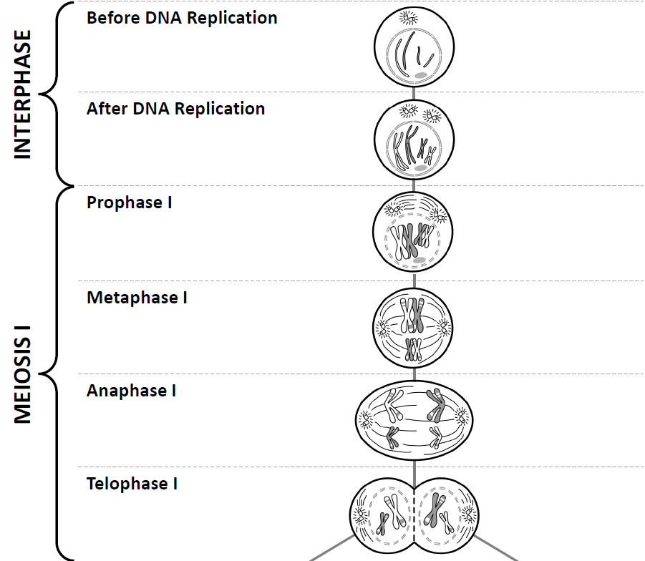
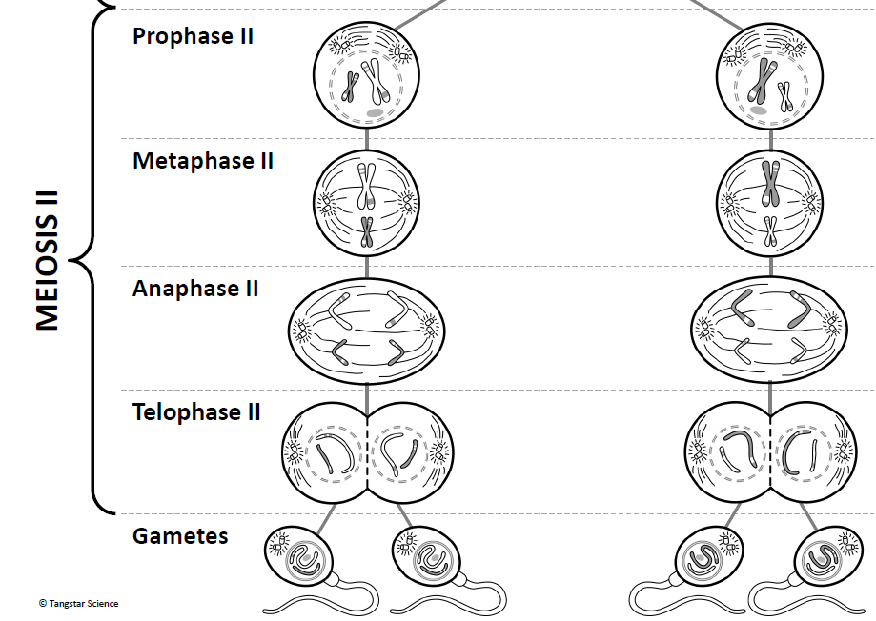

- Describe the process of making a protein.
A chemical messenger (hormone) travels into the nucleus and signals the cell to make a specific protein. A section of DNA (a gene) responsible for that protein is copied (transcribed) to mRNA. mRNA leaves the nucleus through the nuclear pore and moves to the rough endoplasmic reticulum where it binds to a ribosome. The ribosome reads the mRNA (codon) 3 bases at a time and a tRNA brings the appropriate amino acid (protein building blocks) for each codon. Once the protein is made, it is put into a vesicle and transported to the Golgi body where it is completed and repackaged into another vesicle. Finally, this vesicle containing the finished protein is exported out of the cell by binding to the cell membrane and releasing its contents outside of the cell.
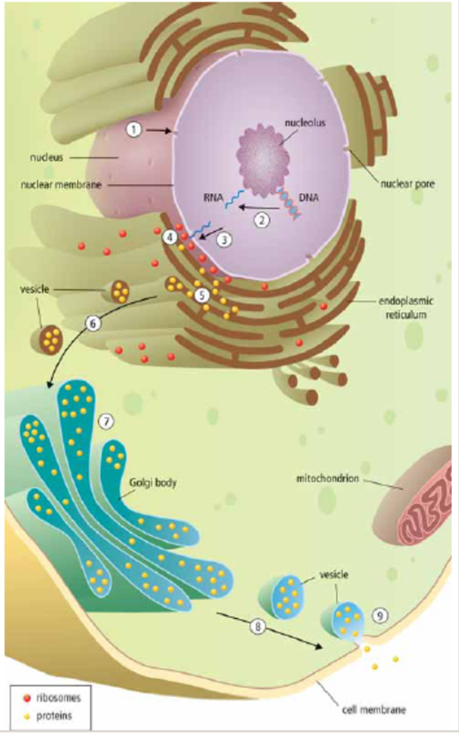

- Explain the 8 characteristics of life. Drawings may help with your explanations!
All life …
- … is made up of at least one or more cells (Unicellular and multicellular organisms)
Cells are the basic unit of life. All have cytoplasm, cell membrane, and DNA.
- … must obtain and use materials and energy
Phototrophs produce their own food by capturing energy from the sun and to make sugar(chemical energy) in the process of photosynthesis. All living things do cellular respiration in order to break down sugars and produce biological energy (ATP). Heterotrophs eat their food to meet their energy needs.
- … grows and develops
Cells grow and divide to increase biomass. Cells differentiate in multicellular organisms as they develop according to DNA instructions.
- … reproduces itself
Sexual reproduction involves hereditary information from sperm and egg from two parents combining to form a zygote. In asexual reproduction, hereditary information is from one parent.
- … responds to its environment
Living things detect and respond to environmental stimuli such as light, heat, sound, chemicals, and mechanical contact.
- … adapts over time - evolves - to survive in its environment
Populations of organisms evolve over time (generations) due to Natural Selection. Favourable characteristics allow organisms to survive and pass on their traits to their offspring, leading to adaptations.
- … maintains homeostasis (stable internal environments)
Regulation of internal environment such as maintaining body temperature by sweating or shivering when too hot or too cold.
- … is based on a universal genetic code
DNA is made of segments called genes which are instructions to build proteins. These proteins determine traits in the organism .

