Unit 2: Taxonomy Date: _____________
Objectives
By the end of the lesson you should be able to:
- State the levels of classification and the man who created the classification system
- Describe the 3 domains and the 4 kingdoms
- Discuss the relatedness of organisms based on their classification
Recall:
1) Life is both similar and diverse
2) Evolution helps us understand who is related to who
BUT….How do we organize and make sense of all these different life forms?
Taxonomy
- The solution to this problem is _________________________________________
- Based upon Carl Linneaus’ system of ___________________________________________
(__________________________________________________________)
Classification Problem
- Any classification system is artificial and based upon the relationships that seem important to the person classifying. This is called Personal Bias.
Classifications
- The first question in taxonomy is: ______________________________
- There used to be only 2 kingdoms: plants and animals.
- Now, the latest classification system employs a “super category” called _________________

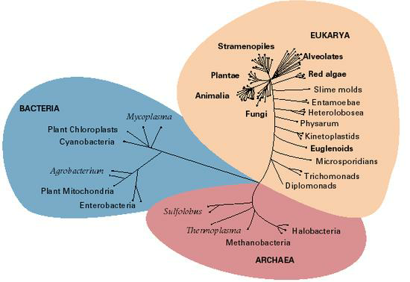
Domains
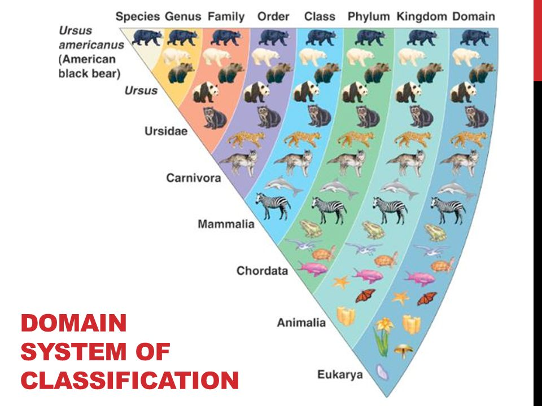

Domain Archaea
- This includes the ________________________________.
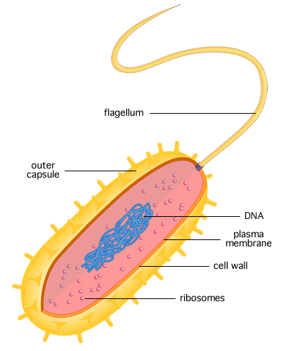
- They include forms of bacteria today that live in the most _______________________ such as hot springs and sulfur pools.
- Also includes:
  - ___________________
  - ___________________
Characteristics:
- _______________________________
- __________________________ and microscopic
- ________________ (_______________________________________________)
- Some autotrophic (______________________), some heterotrophic (_______________________)
- Have a cell wall but lacking ______________________
- DNA unique to Archaea
- Live in ________________________________

Domain Bacteria
- Includes most of the prokaryotes and all the bacteria ( ______________________
__________________________) that we are familiar with.
Characteristics:
- __________________________
- Single celled and microscopic
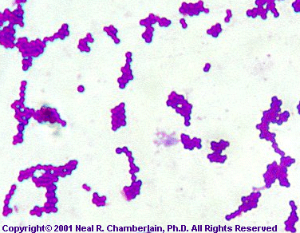
- ___________________________(__________________________________________________)
- Cell walls _________________ ____________________
- Some autotrophic, some heterotrophic
- DNA unique to Eubacteria
- Live in ____________________________________

Domain Eukarya
- This is a huge domain that includes all the __________________________________ organisms.
- In this domain, we will see and use the more conventional 7 levels of classification.

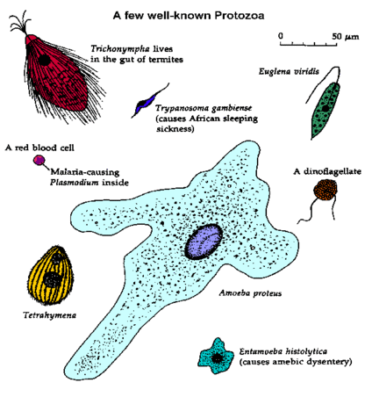
We divide domain Eukarya into four ____________________________:

Kingdom 1: Protista
- _________________________ cells
- ____________________________some colonial,
some multicellular
- __________
- ____________________ and _________________________
- May have cell walls of cellulose or may have chloroplasts
- “Catch-all” or "Junk Drawer" of the Kingdoms

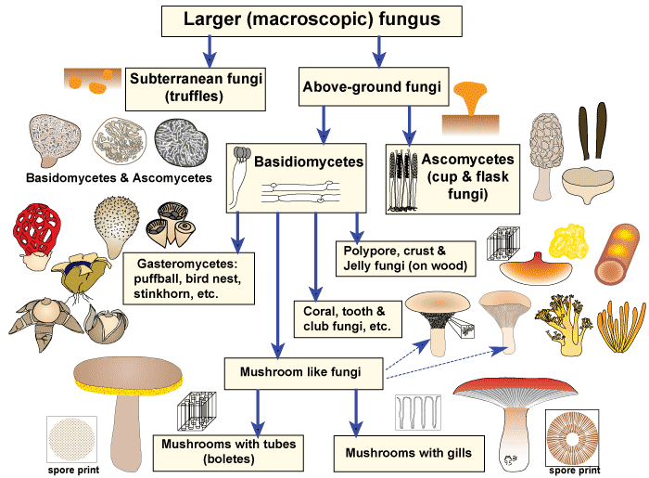
Kingdom 2: Fungi
- Eukaryotic cells
- Mostly multicellular, some unicellular (such as yeast)
- Non-motile
- _________________________
- ___________________________
- Cell walls made of chitin
- _________________________

Kingdom 3: Plantae
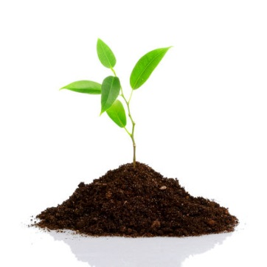
- Eukaryotic cells
- ______________________
- ______________________
- Have chloroplasts and cell walls made of cellulose
- ________________________________
- Asexual and sexual reproduction

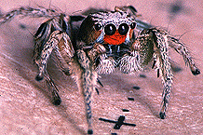
Kingdom 4: Animalia
- Eukaryotic cells
- Multicellular
- ________________________
- Largest group is the ________________________ = 70% of all animals
- No cell walls or chloroplasts
- ______________
- Sexual and asexual reproduction
Conclusion
- Taxonomy shows us where a __________________________________________________
- Let’s use humans, the house cat, lions, and a maple tree as examples to illustrate this:

Examples of Taxonomic Classification
Human House Cat Maple Tree
Domain Eukarya Eukarya Eukarya
Kingdom Animalia Animalia Plantae
Phylum Chordata Chordata Tracheophyta
Class Mammalia Mammalia Angiospermidea
Order Primata Carnivora Sapindales
Family Hominidia Felidae Aceridea
Genus Homo Felis Acer
Species sapiens catus rubrum

- We use the _________________________ and ________________________ name to identify organisms.
Ex. __________________________________ , _______________________________________
Notice that the Genus is capitalized, and the species is not. The name should be in italics if typed or underlined if printed.

House Cat Lion
Domain Eukarya Eukarya
Kingdom Animalia Animalia
Phylum Chordata Chordata
Class Mammalia Mammalia
Order Carnivora Carnivora
Family Felidae Pantherinae
Genus Felis Panthera
Species catus leo

How do we identify lions? ____________________

