Life Sciences 11
Unit Project/Journal/Portfolio

Your job: In this activity, you will demonstrate your learning that has occurred over the course of the semester. You will showcase your learning for each unit using one individual format that will gradually grow as we work through each unit. You may choose to make a notebook or an electronic option such as a website.

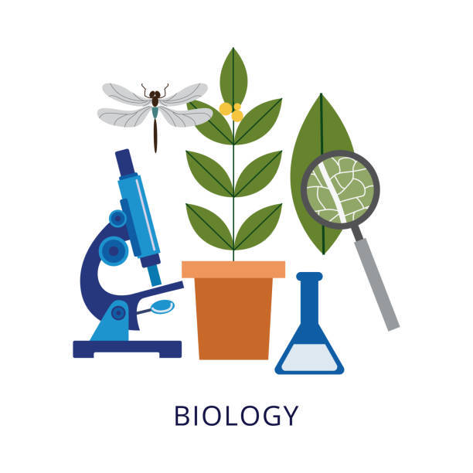
As we learn about each unit, you will show connection, interrelatedness and basic definitions of the learning standards from each unit. You will be given a list of 'I can statements' at the beginning of each unit which outlines the basic learning standards. The decision about what specific information is included and what is an accurate representation of your learning is up to you. Each of your projects should be unique to you as you make the connections of the different topics that we discuss. Hopefully by the end of the semester you will be able to easily see all the connections in this course and provide an excellent resource for studying for your unit tests and final exam.

The bulk of this assignment will be completed outside of class time, though class time will be given when available. This is a large assignment which takes time to do a good job, so please budget your time accordingly. Remember, you are making yourself a study resource. Make it worth your time to study from!

Marking guide: Each unit project/journal/portfolio will be due the same day you write your unit test. You will be marked based on presence, depth of understanding, and relevance of information. All of the unit projects/journals/portfolios over the course of the term will be combined and will equate to 10% of each term mark.
LEARNING TARGET: | I can use the learning standards to show how BIG IDEAS / THEMES
Criteria | Level 1 | Level 2 | Level 3 | Level 4
Depth of content  (Knowledge) | - Bare minimum of  content covered  - No extension of ideas evident | - Shows a basic level of coverage of key ideas only  - Attempts extension of a  few ideas | - Shows a solid grasp of most of the content  - Shows extensions of most key ideas | - Shows a solid grasp of all the content covered  - Extensions of the key ideas show a deep understanding of the interrelated nature of the content
Central Ideas  (Communication) | - Present but difficult to separate from other information | - Present but not clearly  related to key idea | - Key words clearly show an understanding of the content | - Key words clearly and dynamically show an understanding of the content.
Interrelating Ideas  (Analysis & Synthesis) | - The links between larger concepts clearly articulate questions that connect the topics (at least 2) | - The links between larger concepts clearly articulate questions that connect the topics (at least 3) | - The links between larger concepts clearly articulate questions that connect the topics (at least 4) | - The links between larger concepts clearly articulate  questions that can connect the topics (at least 5)

Making your Unit project/Journal/Portfolio: You can complete this task electronically or submit a hard copy prior to each Unit Test. I am flexible with how you choose to complete this assignment. A hard copy may be in the form of a journal, mindmap, poster, set of flashcards, etc. Some suggested sites for an electronic portfolio: Weebly, Google Docs, Google Slides, Prezi, MindMap, Bubbl.us, Quizlet, etc.

Plagiarism: If you choose to do this as a digital assignment, it may be tempting to "copy and paste" information found from the internet and classmates. Any plagiarism (ie. direct copying) will be marked with a ZERO. I want to see what you know and understand not what your friend or Google "says"! Likewise, the intent is not to simply copy down the notes word for word into a notebook either!

