Name: Vaccines Date:
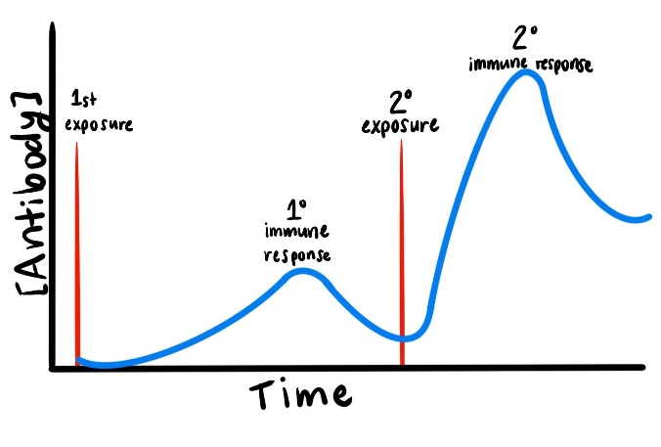
Immune Response
- The reason you do not get infected with the same virus multiple times is due to your body’s adaptive immune response. Your main defense is your _______________________ which are like _____ ____________________________________________________ virus.
- After learning the virus structure and how to make antibodies against it, your body creates __________________ which allow your immune system __________________ specific infections and __________________________________ _______________________________________________________________ of antibodies against the infection.
Vaccines
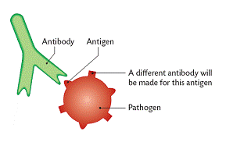
- A vaccine is a ______________________ measure. They work by triggering your body to start an immune response against a disease before you ever get the disease. The goal is to make you ____________________ to the disease so you will never get it.
- A ______________________________ (a foreign invader such as a virus or bacteria) has ________________ ___________________________ unique to it called ___________________________.
- Antigens (__________________________________) are specific to each type of virus or bacteria.
- Once your body has encountered a specific pathogen with antigens on it, it will begin to produce _____________________ to fight the infection.
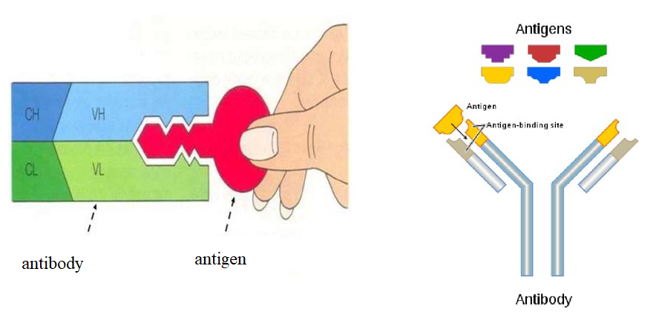
- The antibodies are highly specific and their shape allows them to attach like a _______________________ to specific foreign antigens.

- After the infection is over, __________________________________ are produced which remember the antigen structure.
- Your body is now immune to getting this same disease again as it is able to recognize the virus or bacteria (by its antigen) and is already prepared to fight with premade antibodies.
- You are protected from future infection! This protection is called _______________________.
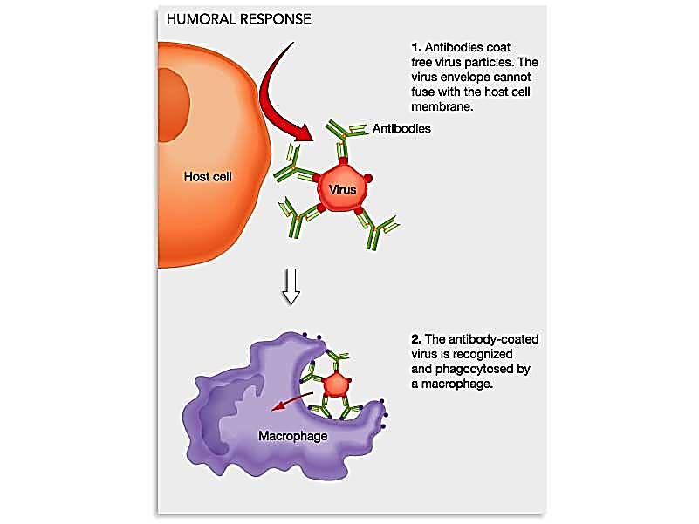
- A ____________________________ is a safe way to cause your body to produce _______________________ and ____________________ against a specific virus or bacteria (by its antigen), protecting you if you ever encounter it. A vaccine essentially teaches your immune system how to fight against specific infections.
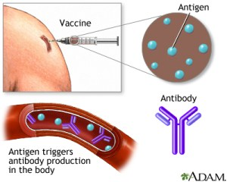

Spread the Word to Protect the Herd!
- When lots of people in an area are vaccinated, fewer people get sick. Then fewer germs are around to spread from person to person.
- This concept is called ____________________________________, or community immunity.
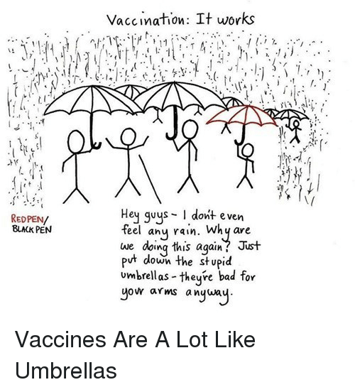
- When you vaccinate somebody, you protect them from getting infected, but you can also help _______________ _________________________________________to other people.
- Herd immunity __________________________________________ _________________________________________ because their immune system is weak and vaccines might make them sick. This includes babies, people with vaccine allergies, and anyone with an immune-suppressing disease like HIV or cancer.
- Often the people we need to protect with herd immunity are ______ _________________________ to serious disease.
Can you …
… explain what a vaccine is and how they work?
… draw, explain, and differentiate between pathogens, antigens and antibodies?
… explain the concept of heard immunity?

