Life Sciences 11 Microbiology: Viruses Date:

Objectives - By the end of the lesson you should be able to:

- Classify viruses as living or non-living
- Describe the structure of a virus
- Explain how a virus infects a host
- Compare and contrast the lytic and lysogenic cycles of viral reproduction
- Describe different types of viruses
- Explain human responses to viral infections

Introduction
- Viruses are not included in any of the Domains or Kingdoms of life. Why?

The 8 Characteristics of Life (Review)
- 1. All life is made up of at least one or more ____________________
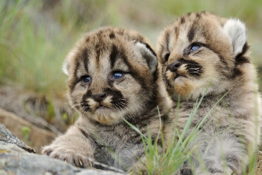
- 2. All life must obtain and use ____________________________ (metabolism)
- 3. All life grows – increasing its biomass as it develops
- 4. All life reproduces ____________________________
- 5. All life responds to its environment
- 6. All life adapts - ____________________________ to survive in its environment over generations
- 7. All life maintains ___________________________________ (stable internal environment)
- 8. All life is based on a universal ________________

Viruses…..Life?
- They ______________________ all of the characteristics of life
- Viruses are not cells and do not contain ____________________ or any other ___________________
- They can’t do any of the chemistry of life (_________________________) by themselves
- They can be _______________________________________ rehydrated, and still be infectious
- Viruses contain _________________________ …which can mutate and evolve just like ours!
- Viruses cause diseases which can be contagious
- Viruses can reproduce, ______________________________ - they force a host cell to help!

So what are viruses?
- They are very tiny particles (seen only with an electron microscope) that have some of the properties of life
- Definition: an infective agent that typically consists of a ___________________ ______________________________, is too small to be seen by light microscopy, and is able to multiply only within the _________________________________________________.

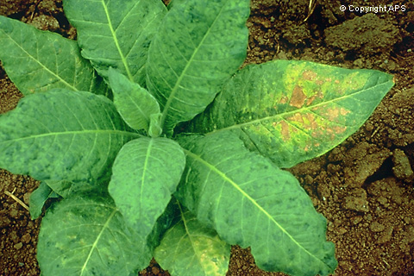
Discovery of Viruses
- By Dimitre Ivanowski - experimented with Tobacco Mosaic Disease
- Knew a pathogen was involved but couldn’t see it!
- Did 3 experiments
- Experiments:
1: Extracted juice from diseased leaves and spread on healthy leaves
- Healthy leaves became diseased
2: Boiled the diseased juice then placed it on healthy leaves
- Healthy leaves did NOT become diseased
3: Passed the unboiled diseased juice through a fine porcelain filter (too small for any life, even smallest bacteria, to get through) then place filtrate onto healthy leaves
- Healthy leaves became diseased!

Martinus Beijerinck
- Suggested that ______________________________ in the juice caused the disease

- Called these particles ___________________

Wendell Stanley's Experiment:
- Left the filtrate sitting out overnight and water evaporated away and ______________________ formed. Added water back to dissolve the crystals and placed this solution on healthy leaves
- _______________________________________
Experimental Conclusions:
Ivanowski Stanley
1. Disease was ______________________ Disease caused by something ___________
2. Disease was caused by ____________________ because it could be crystallized and all life
3. Disease caused by a ________________________ dies without water
Virus Structure
- All consist of a _______________________________________ called a (________________________)
surrounding a ___________________________
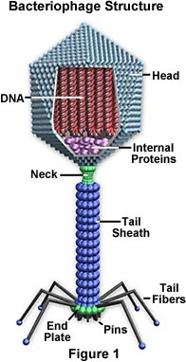
- All are _________________________________
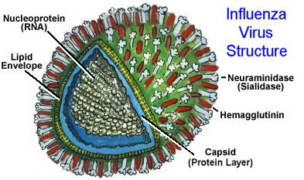
Structure of viruses are highly variable but all have the same basic layout
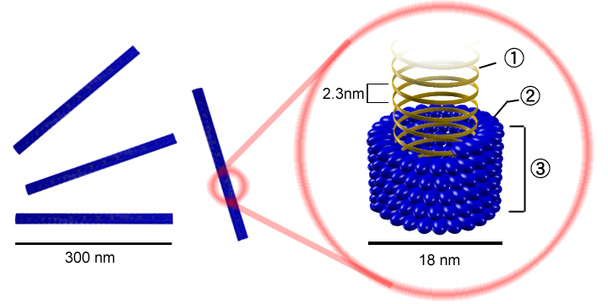

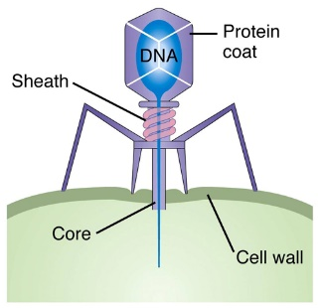
How do viruses infect?
- The virus lands on the cell then pierces its cell wall with its tail and ________________________________
- The now empty virus coat is useless - like an empty egg shell

"Life" Cycles:
1. The_____________________________This results in the death of the host cell by ________ (to burst) as the virus uses the host cell to make copies of itself

2. The ______________________________ This results in the ______________________________
__________________________________
- The new genes are called a _________________________ (provirus if inserted into a human)

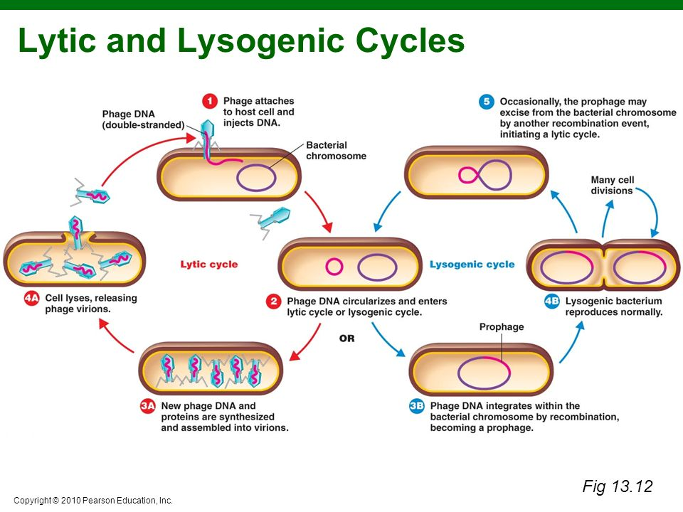

Viral Diversity
- Viruses can use either _______________ or ___________________ as their genetic material
- Two examples of viral diversity are ________________________ and _____________________
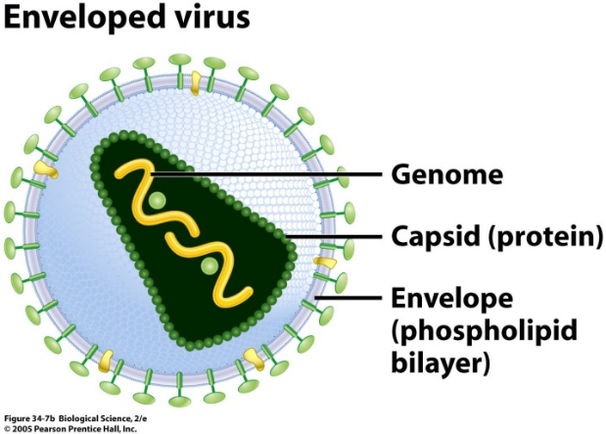
Enveloped Viruses
Some viruses have an outer membrane (captured from past host)
called a _______________________
Helps them enter host cell by fusing envelope to cell membrane
– acts like _________________________
(Ex: HIV, chickenpox)
Retro Viruses
RNA ________________________________________________ (Ex: HIV)
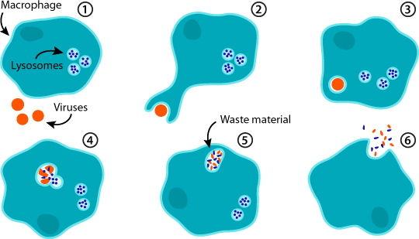
__________ quickly due to being _______________________

Responses to Viral Infections
1. __________________________
- The host’s white blood cells can “_____” the virus particle by engulfing and destroying it with enzymes in their lysosomes.
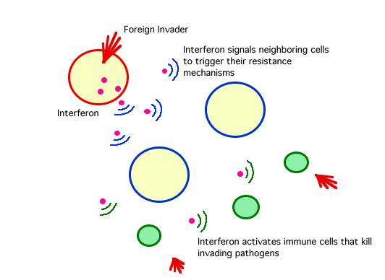
2. Immune System Response
A. _________________________:
- A protein made by an infected host cell before it dies
- ________________________ to defend against the virus
- ______________________________________ to kill virus
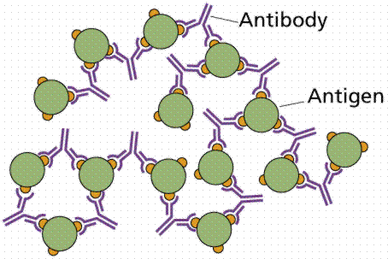
B. _________________________:
- Highly specific proteins made by white blood cells
- Attach to virus, ______________________________ (deactivating them) and making them easy to be destroyed by other WBC.

Can You …

… classify viruses as living or non-living?
… describe the structure of a virus?
… explain how a virus infects a host?
… compare and contrast the lytic and lysogenic cycles of viral reproduction?
… describe different types of viruses?
… explain human responses to viral infections?

