**Scientific Method-DRY-MIX Lab**

**Date: Drip Dropper (Name):**

**Purpose**: To correctly utilize the scientific method to investigate the effect of drop height on the size and shape of water droplet splatters.

When conducting research and using the scientific method, we only change one variable at a time. This changed variable is referred to as the manipulated, or **independent variable**. All other conditions must be kept completely identical. These conditions are called **controls** or constants. The effect that the manipulation has on the other variables is known as the responding, or **dependent variable**. The acronym DRY MIX can be used to help you distinguish between these two types of variables. DRY stands for dependent, responding, Y axis, while MIX stands for manipulated, independent, X axis.

**Hypothesis: If the height that water is dropped from increases, then the diameter of the water splatter**

**created will increase.**

**If the _______________________ is _____________________, then the __________________**

**(*independent variable*) (*describe how you will change it*) (*dependent variable*)**

**will ________________________.**

**(*describe the effect of the change*)**

**Materials**: transfer pipette, colored water, beaker/cup, white paper, meter stick, ruler

**Procedure**:

1. Partially fill a pipette with colored water.
2. Measure the heights listed in the chart using a meter stick positioned with one end on the white paper and the other end measuring the dropper height.
3. From each height, drop 3 drops of water clustered together, but not overlapping. Label the splatters on the paper.
4. Measure the diameter of the splatter in millimeters, and record each trial size in your data table.
5. Repeat the process for each height.
6. For each drop height, record qualitative data on the splatter in your data table. Examples: “Drop is very round,” “Drop broke apart and irregularly shaped,” or “Drop is surrounded by little splatters.”

**Data Table**:

|  |  |  |  |  |  |
| --- | --- | --- | --- | --- | --- |
|  | **Quantitative Data**  **Diameter of Drop Splatters (mm)** | | | |  |
| **Drop Height** | **Trial 1** | **Trial 2** | **Trial 3** | **Average** | **Qualitative Data** |
| 5 cm | 11 | 10 | 9 | **10** | The drops have smooth edged and are uniformly round. |
| 10 cm | 15 | 16 | 15 | **15.3** | The drops are relatively smooth edged circles with small bumps around the circle. |
| 20 cm | 18 | 17 | 18 | **17.7** | The drops have jagged edges. |
| 40 cm | 21 | 20 | 21 | **20.7** | The drops are surrounded by small splatters. |
| 80 cm | 24 | 25 | 25 | **25.7** | The drops are surrounded by large splatters and some are broke apart and are irregularly shaped. |

**Post-lab Questions**:

1. Create a graph showing the relationship between the average size of water splatter and drop height. Use DRY MIX to remember which data are plotted on the X axis and Y axis. Don't forget to give your graph a title!

The Effect of Drop Height on the Size of Water Droplet Splatters

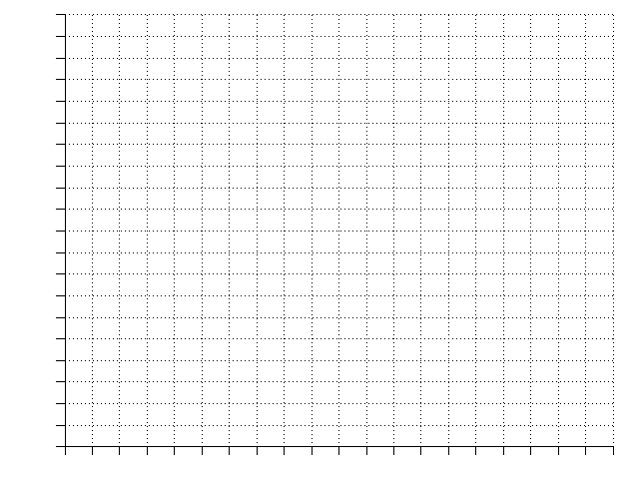 **(*independent variable*) (*dependent variable*)**



Diameter of Water Droplet Splatters (mm)



Drop Height (cm)

1. Based on your observations and data collected, what is your conclusion regarding the relationship between size of water splatter versus drop height?

As drop height increases, the size of the water splatter also increases. It is not a straight-line relationship.

1. How does your conclusion compare to your hypothesis?

The conclusion supports (*opposite = refutes*) the hypothesis as we found that the water splatter size increased as the drop height increased.

1. Describe two things (controls) that you had to do exactly the same for each trial to make sure you were as accurate as you could be.

For controls, we had the same person doing the dropping, using the same dropper with the same liquid, from the same height, onto the same absorbency paper surface.

1. Why did you do more than one trial at each height?

Increasing the number of trials decreases the error of the experiment and increases the accuracy. More trials gives a better sample of the true size of drop as there is variation between each individual drop size.

1. Do you think that measurements or descriptions are “best” for reporting scientific data? Explain why.

This really depends on what it is you are trying to study. In some cases, quantitative data will be appropriate while in other cases qualitative data will be used. If it is possible to collect both quantitative data and qualitative data, this may help the scientist to better understand their data as they can complement each other. .

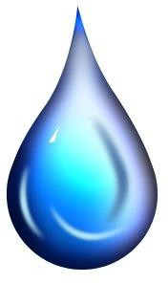

**D.R.Y. M.I.X.**

